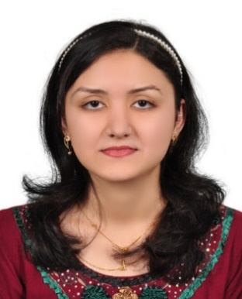

SAIMA
Saima.363387@2freemail.com

Career Objective

Seeking an opportunity to serve as a school teacher in a reputed school & share my knowledge & talent to educate the student & make them literate to survive in today’s world.

Personal Profile

I feel that my greatest strengths are my ability to understand & meet the needs of children individually & in a classroom environment. Having a clear understanding of the importance of confidentiality & being able to provide a stimulating, caring and consistent environment for students.

Key Skills

Good Organisational Skills
- Ability to handle children of different age groups.
- Expertise in using new teaching methodology to explain difficult topics
- Pre-planning lessons.
- Correcting homework daily and returning homework copies on time.

Excellent Communicator
- Clearly explaining the lesson.
- Understanding the student and explaining according to their need.
- Lenient in handling the children.

Ability to work within a team
- Working alongside other members’ of staff.
- Coordinating with teachers of other sections and classes.
- Strong passion towards teaching.
- Positive attitude with all.

Educational Qualifications

Allama Iqbal University, Pak.
Bachelor of Education 2012 – 2013
Major Subjects (Islamic Studies & English)

University of the Punjab, Pak.
Bachelor of Arts 2009 – 2011

Rawalpindi Board, Pak.
Intermediate (HSC) 2007 – 2009

Rawalpindi Board, Pak.
Matriculate (SSC) 2005 – 2007

Technical Skills

Extensive knowledge of Internet, computer software’s (MS–Office Suite) & also knowledge with computer’s hardware system.

Language Known

Urdu, English, Punjabi, Arabic, Hindi.

Employment Summary

School Teacher for High Classes 2013-2015

Helping students to learn with confidence and providing them with the tools to make learning a positive experience. Providing a classroom presence and contributing to the positive ethos of the school. Putting students first by demonstrating energy, vision and creativity.

Responsibilities & Skills:
- Helping students to define and identify difficulties and overcoming them.
- Tailoring teaching methods to suit the needs of individual students.
- Planning, preparing and delivering lessons to a range of classes.
- Marking work and giving appropriate feedback to students.
- Researching and using a variety of materials to reinforce concepts.
- Managing students’ behaviour in the classroom and on school premises.
- Administrating and marking examinations.
- Preparing coursework for students and the class.
- Putting up displays in the classroom.
- Liaising with other teachers and provide solutions to any problems that occur with pupils.
- Keeping parents updated about their child's progress.
- Arranging homework.

Internship for 1 month [May 1st, 2013 – May 31st, 2013]
During My B.Ed. Classes

Responsibilities:
- Impart education on children according to the syllabus
- To create interest amongst the children
- Devise interactive methods to teach the students
- Assigning Homework and giving feedback
- Maintain records on student’s’ progress.
- Applying innovative interactive methods to make learning fun.

Interests

I love to visit different places, I can’t refuse to go anywhere anytime. I also enjoy reading ancient literature. I have a love for history & enjoy studying about historical events & personalities. I also enjoy listening music, watching movies & playing different games.

Personal Information

- Age : 24 years old
- Date of Birth : May 13, 1992
- Citizenship : Pakistani
- Civil Status : Married
- Gender : Female

