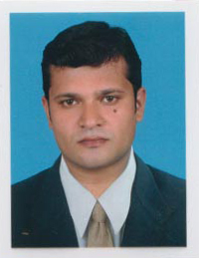
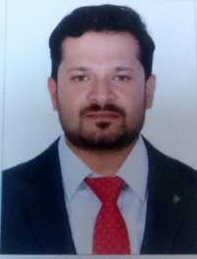 SAYID
SAYID.363395@2freemail.com

Professional Strength

Objective

- Seeking a challenging carrier in an organization where I believe I can contribute my skills, knowledge and experience to a team for achieving business performance, betterment and professional advancement.

Skills & Abilities
- Ability to communicate, interact and work effectively and cooperatively with all people including those from diverse ethnic and educational backgrounds.
- Learning the occupational hazards, safety standards and procedures, and appropriate
- Safety precautions to protect self and others.
- Following oral and written directions, preparing reports and maintaining accurate records.
- Operating and maintaining tools and equipment in a safe and effective manner.

Professional Experience
- Worked as a management officer of customer support and also complete system management with Kerala vision broadband service ltd. From Oct.2014 – Mar.2017
Two years’ experience in Kerala vision broadband service ltd (CISCO Switch , OLT System Management and System service engineer .Also experienced with OFC (Optic-Fiber Networking)
• Hardware Management (Servers, Desktops, Peripherals etc.)
• Computer Hardware & Peripherals, infrastructure and other equipment’s
maintenance
• Software Support
• Version Management
• LAN and Server Administration
• IT Security
• IT Helpdesk Management
• Application Management including day-end, day-begin, month-end,
year-end, periodic and daily back-ups
• Software updates, patch management, security updates, data updates
from one application to another application
- Worked as a system service engineer with CITRIX info solution ltd from Sep 2006 – Sep.2014
8 years’ experience in Computer Hardware and Networking Field with CITRIX INFO solution (customer related services like software and Hardware, Networking bases on Schools and Hospitals with high level switches, and as worked as senior system service Engineer
• Software Maintenance
• Hardware Management (Servers, Desktops, Peripherals etc.)
• Computer Hardware & Peripherals, infrastructure and other equipment’s
maintenance
• Software Support
• Version Management
• LAN and Server Administration
• IT Security
• IT Helpdesk Management
• Application Management including day-end, day-begin, month-end,
year-end, periodic and daily back-ups
• Software updates, patch management, security updates, data updates
from one application to another application
• Back-up & recovery operation & management • Administration of Microsoft Windows 2003 Server and XP and windows 7 Clients

Scholastics
Aug 2003 to Oct 2006 | Diploma in computer Hardware and Networking Engineering in poly tectonic.  Diploma in computer application DCA Gov. Of Kerala (well versed with MS-Office, Windows and internet applications and Graphics )
Oct 2001 to Apr 2003 | Secondary School Leaving Certificate Examination (Plus Two) Passed Form Higher Secondary Board of Examination Kerala, Issued under the authority of the Government of Kerala. 2003

Languages Known
English, Hindi, Tamil & Malayalam.
Personal Dossiers
Nationality : Indian.
Date of Birth : 16.May.1982.
Sex : Male.
Marital Status : Married
Religion : Islam. /Muslim
Blood Group : B+ve.

Declaration:-
If given any suitable opportunities to serve your establishment organization I assure you my sincere co-operative to the success of your company.

