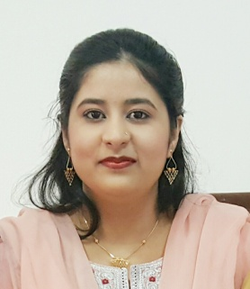
CARRICULUM VITAE

UMRA
UMRA.363492@2freemail.com

CAREER OBJECTIVE
Seeking a position where I can utilize my knowledge, abilities and personal skills while being resourceful, innovative and flexible that offers professional growth along with the organization.
EDUCATIONAL QUALIFICATION

COURSE | UNIVERSITY | YEAR OF STUDY | PERCENTAGE
Web designing & publishing | A.M.U | 2014 | 96%
Diploma in IT | A.M.U | 2013 | 71%
SSC | A.M.U | 2010 | 79%

Project title : 3 Tier data management system
Project detail: Developed an information system for a hostel in Microsoft Visual Basic 6.0, C and MySQL. This system is useful to perform the complete management functionalities of any hostel.
TECHNICAL SKILLS
Language : C, C++
Operating Systems : Windows XP, 7
Web Development : HTML, CSS
Application Software : MS Office
Database : MS Access

EXTRA CARRICULAR ACTIVITY
Short term Course in Web Designing and publishing from A.M.U in 2013-2014
Grade: A
Project detail: Developed a Website using HTML and CSS
PERSONAL DETAILS
Date of Birth : 11th March 1994
Nationality : Indian
Marital Status : Married

Date:

