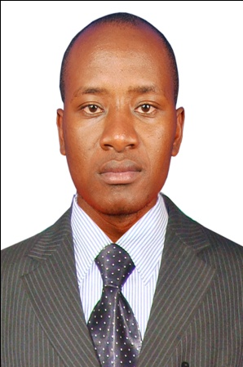
ALEX
Alex.363548@2freemail.com
ACADEMIC QUALIFICATIONS.
2010-2012: MOI UNIVERSITY ELDORET
: attained a diploma in hospitality
2006-2009: ST.TERESAS HIGH SCHOOL KITALE
: attained a mean grade of B-
1998-2005 : MATISI PRIMARY SCHOOL KITALE
: attained a mean grade of B plain of 331/500marks
SKILLS PROFILE.
COMMUNICATION SKILLS. Learnt to speak effectively in formal meetings through my course representatives duties Experience of dealing effectively with a wide range of customers during my internship period.
TEAMWORK. Learnt how to listen to needs of others and provide support and solutions. Gained insight into how teams can develop strategies to deal with problems through participating as a team member in my assignments as part of my course back at the university.
PERSONAL ORGANIZATION AND TIME MANAGEMENT. Adapted successfully to the various departments within the organization during my internship period. I perform my duties diligently under minimal supervision. I have fundamental knowledge in; Microsoft office, Microsoft excels; Microsoft power point, Page making, Mail merging and internet surfing.
WORKING EXPERIENCE. Worked with the Naivas supermarket Ltd as a cashier and later with leopard restaurant Diani as a waiter

DUTIES AND RESPONSIBILITIES AS WAITER
I) collect payment from clients II) Take orders from patrons for food or beverages III) Remove dishes and glasses from tables or counters,
III) Present menu to patrons and answer questions about menu items, making recommendations upon request.
V) Clean tables and/or counters after patrons have finished dining
VI) Prepare tables for meals, including setting up items such as linens, silverware, and glassware.
VIII) Check with customers to ensure that they are enjoying their meals and take action to correct any problems
DUTIES AND RESPONSIBILITIES AS A CASHIER
I) Receiving money from the clients at the counter and making sure it’s genuine legal tender
II) Feeding the total cost into the system and giving back the balance to the client
III) Welcoming and greeting clients
Iv) Handling minor client complaints at the counter
v) Accounting for daily cash transaction at the end of the day and submitting the result to the chief cashiers office
AWARDS.
Certificate of participation in Moi University sports programme
Certificate in Computer Application (credit).
Certificate in customer service with Leopard restaurant Diani
ACTIVITIES/INTRESTS.
SPORT: I was a member of the football team back at the university
TRAVELLING: I enjoy experiencing new cultures and have travelled to various parts of Kenya.
OTHER: I like reading and socialising.

