CURRICULUM VITAE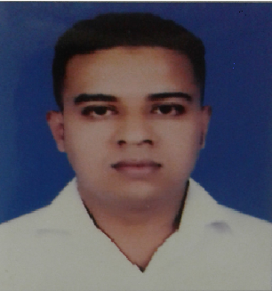

SOHAG
SOHAG.363559@2freemail.com

Personal Summary:

A reliable and energetic work with 11 years Catering & Housekeeping experience with the following skills.
- Comprehensive knowledge of safety & Regulations.
- In depth knowledge of Cleaning methods and operation of housekeeping equipment.
- Proven commitment to providing a high standard of care and concern to senior resident.
- Personal reputation an individual of high ethical standards.

Skills:
- Guest Relations.
- Corporate Hospitality.
- Human Resources.
- Guest Experience Sales & Marketing.
- Front Desk Management.
- Managing Housekeeping.
- Customer Service.
- Performance management.
- Hotel operation.
- Food & Beverages.
- Business Administration.
- Event Management.
- Knowledge of basic Food safety Hygiene.
- Participation in Staff supervision, training & meeting activities.
- Take responsibility for personal development by keeping abreast of developments in the field of caring for older people.

Education:
- H.S.C Exam Passed from D.M.H.C.D.C, Comilla (Dhaka) Bangladesh.

Computer Skills:
- Knowledge of Computer Application, Web Browsing.

Employment History:

BEST GROUP TRADING & CONTRATING
Designation: Senior catering Supervisor
Duration: 26th Jan 2005 to 27th Jan 2006
Designation: Housekeeping Supervisor
Duration: 2nd Mar 2006 to 3rd Mar 2007
Location: Doha, Qatar.

SHAQAB ABELA CATERING SERVICE CO.W.L.L
Designation: Supervisor
Duration: 30th April 2008 to Until

Professional Experience:
- Responsible for the overall Cleanliness and sanitation of the resident areas including scrubbing, mopping, vacuuming, polishing, dusting and using germicides.
- Monitor and maintain housekeeping supplies.
- Clean and maintain housekeeping equipment
- Respond appropriately to resident special requests.
- Collect linen and assist in laundry.
- Adhere to safety and hygiene guidelines and OSHA standards.
Key Skills:
- Communication skills.
- Team Work.
- Attention to details.
- Time management.
- Dependability.
- Integrity.

PERSONAL PROFILE:
Date of Birth : 10th FEB 1982
Nationality : BANGLADESH
Marital Status : MARRIED

DECLARATION:
Presently I am working Shaqab Abela CateringCo.As Supervisor. I hereby declared that all information Furnished above is true to the best of my knowledge and belief.

