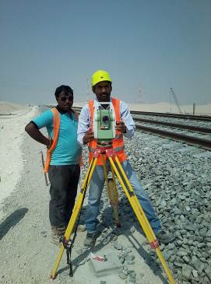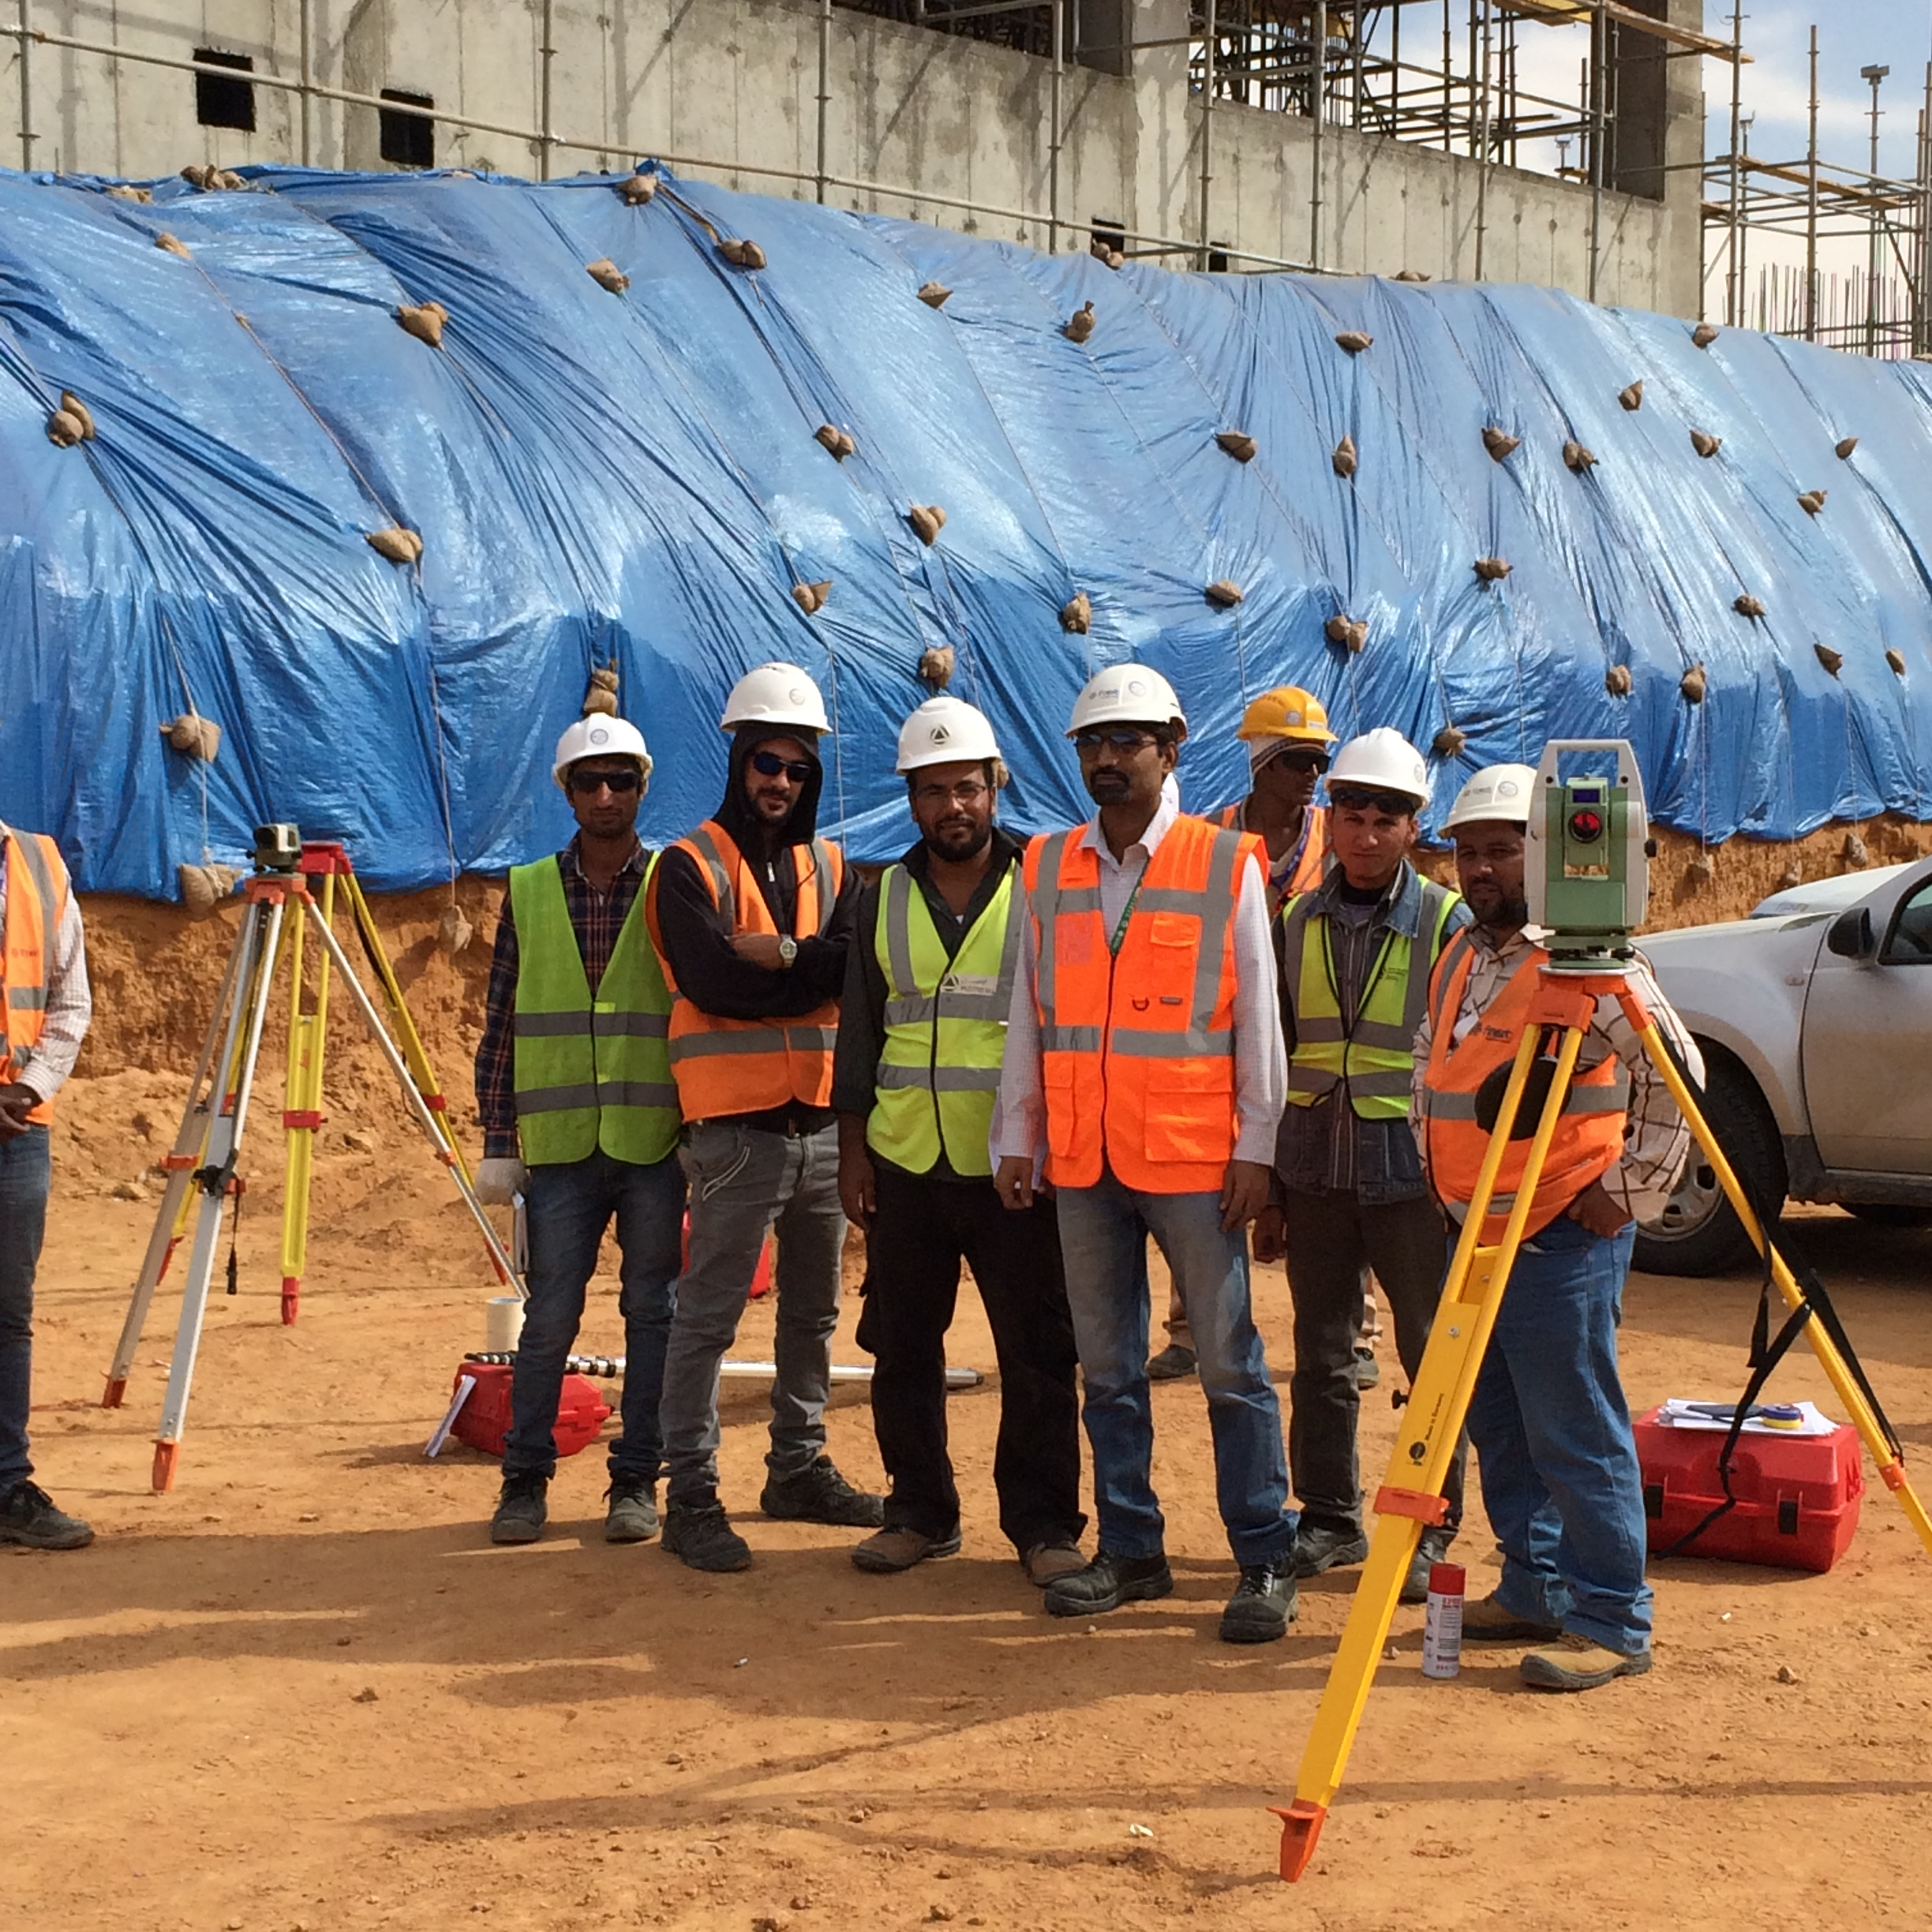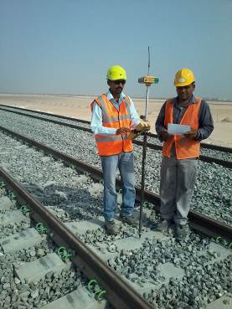 | 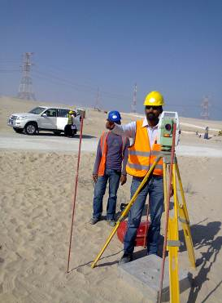
PROFILE SYNOPSIS
Total Experience 15 years over included 8 years Gulf Experience with Driving Liecense.

Current Organization : Hill International (upto 27/011/2016)
Current Designation : Sr. Land Surveyor
Current Location : Varanasi, India
Project Name : Riyadh Metro
Total Experience : 15years over
Abroad Experience : 8 Years: Bahrain , Indonesia, Qatar ,UAE and Riyadh(KSA)
Current Salary : AED 11000/PM + Company benefit
Expected Salary : Not specified/Company Stander
Notice Period : Immediate.
Competency Exam. : Survey Competency the Mine Act 1952
Professional Qualification : 2 Years Government training of Land Surveyor (India)
Highest Qualification : B.E (Civil)
Driving License : United Arab Emirates and India
Date of Birth : 30 June 1978

PROFILE SYNOPSIS
Surveyor Party Chief in charge of all field work. Responsibilities included construction layout of Railway Line & Heavy Highways (Layout of curb and gutter, slope staking, Bridge abutments and Metro line to TBM shifting Lay out for excavation to tunnel width 9.2m …etc. In charge of creation of all data files necessary for job stakeouts, Schedule planning, job estimates. TDS Survey 4 card for data collection. Corroborate with draftsman in regards to all drawings.
Over 14 years’ experience in land surveying, extensive knowledge of Construction Surveys, Topographic Surveys, as well as built Surveys.
I have completed 6 years GCC Experience and my preliminary project Etihad Railway as built Surveys on more than 260 KM Of Railway line, worked on numerous multi-million dollar construction companies, supporting coalition in Desert of Abu Dhabi,UAE.

CAREER OBJECTIVE
- To obtain a full time position in Land Surveying where I can utilize my skills, knowledge and experience as I pursue professional licensure as a Land Surveyor
- To obtain a challenging position in an organization where I can make my useful contribution to the Industry and prove credentials as better professionals.
- To lead an Organization towards a horizon of success while holding a key position in its Management or Technical Cell.

AREAS OF SPECIALIZATION AND RESPONSIBILTY

- Route Survey--Carry out Reconnaissance and Alignment surveys.
- Perform Topographic Surveys.
- Carry out Longitudinal and Cross-Section surveys and data recording and analysis
- Identify type and location of existing utility services (e.g. Fibre, Optical Cable, O/H and U/G Electric, Telephone line, Water mains, Sewer, Trees etc
- Carry out Road Inventory Surveys along with associated structures
- All activities of Establish horizontal and vertical control station.
- Carrying Out Detailed Topographical Survey for Tender Bidding also for Quantity and Design.
- Construction Alignment Setting Out as Pear Design Drawing.
- Used Hand GPS (Trimble) to Road Survey.
- Feasibility Report with help of Google Earth Software.
- Self command of all Land Survey Equipment DGPS, Total Station, Digital Auto Level and Auto Level.
- Calculate heights, depths, relative positions, distances, and other characteristics of the terrain to perform a work activity.
- Compute measurements and interpret survey data in order to determine positions, shapes and elevations of topographic features
- Establish fixed points for use in making maps, using and engineering instruments.
- Sketch the path above a surface area, following any excavation work.
- Prepare and maintain sketches, maps, reports and legal descriptions of surveys in order to certify and assume liability for work performed.
- Prepare/supervise preparation of all data, charts, records, etc… and to record the results of land surveys and features.
- Roads experience is mandatory.
- Good Communication with client and Senior persons.
- Knowledge of civil engineering principles and practices and construction specifications, plans and regulations related to construction;
- Knowledge of industry specific safe workplace principles and practices;
- Ability to operate motorized equipment;
- Ability to work long hours outdoors under various field conditions and exposure to traffic, heat, cold, and other adverse conditions;
- Valid Driver’s License.

PERSONAL SKILLS

- Extremely Energetic and Self-motivated , a gift for problems in a fast paced Environment, Committed to excellence, good communication skills ,Team building capability and can motivate a group of people to achieve a particular goal.

JOB EXPERIENCE
Company : Hill International, Saudia
Name of Project : Riyadh Metro
Designation : Sr. Land Surveyor
Duration : From 03 July 2014. To 27 July. 2016.

Company : Saipem SpA , UAE
Name of Project : Etihad Railway (260km)
Designation : Topographer (Supervision of 260km, Railway Line)
Duration : From 8th July 2012 to 31, March 2014

Company : Al – Mohanna Group
Name of Project : Al-Shamal Road (Qatar)
Designation : Sr. Survey Engineer (Department Head)
Duration : From 10th Sep. 2011 to 4th July,2012

Company : Larsen & Toubro Ltd.
Name of Project : Rail Link of Maithon Power (India)
Designation : Sr. Survey Engineer (Survey In charge)
Duration : From 1st December 2008 to 3rd Sep. 2011
Name of Project :Rail connectivity of Rajpura power plant ( India)
Name of Project : Mumbai Mono Rail, Mumbai, India
Name of Project : Rail connectivity of Star Light Energy Power Plant, (India)
Name of Project : Rail connectivity From Port (Sengata) to Coal Mine (maurawahau) in
(East-Kalimantan, Indonesia).

Company : D. S. Constructions Ltd.
Name of Project : Four Lining Road Project of Highway NH-6
Road BOT Project Raipur To Arang (43 Km.) (Raipur, Chhattisgarh, India)
Designation : Sr. Survey Engineer
Duration : From 01st Jan.2008 to 27th Nov. 2008.

Company : Atlas transport Construction, mechanical & Services Co. W.L.L
(Kingdom of Bahrain)
.Name of project : Replacement of Sitra Bridge
Designation : Senior Surveyor
Duration : From 11th Nov.2006 to 06th Dec.2007
Company : PNC Construction Co. Ltd.
Name of project : Four line National Highway – 24 Grahmkutershwar to Moradabad, U.P, India.
Designation : Land Surveyor
Duration : From 11th Oct.2005 to 28th Oct.2006.

JOB EXPERIENCE

Company : R S B Project Ltd. (under the Bharat Oman refinery Ltd.), Bina , M.P.
Name of project : Granding Road & Drain and cutting & Filling
Designation : Land Surveyor
Duration : From 7thJune 2003 to 30TH sep.2005
Company : R.K. Minerals & Constructions company Sidhi, M.P, India
Designation : Land Surveyor
Project : Extend National Highway- 75
Duration : From 2nd April 2001 to 30th May 2003.
.
ACADEMIC

- Bachelor of Engineering (Civil Engineer) from Kerala University 2004 (58%).
- Intermediate (Science) From Bihar Board, Gaya in 1995 (71%).
- High School from Bihar Board, Bokaro in 1993 (56%)
PROFESSIONAL QUALIFICATION
GOVERNMENT TRAINING OF LAND SURVEYOR (two Year)I have done Directorate General of Mines Safety Training (D.G.M.S.) with specialization in Civil Engineer and First Aid Medical under taking of Government of India .
- One Year underground training in Karo-incline, B&K Area, Central Coal Field Ltd., Bermo, Bokaro, Jharkhand.
- One Year Open cost training in Karo-open cost project, B&K Area, Central Coal Field Ltd.
- First Aid Medical Certificate.
COMPUTER
- Auto-Cad
- Transfer data from Total Station and DGPS (survey Instruments) to computer.
- Google Earth.
- MS-Office, Excel, Internet.
HOBBIES
- Playing and watching Volley-Boll.

- Playing and watching Cricket.

- Travelling.

