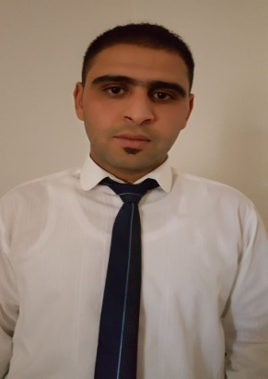
Name : Cherif
Cherif.363678@2freemail.com
Date Of Birth : 28 April 1991
Location : Dubaï, UAE

PERSONAL SUMMARY

A polite, well spoken and hard working waiter with experience of working in a busy restaurant environment looking after the needs of patrons. Attentively at all times with a willing and helpful manner that is required to answer phone calls, taking reservations and prepare bills. Always approachable, cheerful and possessing good observation skills as well as the ability to work alone or as part of a team.
Keen to find a challenging position within an exciting employer where I will be able to continue to increase my work experience & develop my abilities.

WORK EXPERIENCE

Movenpick Hotel –Sousse-TUNISIA
Waiter , June 2015- Present

Provide high standards of customer service and financial transaction management while sustaining high levels of proficiency in the delivery of services in this busy restaurant.
Duties:
- Providing a warm welcome for customers.
- Receive food & drink orders & serve customer requests to the standards required. Serving dishes to customers at tables.
- Learning the names of & building relationships with regular customers.
- Ensure timely delivery of all food & beverage items to customers.
- Understand menu content and keeping up to date with any menu changes.
- Making recommendations from the menu if requested.
- Answer guest queries in a polite and helpful manner.
- Clearing cutlery and dishes away from tables.
- Passing food orders through to the kitchen staff promptly.
- Ensuring all hotel corridors are kept clear from rubbish, glassware and crockery.
- Full product knowledge of all menu items and hotel facilities and services.
- Check on customers asking if they are enjoying their meals and service.
- Ensuring the food service area is left clean and tidy once all the guests have left.
- Relaying, preparing and setting tables for the next guests.
- Looking after guests with special needs i.e. dietary requirements, allergies, mobility etc.
Billionaire Restaurant( BAR– Restaurant )-Tunis-TUNISIA
Waiter , January 2013- July 2015

Worked in close collaboration with team members to ensure that customers received high quality of service, carefully taking orders, welcoming and seating guests, and monitoring quality and accuracy of order delivery.
Duties:
- Greeted guests, checked bookings and escorted guest to tables, consistently checking their requirements and providing response to their enquiries.
- Presented menus, explained menu items and made recommendations along with assisting guests with particular food allergies and preferences to select items.
- Served and cleared food following correct etiquette.
- Checked orders for accuracy, quality and presentation standards.
KEY SKILLS AND COMPETENCIES
- Familiar with all cash handling & Credit card payment procedures.
- The motivation to learn new knowledge and skills.
- Good Housekeeping duties.
- Have a full knowledge of all food & beverage policies and procedures.

AREAS OF EXPERTISE
- Preparing food & drinks
- Cocktails
- Hospitality
- Up selling techniques for wine & meals
- Waiting on tables
- Taking customer orders
- Customer service
PROFESSIONAL
High School , Mathematic , Chebba –MAHDIA-TUNISIA
Higher technician , Oil & Gas drilling , Gabes-Tunisia
English, French,Arabic speaker
PERSONAL SKILLS
Team player ,Guest focused ,High standard of personal hygiene.

REFERENCES – Available on request.

