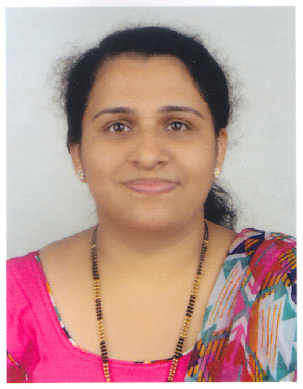 | CV for the post of PHARMACIST/ PHARMACY MANAGER
Teema
Teema.363686@2freemail.com

- Professional Experience
Nov 2014 – Aug 2016 > Life Line Hospital, Sohar, Sultanate of Oman.
As Pharmacist
Role: >>
➢ Checking prescription for proper dosage
➢ Dispensing medicines to in and out patients
➢ Ensuring proper usage of medicine
➢ Maintaining of pharmaceutical supplies and stocks
➢ Computer billing

Dec 2009 – Mar 2014 > Amballore Clinic and Pharmacy, Chengannur, Kerala, India.
As Pharmacist
Role: >>
➢ Checking prescription for proper dosage
➢ Dispensing medicines to patients
➢ Ensuring proper usage of medicine
➢ Checking of pharmaceutical supplies and stocks

Oct 2004 – Nov 2007 > Pushpagiri Medical College Hosptital, Thiruvalla, Kerala, India.
As Pharmacist
Role: >>
➢ Dispensing of both in and out patients
➢ Advising patients on administration, uses and effects of the medication, interaction or contraindication; if any.
➢ Ensure proper storage of medicine
➢ Maintaining of pharmaceutical supplies stocks/stock records, records of narcotic products
➢ Advising customers about selection and usage of OTC products (Non prescription medication)
➢ Coordinating activation with other pharmacists, hospital staff and training the junior pharmacists

- Highlights
- Good communication and organizational skills.
- Language proficiency in English and Arabic
- Passed UAE Prometric license examination
- Time Management work under tremendous work pressure and meet the dead lines with efficiency
- Ability to learn quickly and adapt to changing environments
- Administrative, day to day management
- Strong client and account management skills

- Objective
- To seek a suitable placement in an esteemed medical organization in order to utilize my skills, expertise and extensive practical knowledge of 13 years as a Pharmacist.

Jun2004 – Sep 2004 > The Koothattukulam Co-operative Hospital Ltd, Kerala, India.
As Trainee Pharmacist
Role: >>
➢ Dispensing of both in-patients and out-patients
➢ Computer billing, labeling and packing on issuing medicine
➢ Checking of expiry medicine and making a list of short expiry medicine
➢ Advising patients on administration

Mar2004 – Apr 2004 > Industrial Training Experience: at EROS Pharma, Penya, Bangalore, India.
As Apprentice
Role: >>
➢ Assist in manufacture of oral liquids, tableting, capsulation and ointments
➢ Assist in store keeping and quality control sections

- Education

COURSE | YEAR | INSTITUTION | BOARD/UNIVERSITY
B.Pharm | 2004 | St. Johns Pharmacy College, Bangalore, Karnataka, India | Rajiv Gandhi University of Health Science, Karnataka, India
Pre-Degree | 1999 | Marthoma College, Thiruvalla, Kerala, India | M.G University, Kerala, India
SSLC | 1997 | MGM Higher Secondary School, Thiruvalla, Kerala, India | General Education Department, Kerala, India

Kerala State Pharmacy Council Registration Number - 30604
Kerala State Pharmacy Council Registration Number – 30604

UAE Prometric Examination License Number – 152579

- Language Proficiency

English, Arabic, Hindi, Malayalam and Tamil

- Hobbies

Music, Reading and Travelling

- Personal Profile

Nationality | : | India
Gender | : | Female
Date of Birth | : | 31- May -1982
Religion | : | Christian
Marital Status | : | Married
UAE Visa Status | : | Visit

