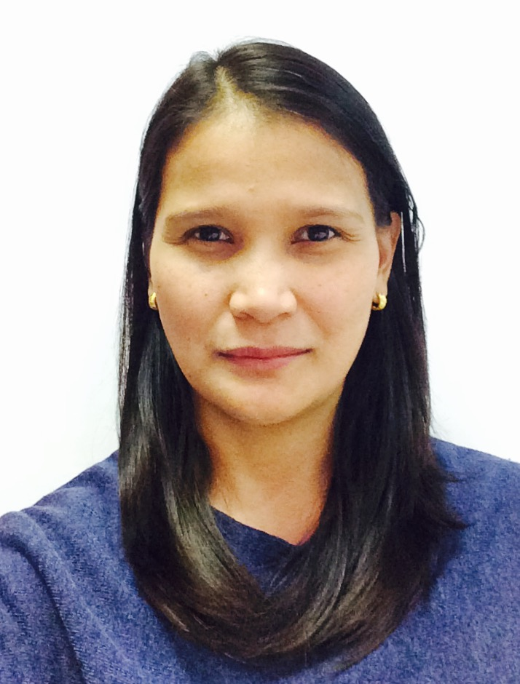
CLARIZA
CLARIZA.363694@2freemail.com

QUALIFICATIONS

Bachelor of Commerce Major in Banking & Finance 1996
Canossa College, San Pablo City, Philippines
Banking and Finance graduate, work at Barney School Abu Dhabi as Teacher Assistant (EYFC Training) more than 10 years of experience in diverse industries and sectors, which which includes six (6) years successful experience in Banking and more than four (4) years of experience in Customer service committed professional with invaluable experience and knowledge in Banking, Customer Service, Financial & Payroll process. Have excellent attention to detail, strong analytical and planning skills, combined with ability to coordinate efforts of many to meet organizational goals. Productive & efficient work habits, ability to remain focus and perform well under stress. A team player, acknowledged as “Total Quality Customer Service”.
WORK EXPERIENCE

Energy Star Household Appliances (SM)-Consultant, Abu Dhabi, Jan 2016- present.

Barney Nursery School Shamka Branch Abu Dhabi - Oct 2016 - Feb 2017
Teacher Assistant (EYFS training)

Khidmah Clubhouse /Health Club LLC, Abu Dhabi U.A.E. 2011-2012
Reporting to the Supervisor/ Team Leader
Khidmah LLC is a fully Integrated Property Service Solutions Provider, delivering comprehensive Services under a single point of contact to the finest properties and most prestigious clients not only in the Middle East, but throughout the world.
Receptionist/Spa Assistant / Front-of-house Customer Service Representative
- Process payroll, payroll reports and filings. Maintain/update accurate inventories.
- Preparing report on daily basis including timesheet and other report regarding the facility.
- Monitoring the facility usages of residence and guest on a daily basis per hour.
- Quickly and effectively solve customer complain/challenges. Maintain quality control/satisfaction records, constantly seeking new ways to improve customer service.
- Create an environment that inspires and motivates our residents and members to live a healthier and more fulfilling lifestyle.

The Nail Spa LTD. Dubai, U.A.E. 2009-2011
Reporting to the Team Leader and Branch Manager
Senior Receptionist
- Scheduling customer appointments both external and internal.
- Reconciling customer bills and collecting payments from client.
- Prepare daily reconciliation, proof of cash report and balancing.

Crowne Plaza & Trader Vic’s Dubai , U.A.E. 2003-2006.
Reporting to the Outlet Manager
Administrative Cashier, Feb 2006 – Nov 2006
- Handles clerical duties, as well as totaling customer bills and collecting payments.
- Preparing report with total sales report.
Waitress, Jun 2003 - Jan 2006
- Greet guests and make them feel comfortable.
- Learn menu items and be able to describe them appropriately to guests.
- Take beverage and food orders. Deliver beverages and food in a timely manner.
- Check-in with guests to ensure that everything is going well.
- Deliver guest’s bill and thank them for dining at the restaurant.
- Work with other servers and be a team player.
- Provide regular feedback/s to supervisor, maintain good outlet condition.

Carlo Reyes Construction Mdse. Manila, Philippines, 2002-2003
Encoder
- Encoding and monitor sales in every site.

Turumba Rural Bank of Pakil, Laguna INC, Philippines
Reporting directly to the Owner/President and Manager
Cashier/Teller/Savings Bookkeeper, 1996-2002
- Fully responsible with cash deposit, withdrawal and all transaction regarding cash.
- Monitoring of maturity of personal /time deposit and personal account.
- Recording all savings deposit/withdrawal on daily basis.
- Preparing daily summary report ,interest on quarterly basis and updating client savings account (PSA, Time Deposit
TRAININGS ATTENDED

- Tally ERP 9 Basic Accounting; Dubai UAE
- Banking Course Training; Bangko Central of the Philippines
- Computer Science Course Training; ARA Modern Technical Services, Philippines
- Family and Income Management Seminar (Financial Literacy) ; Atikha Overseas Workers and Communities Initiative, Inc. Philippines
- IQ Interaction Program; Crowne Plaza Dubai UAE
- Be my Guest Training; Crowne Plaza Dubai UAE
- Alfresco Italian restaurant – fine dining service; Dubai UAE
- Basic Food Hygiene; Dubai UAE
- Introduction to Performance Management for Employee; Dubai
Reference available upon request

