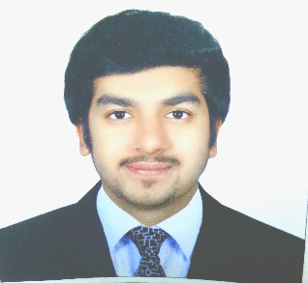

SAGAR
SAGAR.363697@2FREEMAIL.COM

_____________________________________________________________________________________
PROFILE
Seeking a position within your organization that would utilize my skills, abilities and give me higher abilities to do my best. I am looking for challenging job opportunity at your company that offers a promising future and personal growth prospects, in return , I am willing to offer my hundred percent sincere efforts and the performance as my contribution towards the overall progress of the company , currently I am developing skills to meet many industry challenge and requirement under any pressure.
PERSONAL DETAILS:
Date of birth : 01/08/1996
Gender : MALE
Nationality : Indian
Religion : Hindu
Visa Status : Father's Visa.
Language : English, Hindi, GUJARATI, MODERATE ARABIC.
Driving Licence : YES.

KEY ACHIEVEMENTS AND EDUCATION QUALIFICATIONS:
- INDIAN EXCELLENT PRIVATE SCHOOL.

KEY COMPETENCIES:
- Customer acquisition.
- PowerPoint Presentations.
- Public Speaking.
- Complaint Handling.
- Consultative Sales.
- Sales reports & correspondence.
EMPLOYMENT EXPERIENCE:
- WORKED AS A SALESMAN IN SUWAIS JEWELLERY.
- Worked for TNS company based on Project works in dubai.
- Participated in the Samsung infinity band exhibition in world trade centre and conducted exit interviews.
- Worked as a promoter for Samsung Electronics in spring Gitex 2014 through Tasc Agency LLC.
- Worked as a promoter for Samsung Electronics in Gitex shoppers 2014 through Tasc Agency LLC.
- Worked as a promoter for Samsung Electronics in spring Gitex 2015 through Tasc Agency LLC.
- Worked as a promoter for Samsung Electronics in spring Shoppers 2016 through Eyka Agency LLC.
- WORKED AS A PROMOTER FOR SEIMENS HEALTHINEERS IN ARAB HEALTH 2017

CORE SKILLS:
- Microsoft Office(word, PowerPoint and Explorer).
- Strong communications and writing skills.
- Team leadership.
- Can work under pressure.

