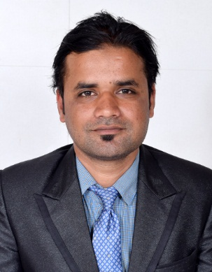

MOHOMMAD

MOHOMMAD.363753@2freemail.com

POST APPLIED FOR FRONT DESK AGENT/ HOUSEKEEPING SUPERVISOR
OBJECTIVE
As a highly self-motivated individual with strong track record in delivering quality customer service, I am seeking my next position in challenging organization and results driven company.
PROFILE
- Self motivated, hard working and goal-oriented with a high degree of flexibility, creativity, resourcefulness, commitment and optimism
- Result oriented individual with strong analytical and interpersonal skills and a quick learner with high levels of adaptability and ability to take initiative.
- Good communication skills, verbal as well as written coupled with exceptional presentation skills.
- An effective team player with exceptional planning and execution skills coupled with a systematic approach and quick adaptability

EXPERIENCE IN UAE: 2 YEARS

EXPERIENCE: RAS-AL-KHAIMAH
ACACIA HOTEL, RAS-AL-KHAIMAH
Designation: Front Office
17 May 2016- 13 Jan 2017
- To complete the registration formalities of the guest with confirmed reservations.
- To communicate with all other departments through the proper channels.
- To check all the arrivals of the day including VIP arrivals.
- Handle guest complains and resolve them immediately.
- To provide CID report of all in-house guest and check-in guest.
- To ensure that all hotel standards and procedures are applied.
- To attend guest call and give information about the facilities of hotel.

EXPERIENCE: ABU DHABI
NEHAL HOTEL, ABU DHABI
Designation: House-Keeping Team Leader
2 December 2014-17 May 2016

Key Responsibilities:
- To assign housekeeping staff their duties and inspect their work for conformance to prescribed standards of cleanliness.
- To coordinate work activities among departments.
- To prepare reports concerning room occupancy, payroll and department expenses.
- To inform the manager, desk clerk and admitting personnel of rooms ready for occupancy.
- To attend staff meetings to discuss company policies and patrons' complaints.
- To monitor and support the housekeeping staff in delivering a high quality cleaning standard consistently.

EXPERIENCE: ABU DHABI
EUROPEAN CONTROL SYSTEM CO.LLC JULY 2008 TO MARCH 2009
Designation: Sales Representative

Key Responsibilities:
- Correctly advising customers on the right products for them.
- Visiting clients at their place of work.
- Advising and building strong relations with both new and existing clients.
- Compiling monthly financial planning reports.
- Holding regular weekly meetings with senior managers and providing them with progress reports.
- Detail-oriented with ability to manage multiple projects simultaneously.
- Customer-focused problem solver, who effectively handles difficult situations.
EXPERIENCE IN INDIA
6 month Industrial training in Oodles Residency, Nehru Enclave, New Delhi

EDUCATIONAL CREDENTIALS

- Passed Secondary School Examination from CBSE in the year 2004
- Passed Senior Secondary Examination from CBSE in the year 2007
- Bachelor of Hotel Management and Catering Technology from IIMT Hotel Management College, Meerut (2010-2014)
(DEGREE ATTESTED BY INDIAN EMBASSY AND UAE EMBASSY)

Technical Proficiency
Opera PMS, Vicas, CID Work All
Windows 97/2000/XP/7/10, MS Office, Internet Applications

Strengths

- Strong leadership qualities: Able to analyze and solve problems
- Quick decision making
- Diligent in handling responsibility.
- Hard working
- Good Communication Skills

Nationality: Indian
Religion: Islam
Date of Birth: 23/05/1988

