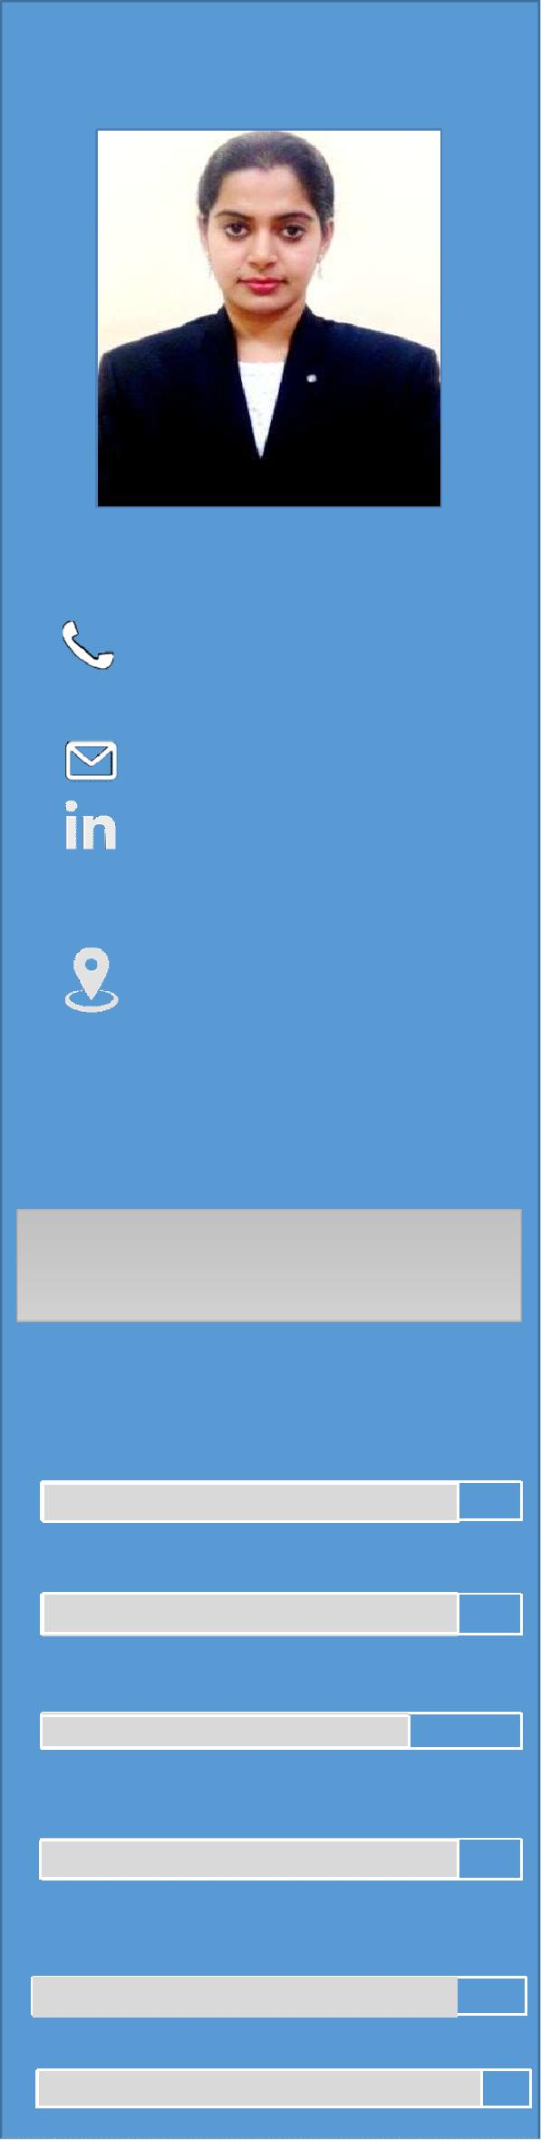

DEEPTI.363756@2freemail.com

Skillsummary

Managing, interpreting & persuading customer

Administering client accounts & Offering after-sales support services

Negotiating and closing sales by agreeing terms and conditions

Calculating client quotations

Technical assistance and preparing reports & documentation

Technical presentations and demonstrating
DEEPTI

Objective: To become associated with a company where I can utilize my technical skills and gain further experience while enhancing the company’s productivity and reputation.

Professional Experience
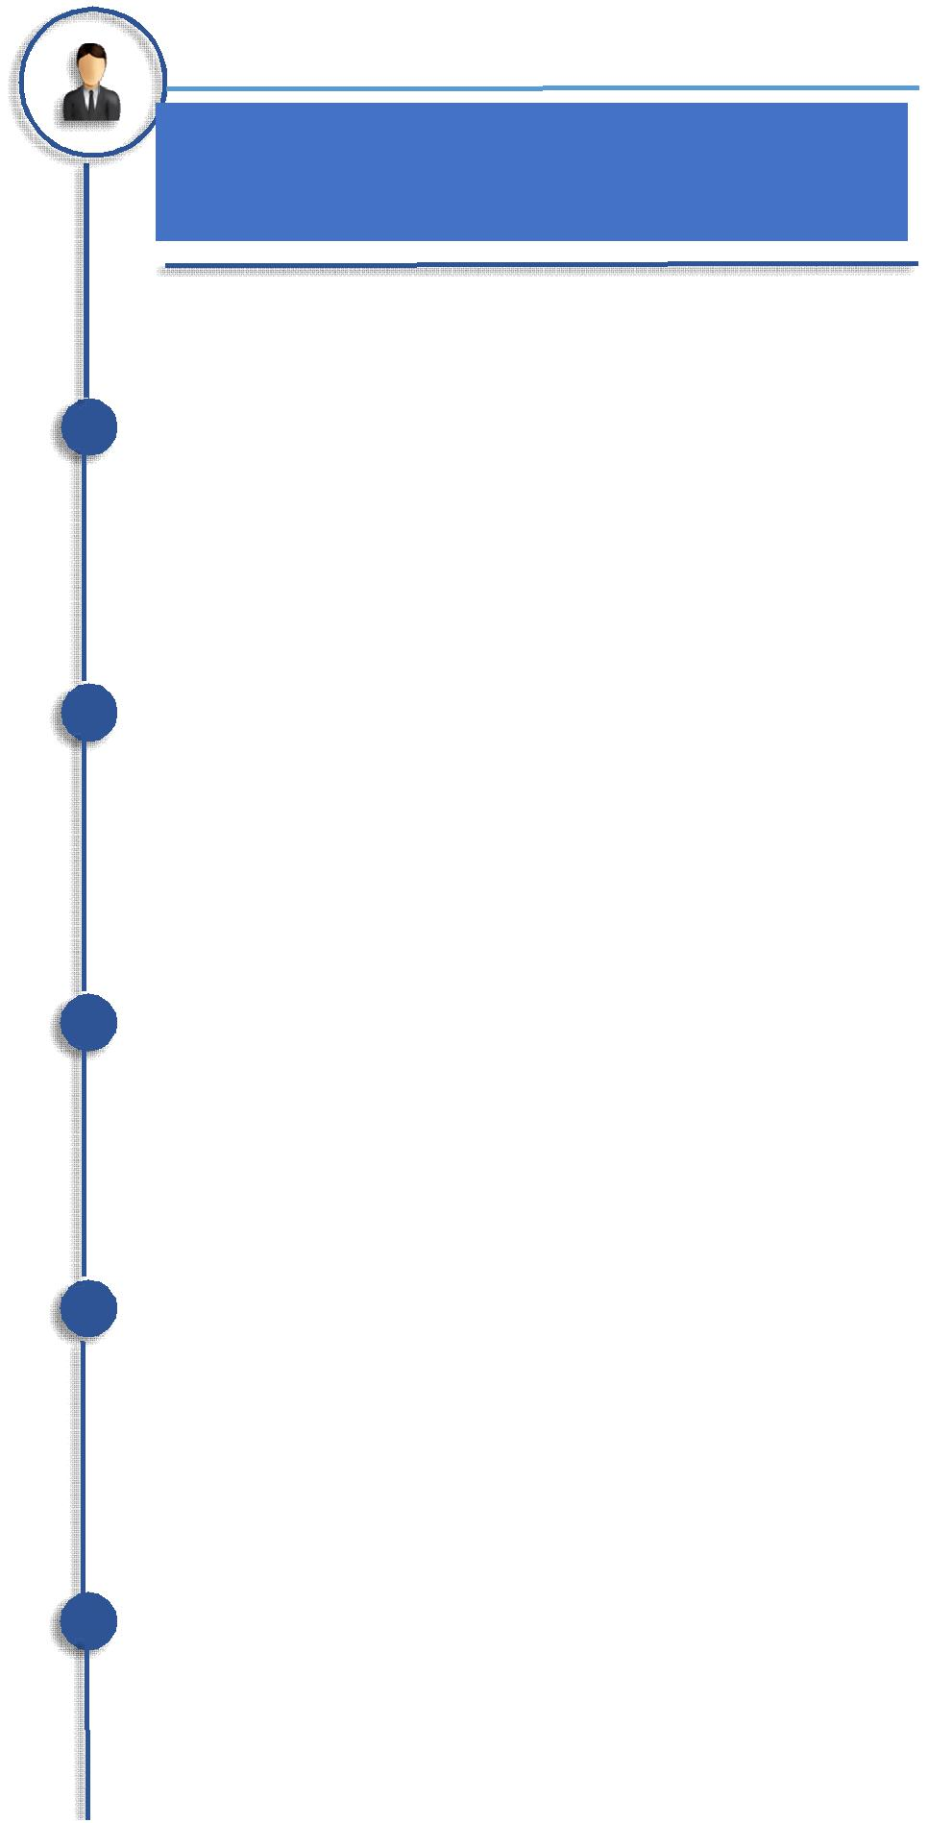

Sales & Pre-sales Executive:

United Security Technology LLC, AbuDhabi

•Conduct meeting with clients to introduce company portfolios and potentials.

•Search the useful information related to new sales opportunities, competition, local events, etc. in order to upgrade the company portfolio.

•Coordinate internal activity to meet customer requirements and interface with operations personnel regarding process methods and terms.

•To provide the Sales Team with a full range of administrative support and assistance in documents processing and projects coordination.

•Verify and assist in preparation of sales proposals and quotations after reviewing customer inquiries and project requirements.

•Preparation and submission of technical documents, such as tender documentation, technical inquiries, site survey reports.

•Follow up and expedite timely delivery of Sales Orders.

•Ensure effective maintenance and timely update of electronic documents filingsystem.

•Following-up on the specific project activities and communicate it to the client.

•Maintain Sales & customer database.

•Take adequate care of office & vital data security in the office.

•Provide support to clients as per on call requirement.

•Projects DealtWith:

•Implementation of 250 CCTV cameras at Sheikh Khalifa Energy Complex (SKEC), Abu Dhabi.

•Access Control System implementation at Fly Dubai Terminal, Dubai.

•Way Finding System at Al Wahda Mall, AbuDhabi.

•Way Finding System at Mazyad Mall, AbuDhabi. •Standalone Access Control & Magnetic Locks at Dragon Mart 2, Dubai

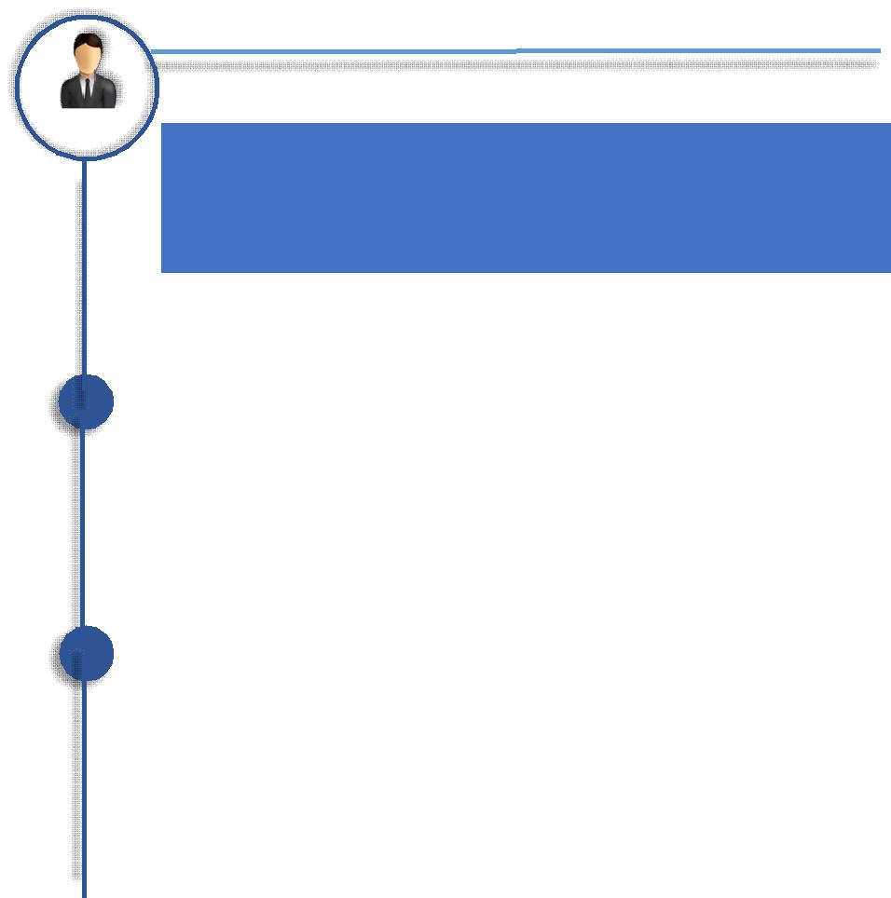

Junior Engineer Telecom:

Bharat Sanchar Nigam Limited (A Central Government institution ofIndia) - June 2014 to June 2015

Equipment inventory management of C-DOT switching equipment

with a capacity of 6k landline connections and 5 Remote Switching Units(RSU)

Knowledge of fiber, copper, and other materials used in communicationsystems.

Maintain inventory of communicationequipment.

Maintenance of engine, alternator, power plant andbattery.

Configuration and troubleshooting of issues related tomodem.

Capable of explaining complicated telecommunications concepts to non-technical professionals.

Responsible for maintaining the technical quality of the documents and ensure their delivery in a timelymanner.

Preparation of monthly performance report, traffic analysis and quality of services.

Keep follow up forcomplaints

Monitored the work of subordinateemployees

Instructed users and staff on use of telecommunication network systems
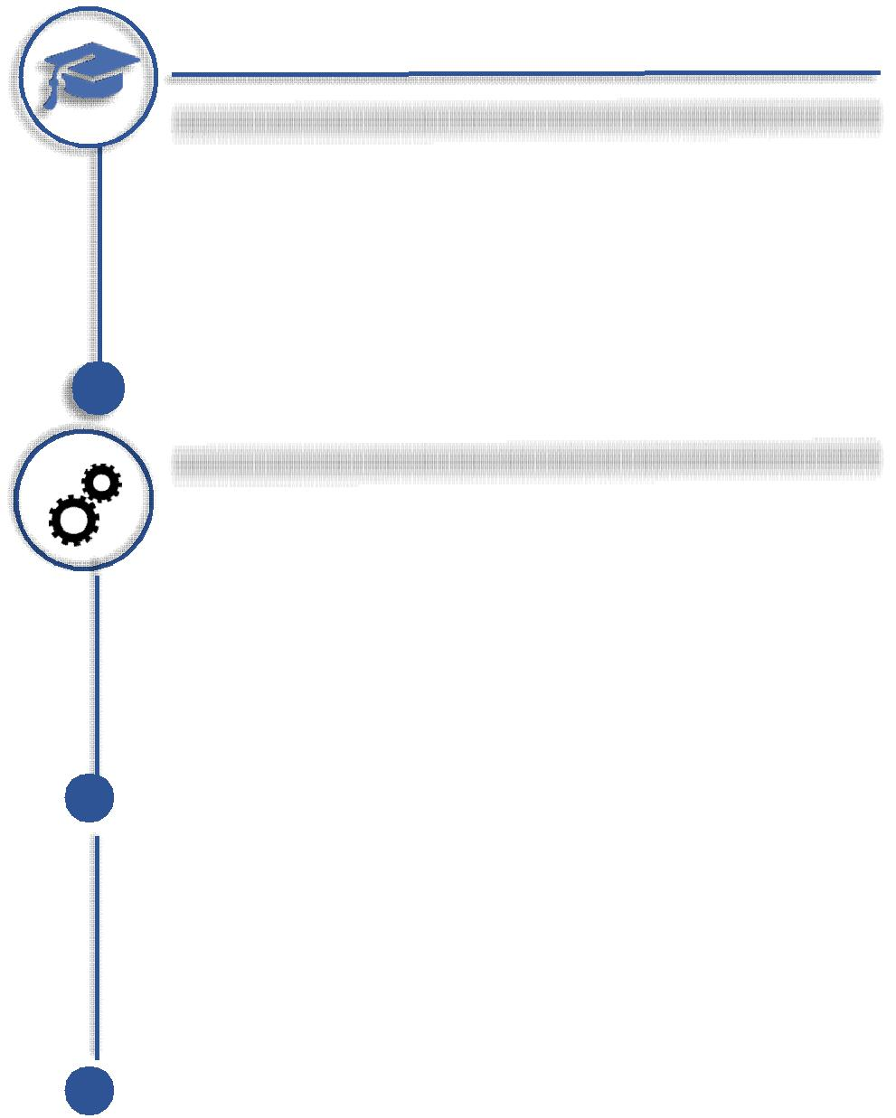

TRAINING /

ADDITIONAL QUALIFICATION

Trained on Way Finding System by ViaDirect, France.

•Attended GITEX’15 &’16.

•Attended INFOSEC’15&’16.

•Training from Bharat Sanchar Nigam Limited

for the post of Technical Telecom Assistant

Optical fibers

Switching networks

Underground

cables

Maintenance of engine, alternator, power plant and battery.
•A workshop on ‘MICROSOBOT’ by Alligator Automations
•A course on ‘Current trends in RF andVLSI Engineering’ conducted by IEEE, CUSAT SB

Academics:

2014 M-Tech, Microwave and RADAR Engineering 9.31 CPGA

Cochin University of Science and Technology University 1st Rank

2012B-Tech, Electronics & Communication Engineering 82%

Cochin University of Science andTechnology

Technical Skills:

Software: MPLAB, PROTEUS ISIS, HFSS, CST,Circuit Maker, appCAD, CorelDRAW, PCBWizard

Programming language: C, 8085 Assembly language, 8086 MASM, MATLAB, PIC(assembly,C)

Hardware : Familiarized with Microcontroller PIC16F877, 8085 kit

Expertise InMicrowave:

•Electromagnetic devices and components like Wave guides, Directional couplers, Tee junctions, Gunn diode, PIN diode, horn antenna

•Design of basic micro-strip transmission lines, power dividers, filter circuits.

•Design and testing of Dipole, Helical, Yagi-Uda and Microstrip patchantennas.

•Vector Network Analyzer and AnechoicChamber. •Manual etching – photolithography. •Expertise in digital image processing:
•Familiar with basics of image averaging, noise removal, filtering, smoothening, sharpening, compression

Projects & Seminars

Mobile Jammer

Digital Watermarking on Images

Audio Steganography Implantable Antenna Tunable Patch Antenna Electromagnetic Rail-gun Medical Antenna

Personaldetails
Personaldetails

Nationality : Indian Marital Status Married
Gender : Female

Visa status: Residence

D.O.B : 15-08-1990

Joining Date: Immediate

Qualities : Dedicated, Disciplined,

trustworthy, flexible, optimistic

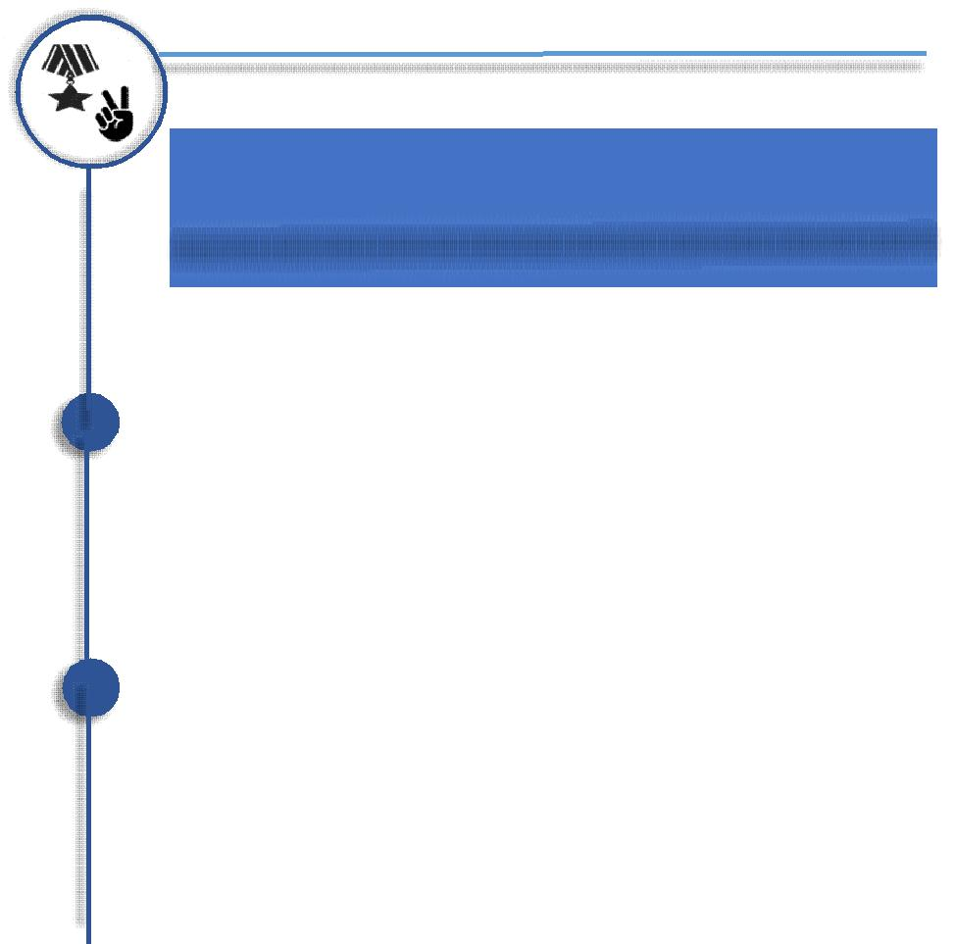

Achievements:

University First rank holder in M.Tech

Qualified GATE 2012 with all India rank 2558(score 567). Served in the post of Chairperson, IEEE CUSAT SB and organized many events.

Served the post of creative head of ECSA (Electronics and Communication StudentAssociation).
Won first prize in Science Quiz competition conducted by DRDE, Gwalior.

Participated in regional badminton at Chennai Zone of Central School.

Served the post of school house captain for 2 years in school and the house won best house award during those two academic years.

Recipient of IAFBA scholarship(during Class 11 & 12) and CBSE- AIEEE scholarship(during engineering)

Declaration:

I hereby declare that the above mentioned information is correct up to my knowledge and I bear the responsibility for the correctness of the above mentionedparticulars.

Deepti

Hobbies
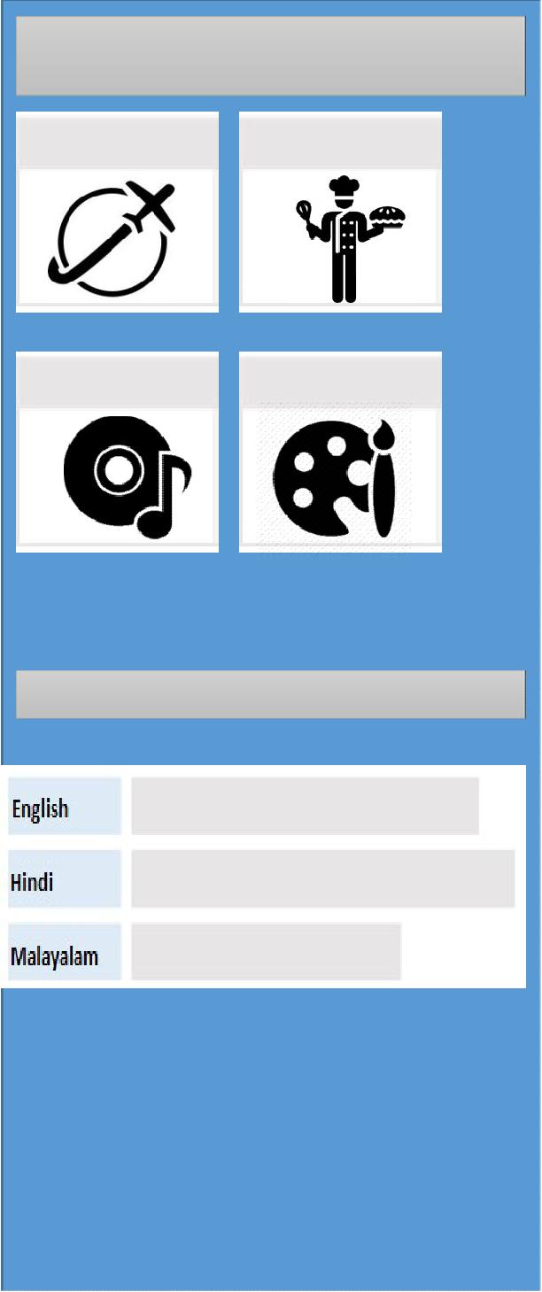

Travelling Cooking

Music Painting

Languages known

