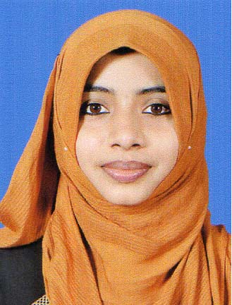
SHAKIRA

SHAKIRA.363764@2freemail.com

CAREER OBJECTIVE
To prove my competence in the field of Pharmacy by using my abilities and to acquire a position where I can work towards the fulfillment of organization goals.
JOB FUNCTIONS
- Provide prescribed medications, drugs, and other pharmaceuticals as needed for adequate patient care.

- Ensure continual compliance with all state and federal rules and regulations.

- Assemble a great team and schedule their work so the pharmacy is always functioning at peak performance.

- Supervise the fulfillment of prescriptions by pharmacy technicians.

- Communicate policy and procedure changes, system enhancements and clinical updates to all pharmacy staff.

- Ensured that every customer received friendly, knowledgeable, and efficient service.

- Checked all work done by pharmacy technicians prior to dispensing medications.

- Worked with other members of the pharmacy to ensure accuracy of prescriptions.

ACADEMIC ACHEIVEMENTS AND CERTIFICATIONS
- DHA (Dubai Health Authority), UAE ELIGIBLE
- Bachelor of Pharmacy from RajiveGandhi college of Pharmacy Trikaripur affiliated to Kannur University, March 2014 with an aggregate of 76% marks.
- Higher secondary from Central Board of Secondary Education, India.
- SSLC from Board of Public Examinations Kerala

PROFESSIONAL EXPERIENCE:
- Worked as a Pharmacist in BKM Memorial Hospital, Payyanur, kannur Dt. Kerala (April, 2014 – feb 2017)
- Completed 2 months of practical training as pharmacist in The Payyanur co-op Hospital Society March 2014.

COMPUTER SKILLS
- Competent user of MS office (MS-Word, Excel, Power point, etc)
- Proficient in use of internet, e-mail and work related databases.

PERSONAL PROFILE

Date of Birth : 27/06/1992

Sex : Female

Marital Status : Married

Religion : Islam

Nationality : INDIAN

Languages known : English and Malayalam

DECLARATION

I hereby declare that the above information and particulars are true and correct to the best of my knowledge.

