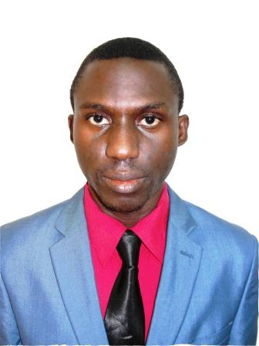
AKINWUMI
AKINWUMI.363799@2freemail.com
Career Objective;
I wish to be engaged in a competitive environment where my skills and potentials will be fully utilized for the growth of my employer’s business, and my own professional development. To provide world class solution that will facilitate the accomplishment of my organisations corporate goals.
Personal Information;
Date of Birth; 23rd August, 1987
Sex; Male
Marital Status; Single
State of Origin; Oyo State
Nationality; Nigerian

Key Skills and Attributes;
* Excellent Communication
* Good Interpersonal skills
* Friendly and team player
* Multi-Task
* Hardworking and willing to learn
* Excellent Knowledge of computer Microsoft office (Excel, Outlook, PowerPoint)
* Reliable, Industrious, Honest, Flexible, Adaptable and a great consideration of others
* Good organization skills
* Understanding of confidentiality
* Diplomacy and Tact
*Accurately forecasts outcomes.
*Identifies and allocates resources appropriately.
* Identifies problems & develop solutions.
* Gathers information & assess current situations.
* Ability to manage people and resources.
* Result oriented and Target-driven.
* Planning of events

Education Qualifications
Walden University, 100 Washington Avenue South suite 900, Minneapolis, Minnesota 55401
Masters in Forensic Psychology 2015 till date

Ladoke Akintola University of Technology, Ogbomoso, Oyo State 2006 – 2011
Bachelor of Technology in APH (Hons)

Kings and Queens College, Ibadan, Oyo State 1998 – 2004
Senior Secondary School Certificate

Community Central Primary School 1992 – 1997
Primary School Leaving Certificate

CERTIFICATE OBTAINED WITH DATES:
National Youth Service Corps Certificate 2013
Graduate Animal Scientist Certificate 2012
B.tech in Animal Production and Health 2011
Desktop publishing/Graphic designing Certificate 2004
Senior Secondary School Certificate (WAEC) 2004
Primary School Leaving Certificate 1997

PROFESSIONAL QUALIFICATION WITH DATES:
Graduate Animal Scientist (GAS) 2012
Desktop publishing/Graphic designing 2004

COMPUTER SKILLS:
Proficient with computer applications such as;
* Microsoft Office (Ms Word, Ms Excel, Power point, etc.)
* Internet software and applications for social media marketing
* Graphics Designing software (Photoshop, CorelDraw, etc.)

CAREER ACHIEVEMENT:
Developed client log form to reduce client complain from 40% to 10% and increase relationship between client and staffs by 70%.

Work Experience;

2015 till date Caribou Coffee Sharjah, UAE
Post: Sales Supervisor
Duties Performed;
      - Helped in the areas of sales and marketing product and services.
      - Helped in providing solution to complaint.
2012 - 2013 National Orientation Agency, National HQ. FCT-Abuja
Post: Administrative Officer.
Duties Performed;
      - Helped in the areas research department in providing information for the company’s website.
      - Anchored educative programmes for the company’s radio station.
      - Helped in memo writing and other administrative work.

2013 INEC Verification Exercise FCT-Abuja
Post: Sales Supervisor
Duties Performed;
      - Helped in preparation of material for election process.
2010 – 2011 I-pave Consult Lagos State
Post: Marketing/Sales Officer
Duties Performed;
- Set smart and workable goals for the realization of sizeable market share and growth in the real estate business.
- Make suggestion regarding products services packaging.
- Workout an approach to pricing and suggest prices for product/services.
- Implement appropriate strategies by selecting, sequencing and targeting marketing goals techniques, deadlines and target success evaluation method.
- Advice clients and staff on a wide range of risk and independence issues.
2012 Guaranty Trust Bank PLC
Post: Customer service Representative
Duties Performed;
- Provided solution to complaints.
- Assisted in filing complaint.
2010 - 2011 Jobcom Group of Schools Ibadan, Oyo State
Post: Class Teacher
Duties Performed;
- Assisted in exam coordination, event management.
- I thought Computer studies, Intergraded science and Agricultural Science to Class ranging from Junior Secondary 1 – 3.

Hobbies; Meeting People, Travelling, Planning and Organizing events & activities, swimming, basketball, Counselling & facilitating, Surfing the Internet, playing chess and scrabble.

