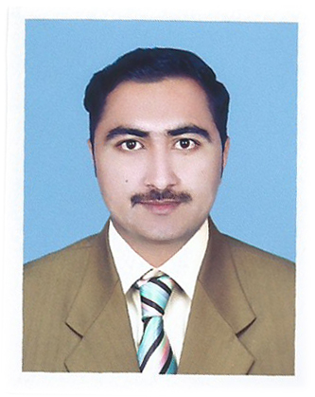
Shahbaz
Shahbaz.363836@2freemail.com
OBJECTIVE

To establish myself as a true professional, enhance my knowledge, improve my skills and pursue a dynamic career in a well-reputed organization and looking for full-time employment in a reputed company where I can work with full enthusiasm.
PERSONAL PROFILE
Nationality: Pakistani
Gender Male
Domicile: Faisalabad
Religion Islam
Date of birth: 03-01-1992
Marital status: Single
Language Abilities: English, Urdu, Punjabi & Hindi

EDUCATIONAL PROFILE

2012-2014 B.Com (Bachelors in Commerce) 3.27/4 CGPA
University of South Asia Lahore
2010 D.Com (Diploma in commerce) 752/1200
Punjab Board, of Techncial Education
Lahore
2007 Secondary School Certificate 573/850
B.I.S.E Faisalabad

Profession

- Accountant

Experience & Extra Skills
      - Experience as Market Manager at Heritage International College from December 15, 2014 to January 31, 2017.
      - Experience as Accountant at Sadiq Filing Station from January 2011 to Sept 2014.
COMPUTER SKILLS
      - Office Management
      - MS Windows
      - Internet for browsing and searching.
HOBBIES
      - English & Urdu Literature
      - Internet surfing & book reading.

Reference will be provided on Demand

