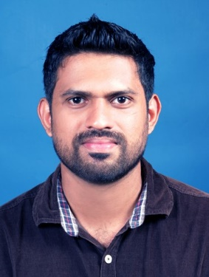 Arifshah
Arifshah.363848@2freemail.com

Objective | A well-presented, self-motivated and confident Business graduate who has extensive knowledge of how to successfully assess the needs of a customer in a fast-paced working environment and then develop and bring success to the business. Possessing excellent listening and general communication skills, along with the ability to communicate complex and sensitive information about the business to the stakeholders and public. Having exceptional multi-tasking and organisational skills, all of which are imperative when working closely with customers and the stakeholders.  Now looking to further an already successful academic track record by  Finding a suitable graduate entry level position with a progressive employer.
Skills | Communication, Self-motive, Initiative, Teamwork, Flexibility, Time management, Confident, IT, Numeracy, Negotiation, Decision Making, Creative.
Education | - Centre for Advanced Software Training, Calicut, Kerala.  2017, SAP HR (Payroll, Recruitment, Personnel Management, Training and Event Management.)  - Leeds Beckett University, Leeds United Kingdom.  2016, Masters of Business Administration. (Business Administration)  - Calicut University, 2012, Bachelor of Business Administration. (Human Resource Management).  - National Institute of open schooling 2008. Class 12.  - Dayapuram Residential School.2006, Class 10.
Experience | Spar UK.  Customer service assistant. 15 July 2013 – 31 August 2016  Assisting customers, stock replenishment, cash handling, assist in the day to day operations of the store, till closing, shift runner, Training new joiners, Admin Support, experienced with Point of Sales (POS) and PDA and HHT Machines.  External consultant at Ernst & Young, UK.  1 February 2014 – 31 July 2014.  Study on how effective social media can be successfully used in process of recruitment.  External consultant at Superhistory, an architectural firm based at Barnsley, Leeds.  1 November 2015- 26 March 2016.  Studies include Brand uplifting, customer decision making, Marketing strategies to attract builders and home owners.  Medical Transcriptionist at aquetrans, Calicut 2008-2009.
HOBBIES & INTERESTS
Most of my spare time in the evening or weekend is taken up with socialising with my close friends or doing activities that I enjoy, such as cricket, table tennis, and jogging. Team sports or games are a favourite past time of mine as they give me a chance to meet new people and make friends.

I, Arifshah hereby affirm that all the above information is true and correct to the best of my knowledge and belief.
.
REFERENCES – Available on request

