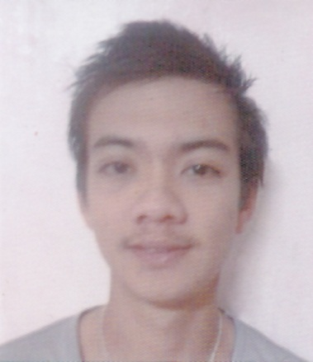
DARELL
DARELL.363870@2freemail.com

OBJECTIVES:

- Seeking an entry level position, where there is an opportunity to exhibit.
- Strengthens and enhance skills while striving to grow professionally.
WORKING EXPERIENCE:

- NETWORK EMBASSY
Computer Technician / Café Attendant
November 14, 2012 – October 31, 2016

DUTIES AND RESPONSIBILITIES:
  - Maintain cleanliness of computers.
  - Accept computer repairs from customers.
  - Accept typing jobs and invitation layouts.
  - Checking and monitor of computer accessories stocks.
  - Set up hardware and install and configure software and drivers.
  - Maintain and repair technological equipment (e.g. routers) or peripheral devices.
  - Install well-functioning LAN/WAN and other networks and manage components (servers, IPs etc.).
  - Manage security options and software in computers and networks to maintain privacy and protection from attacks.
  - Perform regular upgrades to ensure systems remain updated.
  - Troubleshoot system failures or bugs and provide solutions to restore functionality.
  - Arrange maintenance sessions to discover and mend inefficiencies.
  - Keep records of repairs and fixes for future reference.
  - Offer timely technical support and teach users how to utilize computers correctly.

- ROBINSON APPLIANCES
Salesclerk (Samsung)
ACE PROMOTION AGENCY
October 2011 – December 2011

DUTIES AND RESPONSIBILITIES:
  - Smile and greet customers when they arrive at the store and ask if they need assistance
  - Suggest upsell items to customers based on the items they have chosen
  - Execute special orders for items that are not in stock or that we do not carry
  - Call other stores when necessary to find items in stock
  - Replace merchandise on the shelves, paying special attention to end caps
  - Arrange special sale and clearance items at the front of the store for maximum visibility
  - Build rapport with customers and provide them with genuine guidance and support
  - Train new sales staff as needed by management
SKILLS:

- Computer Literate and Internet Savvy
- Proficient in Microsoft Office
- Knowledgeable in Adobe Photoshop
- Able to perform activities systematically in a time manner.
- Able to communicate using both English and Filipino language.
- Able to work according to procedures, regulation and rules.
- Able to work independently or in a group.
- Responsible for other duties as assigned and flexible in work.

EDUCATIONAL BACKGROUND:

Tertiary : CLCC INSTITUTE OF COMPUTER ARTS
AND TECHNOLOGY
Course : Computer Technician (undergrad)
S.Y. 2007 - 2008

Secondary : LEMNAHIS
S.Y. 2006 – 2007 Calapan City, Oriental Mindoro

Primary ADRIATICO MEMORIAL SCHOOL
S.Y. 2001 – 2002 Calapan City Oriental Mindoro

