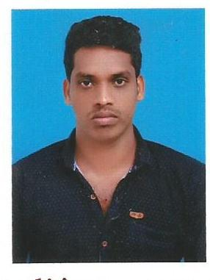
CURRICULUM VITAE

ANTO
ANTO.363876@2freemail.com

CIVIL ENGINEER

CAREER OBJECTIVE:

An experienced site engineer, with over 3 years in the industry looking for a new and challenging position in the established organization, which will make best use of my existing creative skills, experience and also to develop my personal and professional skills.

PROFESSIONAL EXPERIENCE:

1. Civil Engineer at

LS CONSTRUCTION PVT LTD, Tamilnadu,India (from June 2013 to June 2014) Job profile:
Prepare, schedule and monitor the assigned projects
Reviewing and assist in preparation of construction drawings, Bill of Quantities. Coordinate with the Building management / Tenant coordinators for the approvals. Attends the Weekly Progress Meetings with clients & contractors
Monitors work in progress and prepares weekly report of each project. Project coordination with MEP contractors and sub-Contractors
Ensure adherence to Quality, Health and Safety regulations on all assigned sites. Find out The productivity particular work and each labor.
Give to final Clearance Checking for Client, and Target date complete the project.

PROJECT EXECUTED:

G+1 Residential Buildings –Tamilnadu.

2. Site engineer at

R . J CONSTRUCTION PVT LTD ( from Oct 2014 to June 2016 )

Job profile:
Prepare, schedule and monitor the assigned projects
Reviewing and assist in preparation of construction drawings, Bill of Quantities. Coordinate with the Building management / Tenant coordinators for the approvals. Attends the Weekly Progress Meetings with clients & contractors
Monitors work in progress and prepares weekly report of each project. Project coordination with MEP contractors and sub-Contractors
Ensure adherence to Quality, Health and Safety regulations on all assigned sites. Find out The productivity particular work and each labor.
Give to final Clearance Checking for Client, and Target date complete the project.

PROJECTS EXECUTED
G+2 Commercial buildings – Tamilnadu.

SUMMARY:

Civil engineer, worked with small scale to large scale projects (Residential, Commercial, Institutional, projects).
Fluency with various supporting software (AUTOCAD, & MS OFFICE PACKAGES) together with architecture knowledge.

PROFESSIONAL QUALIFICATION:
Completed My Bachlor Degree In The Field Of Civil Engineering From St. Xaviers Catholic College Of Engineering, ANNA UNIVERSITY ( 2009- 2013)

EDUCATIONAL QUALIFICATION:

- H.S.C From ST. MARY’S HIGHER SECONDARY SCHOOL – COLACHEL (2008-2009)

- S.S.L.C From ST. MARY’S HIGHER SECONDARY SCHOOL – COLACHEL (2006 -2007)

PERSONAL PROFILE: visa status – visit visa expire (17-07-2017)

Date of Birth : 19-02-1992

Marital Status : Single

Nationality : Indian

DECLARATION:
I here declare that the particular furnished above are true and correct to the best of my knowledge and belief.

