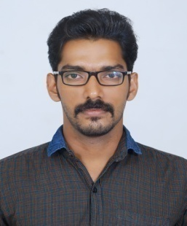

ITHIHAS
ITHIHAS.363892@2freemail.com

PROFILE SUMMARY

- Superior IT skills with exposure in MSP, Excel automation and Project documentation.
- Can facilitate as ‘Single Point of Contact’ for multiple projects of large magnitude within strict time schedule, cost & quality.
- Exposure in Sub Contractor Management, Negotiation, Resource planning, in-process inspection, team building and co-ordination with internal / external departments
- Possess strong analytical, problem solving and organisational abilities

EDUCATION

Bachelors in Technology - Electrical & Electronics Engineering in 2015
Calicut University, Kerala, India

WORK EXPERIENCE AND OTHER QUALIFICATION

- Worked in AURINKO consultancy services for 1 year as Assistant Electrical engineer
- Certified REVIT MEP engineer by UIT international
- Certified for A-CAD and E-CAD by UIT international

CAREER OBJECTIVE

Intended to build a career with a leading company in a professional environment and the opportunity to work with
committed, dedicated and well focused people, which will help me to explore my full potential and also willing to work as a key player and take up responsibilities in a challenging and creative environment

AWARDS AND ACHEIVEMENTS

- Volunteered and participated in various technical and arts fests conducted in our college.
- Member of ISTE student chapter.
- Govt.Engineering college magazine committee member
- Volunteer committee convenor of Yukthi 14-project Expo a 2 day event
- Faculty in Ignite B Tech coaching centre.
- Faculty in IBS entrance coaching
- Industrial Visit to Nallalam Diesel Power Plant, Calicut
- 5 days at Sengulam Power plant KSEB
- 5 days at Madakkathara 400kV Substation KSEB
- Participated in second NATIONAL TECHNOLOGICAL CONGRESS,KERALA (NATCON 2012)

ACADEMIC PROJECTS

MINI PROJECT: Automatic star-delta converter
MAIN PROJECT: Regenerative braking in electric vehicles
INDUSTRIAL TRAINING:
5 days at Sengulam Power plant KSEB, 5 days at Madakkathara 400kV Substation ,KSEB
IT SKILLS

- Microsoft Projects (MSP)
- AutoCAD, Electrical CAD
- Microsoft Office and Microsoft Excel Application development and Macro Programming

PERSONAL DETAILS

Date of Birth : 13 june1992
Nationality : Indian
Marital Status : Single
Visa Status : Visiting visa
Languages Known : English, Malayalam, Hindi and Tamil
Driving Licenses : Indian

DECLARATION

I hereby declare that the above acknowledged is precise to the best of knowledge and belief

