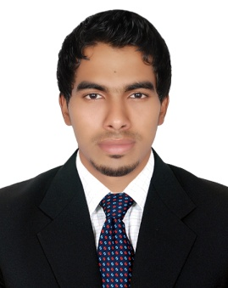

**AJMAL**

[**AJMAL.363953@2freemail.com**](mailto:AJMAL.363953@2freemail.com)

**CURRICULUM VITAE**

**Career Objective:-**

Seeking a challenging Career in an Esteemed Organization where my talents can beutilized for the growth of the Company as well as myself in an environment where Team Player role is significant and best to be considered as an asset by Employer to learn, gain and implement.

**Professional Experience:-**

* 3 Years Proven Experience in salesman in Shaklan Supermarket -LLC, in Dubai-UAE.
* 4 Years Computer Service in Shaklan Hypermarket Group-LLC, in Dubai-UAE.
* One year working as a Driver in Shaklan Hypermarket Group-LLC, Dubai-UAE.

**Job Profiles:-**

* Display the Products and Provide best Visibility to the Products and make Maximum Sales.
* Provide the Product Awareness to the Consumers.
* Attending and Assisting CustomersNeeds, Queries & Complaints.
* Prepare Purchase Order & Invoices etc.
* Attending the Weekly Progress Meeting with Regard to the Status of Sales.
* Maintain the Stock in Outlet and Report to the Store by time to time.
* Meet and Collect Requirements and Information from Clients.
* Conduct Technical and Marketing Study, Prepare Reports.

**Educational Qualification:-**

* **B.C.A** (Bachelor of Computer Application)-not completed
* **H.S.C** ( Higher Secondary Certificate)
* **S.S.L.C** (Secondary School Leaving Certificate)
* **Computer Hardware and Software**

**Additional Qualification:-**

* Knowledge of computer Hardware and Networking
* Knowledge of Computer Application (MS Office Application)
* Excellent Knowledge of Internet & Mailing

**UAE Driving License Details:-**

* Date of Expiry : 14.07.2025
* Place of Issue : Dubai-UAE

**Skills & Strength:-**

* Ability to work independently as well as Excellent Team Player.
* Self Motivated and Innovative.
* Proven Capacity to Approach Problems Effectively and Creatively.
* Able to Direct and Lead Others to Produce Desired Results.
* Effective Planning and Organizational Skills.
* Quick in Decision Making.
* Ability to Work Effectively and Efficiently in a Systematic Way.
* An Experienced Leader Bringing Enthusiasm and Energy into Group Effort.

**Declaration:-**

I hereby declare that the above mentioned information is true to the best of my knowledge and belief.

***Proficiency In Languages***

**English**

**Hindi**

**Arabic**

**&**

**Malayalam**