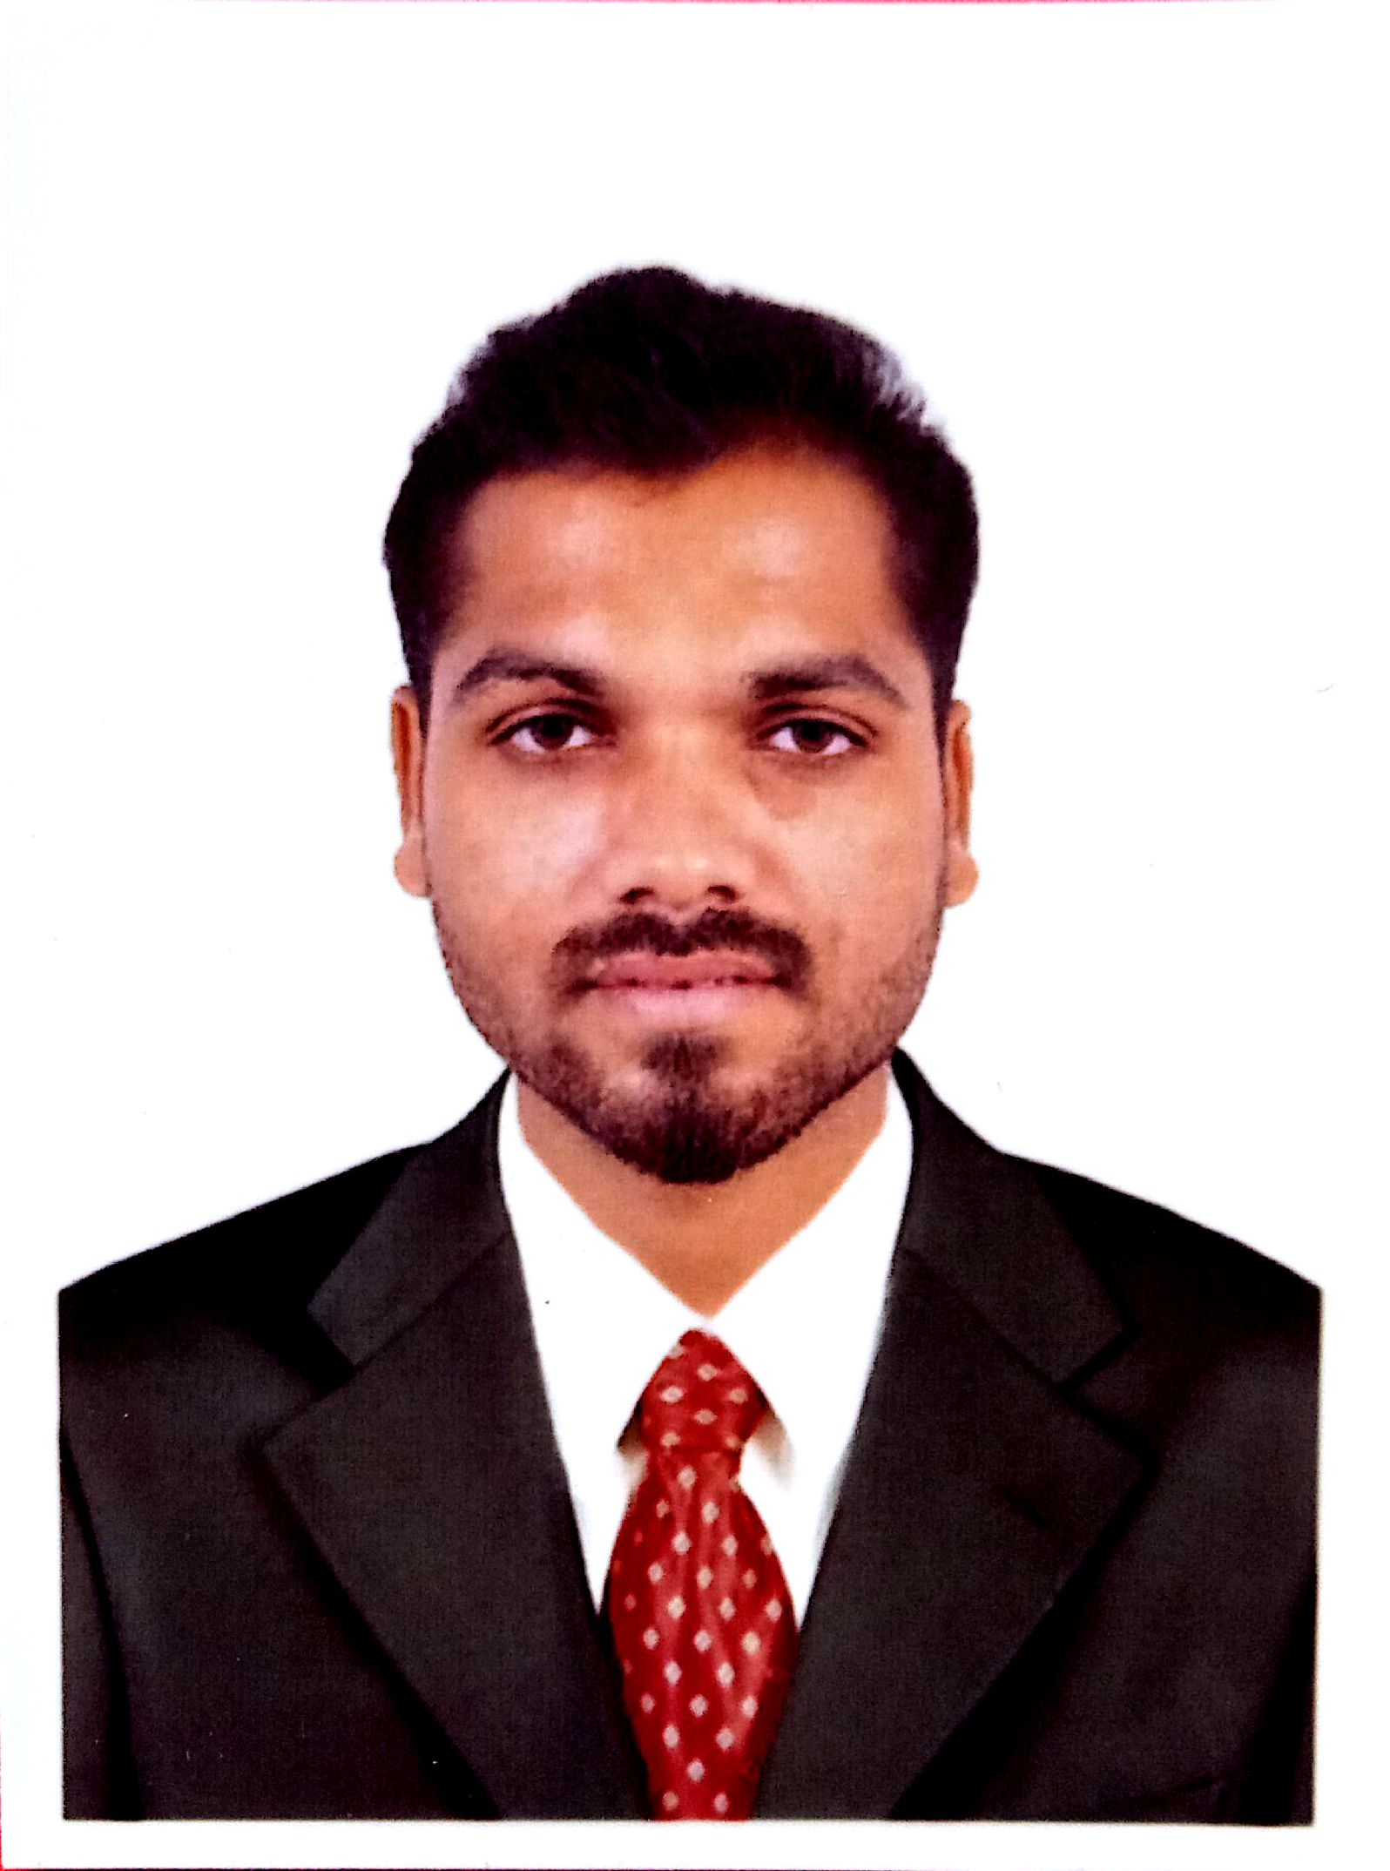
RAGU
Ragu.363985@2freemail.com

CAREER OVERVIEW
A competent professional with over 5 years’ experience in the sales & customer service field. Experience in organizing promotional activities and escalating business & profitability. Proficient and providing value added customer services by resolving customer issues and ensuring their satisfaction with the product and service norms.

PROFFESIONAL EXPERIENCES
Store In charge Win star Traders.
From Apr-2015 to Mar-2017 Salem, Tamil Nadu, India.

Sales team leader Win star India City Developers.
From April 2012 to March 2015 Salem, Tamil Nadu, India.

Quality controller Heritage Granites Factory,
From Sep-2008 to Aug-2012 Sangagiri, TN, India

Production staff Tanishq jewelers,
From Nov-2007 to Aug-2008 Hosur, TN, India

EDUCATIONAL QUALIFICATIONS

- Diploma in Teacher Education (D.T.Ed)
District Institute of Education & Training (DIET), Trivallur, Tamil Nadu. India.

- General certificate HSC Examination
Passed Higher Secondary in Vocational (Accountancy & Auditing) Successfully.

- General certificate SSLC Examination.
Successfully passed all subjects including mathematics, science and English

- Diploma in Microsoft office

- Internet and Email access
Store In charge
Win star Traders, Salem.

- Ensure price tags are attached to all the products displayed on the counters and conduct random daily price verification.
- Conduct daily head count for the stocks in the showroom and compare the same with the book stock for inventory accuracy.
- Assist inventory team to conduct periodic inventory count and provide assistance in investigation of shrinkage
- Maintain proper record of the customer repair products send to service center and follow-up with service center for timely receipt.
- Complete Daily Sales Reconciliation, banking and provide timely update to Finance.
- Handling petty cash and cash counter checklist
- Preparing daily tasks for the sale representatives

SPORTS ACTIVITIES

- Captain of College Foot Ball Team.

- Player of College Cricket Team.

PERSONAL INFORMATIONS

- Gender Male

- Civil status Married

- Date of birth 07.07.1988

- Age 29 years

- Religion Hindu

- Nationality Indian

- Visa status Visit visa

I hereby certify that the above information furnished by me is true and correct to the best of my knowledge.

