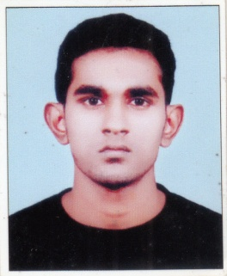
AKHILESH
AKHILESH.364011@2freemail.com
,

OBJECTIVES

To be a part of reputed organization that provides a chance to enhance my skills and ability
to apply my talents.

WORK EXPERIENCE
• 3 Months Internship Training Program in HR section of BENOY MARBLES AND GRANITES , Calicut , India.

PROFFESIONAL SKILLS AND ACHIEVEMENTS

- A great team player with exceptional organizational and leadership skills.
• Ability to work efficiently under pressure and easily adaptable to any working environment.
• Ability to work independently with minimal supervision.
- Ability to prioritize and handle multiple tasks.
- Self-Confident, Hard Working, Dedicated and Honest.

EDUCATIONAL BACKGROUND

- MBA in HR,MARKETING New Horizon College of Engineering ( Visvesvaraya Technological University) , Bangalore (2014 – 2016)
- Bachelor of Commerce from Zamorin’s Guruvayurappan College ( Calicut University ), Calicut (2011-2014)
- Proficiency in MYSQL, VB , HTML

PERSONAL PARTICULARS

Date of Birth : 9th March 1994 Nationality : Indian Gender : Male Marital Status : Single Languages known : English, Malayalam, Hindi

DECLARATION

I hereby declare that that all the above details are true and correct to the best of my knowledge and belief. I promise you that I will be a Dynamic Personality who is very truthful and loyal to contribute to the organization’s goal.

