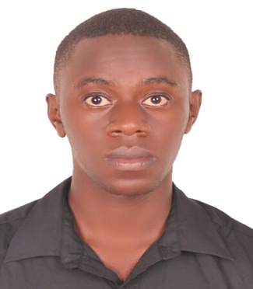
CURRICULUM VITAE
BISASO
BISASO.364037@2freemail.com
PERSONAL INFORMATION
Sex : Male
Nationality : Uganda
Date of birth : 03/29/1994
-------------------------------------------------------------------------------------------------------------------------------
PERSONAL OBJECTIVE
To obtain a position of a Sales Executive, Assistant, Associate, Representative, Customer care to be presented with new challenges to use my abilities, skills, experience, education and competence as to come up with a solution to add a value to the company.

-------------------------------------------------------------------------------------------------------------------------------
WORK EXPERIENCE
SELENA COLLECTION UGANDA SALES ASSOCIATE/CUSTOMER CARE JAN 2013-OCT2014
Working as part of an enthusiastic team within commercial, sales driven and fast- paced fashion retail environment.
Duties and responsibilities
- Actively welcomed and greeted customers into the store.
- Take appropriate and necessary action to resolve customer complaints or inquires.
- Provided accurate and valid information to customers regarding new deals and promotions.
- Processed transactions quickly and accurately.
- Took products orders and verify if the products are available in the stock.
- Merchandised the shop floor.
- Take and make phone calls to answer customer’s inquires and made transfers.
- Met and exceed customer expectations hence boost sales.
- Did cross sale and pushed hence boosting sales.

GIANT EAGLE ELECTRONICS LTD SALES ASSISTANT/CUSTOMER CARE NOV 2014-FEB 2017
- Warmly welcomed and greeted customer on entering the store.
- Interacted with customers to identify and assess their needs to achieve their satisfaction.
- Processed transactions quickly and accurately.
- Took appropriate and necessary action to resolve customer inquiries and complaints.
- Providing accurate information to customers regarding new deals and promotions.
- Met and exceed customer expectations hence boost sales.

KEY COMPETENCES& SKILLS
- Excellent communication, interpersonal, computer and customer care skills.
- Willing to learn and take up new challenges.
- Self- motivated, hardworking and result oriented.
- Am flexible, puncture and willing to work as a team.
- Comfortable to work in shifts; focus on customers, performance and growth.
- Ability to work with people from multicultural background.
ACADEMIC QUALIFICATIONS
2013-2015 Makerere University Business School: Diploma in Business Development.

2011 -2012 Kibibi Secondary School: Advanced Certificate of Education

2006-2010 Kakugungulu High School: Uganda Certificate Education
------------------------------------------------------------------------------------------------------------------
LANGUAGES PROFICIENEY;
Language Written Spoken
English Very good Fluent
Luganda Very good Fluent
REFERENCE
To be provided upon request.

