Alaeddin
Alaeddin.364041@2freemail.com
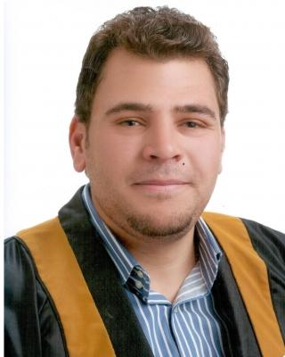

Objective
To obtain a new position that will enable me to use my educational background and practice my skills.

Work experience
Wadi Rum Contracting company | July 2014 — Present
Junior Site Engineer
The responsibilities in the site :
Prepare monthly and annual production report .
Prepare a report on the progress of operations in the field .
Take a GPS points for a work areas and import it to mining program (minex ) .
Following the drilling and blasting process .
Communicate with the Supervisory Committee to follow up the completed sites .
Adnan S. Badran Consulting Engineering | April 2014 — July 2014
office
Junior Geotechnical Engineering
building material and soil test

Affiliations
(May 2014 - Present)

Member of Jordan Engineers Association.

Education
bachelor's degree Geological Engineer September 2009 — February 2014

Tafila Technical University (TTU)

Current GPA: 74.2 (good).

University background courses Include:

(Well Logging, Engineering Geophysics, Site Investigation, General Surveying, Geology of Jordan , Drilling and Blasting, Slope Stability, Soil and Rock Mass Support and Stabilization, Rock Mechanics, Soil Mechanics,, Mining Geology, GIS, Hydrology, Geological Environmental Engineering)

1

Qualifications
- Occupational license: occupational safety and healthy supervisor – craftsman level. (Ministry of Labor) (3-2016) .

- Participation of "7th International Mining Conference (JIMC7)- (10-2014).

- "Training of Trainers (TOT)" We Jordan Youth Authority (14-1-2013 / 21-1-2013).

- Participation of "program of establishment of the company" - Injaz Organization, (2010\2011).

- " Teams Leadership by Interaction Method (TLIM)" King Abdullah II Fund Development Office (KAFDO) (1-7-2010 / 8/8/2010).

Skills
Computer skills: Microsoft office and Internet.

GEOVIA MINEX 6.5.0 : Light user .

Ability to work under pressure and fast learning .

Good communication and personal skills .

Driver's license: 3rd category.

Voluntary work
Two years in a row volunteer work in student clubs within the university, as an administrative (2011\2012, 2012\2013)...

else.

Languages
Arabic ( native ) English ( good )

2

