Sarah
Sarah.364058@2freemail.com 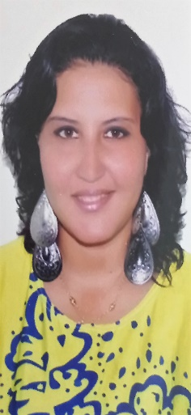

- Personal Information:

- Gender: Female.
- Nationality: Egyptian.
- Occupation: Art teacher.
- Date Of Birth: 16/05/1986
- Marital Status: Married with two beautiful kids.

- Objectives:

I believe that an artist is not a special kind of person, rather each person is a special kind of artist. Art is the only way to run with your dreams without leaving home it speaks where words are unable to explain, it is the last magic that exists. Each and every child is an artist the issue is to stay an artist, my purpose is to inspire them to be creative, to draw their dreams and express themselves.
As an artist I teach them, encourage, instruct, mentor, praise, influence, guide and inspire my pupils, I can show them the way.
- Education:

- School: Primary, preparatory and secondary at Collège de la mère de Dieu
- University: Bachelor of fine arts Decor department Alexandria University class of 2015.
- Computer Courses:
- Adobe Photoshop CS6 from New Horizons computer learning center.
- Adobe Illustrator CS6 from New Horizons computer learning center.
- Autodesk AutoCAD 2013 from New Horizons computer learning center.
- Autodesk 3Ds Max 2013 fundamentals from New Horizons computer learning center.
- Autodesk 3Ds Max 2013 V-Ray from New Horizons computer learning center.
- Microsoft Office.
- Sketch Up.

- Language Courses:
-Translation course from French to Arabic at (Centre culturel Français).
-DELF TD French language certificate.

- Language Skills:

Arabic: mother tongue excellent communication, reading and writing skills.
French: Fluent with excellent speaking, reading and writing skills with DELF certificate.
English: Fluent with excellent speaking, reading and writing skills.

- Duties:

• Promoting Art, Textiles and Photography within the school.
• Consistently teaching high quality lessons.
• Maintaining discipline in accordance with the school procedures.
• Encouraging good practice with regard to punctuality, behavior, standards of work and attendance.
• Ensuring a high quality learning environment within the Art department.
• Completing the paperwork needed to keep track of a student’s performance.
• Contributing to the preparation of student Action Plans and other reports as required.
• Actively promoting school policies and procedures at every opportunity.
• Delivering the curriculum through the scheduled teaching programme.
• Participating in the school’s performance management scheme.
• Communicating concrete and abstract concepts to students.
• Planning and preparing Art courses and lessons.
• Keeping all teacher materials up-to-date.

- Personal Skills:

- Can meet the needs of some of the most vulnerable and challenging children in the education system including children with special needs.
- Creating productive and positive relationships with students and their families.
- Hard-worker.
- Passionate.
- Focused.
- Very talented.

- Experience:

- Art teacher at college de la mere de Dieu French school 2016 to present.
- Part time art teacher at starz center for talents in Alexandria Egypt 2013 to present.
- Presented several drawings at Dr. Shaker Exhibit for talented artists in Alexandria.
- Party planner at ( Splendor ) 2013-2015
- Free-lancer party planner.
- Free-lancer interior designer.
- Free-lancer photographer.
- Real life artist.

To be a teacher is my greatest work of art…

