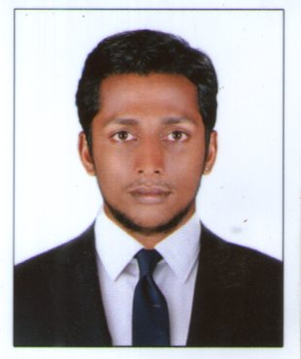
curriculum vitae

Sajith

Sajith.364074@2freemail.com

Career objective:

        - Highly dedicated with strong work ethic
        - Ability to update my knowledge according to the nature of the job
        - To apply my skills in a challenging environment and grow along with the organization.
Profile:

- Qualified BE mechanical Engineering. An effective communicative skill with excellent leadership, analytical and relationship management skills.

Educational Qualification:
2007 : S.S.L.C with 75% marks from Kerala State Board.
2009 : +2 Science with 71% marks form Kerala State Board of
Higher Secondary Examination.

Professional Qualification:

2015 : BE in Mechanical Engineering from Sun College of
Engineering and technology, Nagercoil, Tamilnadu.

Additional Qualification
- QA / QC (NDT Level I & II, Piping Engineering, Welding)

Experience
- Intech Engineering Services – Sept 2015 to Sept 2016 as Junior Mechanical Engineer
languages known :
- English, Malayalam, Hindi & Tamil

Technical skills

+ AUTO CAD
+ CATIA
+ Ms Office
+ MS power point
+ Window XP,windows 7,8 and Linux

Personal data:

Date of Birth : 18th Sept 1991
Age : 25
Nationality : Indian
Marital Status : Single
Gender : Male
Declaration :

I solemnly declare that the above said details are true to best of my belief and conscience.

