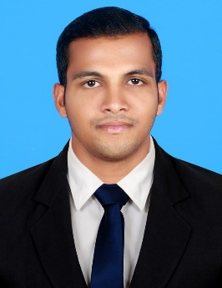

SEBI
SEBI.364089@2freemail.com
Hiring Manager

Sir,
I would like to take this opportunity to submit my application for the position of Electrical Draughtsman in your esteemed organization.
Please find enclosed my resume describing all my theoretical and practical capabilities, which would be asset to your firm. As you will discover, I have been part of several major projects in Qatar and Kuwait two and half year of experience. My academic qualification and practical experience in various projects and zeal to put in hard work, gives me confidence to shoulder challenging responsibilities and execute the job to the best of the project requirements.
During my employment history, and with every assignment I have accepted, I have devoted my energies toward being a good steward of available resources. I attribute my ability to improve the operational performance of my employer almost immediately to my resourcefulness and creativity.
I trust my qualification and experience will meet your requirement and I look forward for an early reply at your earliest convenience.

CURRICULUM VITAE

OBJECTIVE:

Seeking a challenging career where my technical skills and qualifications as
a Electrical Draughtsman can be shared and enriched and make a significant contribution to organization with strong work ethics and diligence.

DETAILED EXPERIENCE:

- One and Half years of experience as a Electrical Draughtsman in
Al-Ahleia Switchgear Co., Kuwait.
- 2 Years Qatar & Dubai project experience

- Celestia Serviced Hotel Apartments On Plot No. Ra – 38 At Residential City,Dubai World Central,Dubai,United Arab Emirates

EMPLOYMENT PROFILE:

  - Preparing all sorts of Electrical & Telephone shop drawings including plans, Elevations & Sections.

  - Presentation of Designs

  - Preparing load distribution schedule

  - Preparation of As built Drawing

  - Filing and copying of drawing for final submission.

SPECIALIZATION:

Electrical Draughting course (6 months) completed from Gulf –Tech MEP Design solutions –Aloor –Kerala – India.

EDUCATION:

2010 Electrical NCVT
From St. Xavier’s ITC, Pullur, Kerala, India.

2008 SSLC
From Gvt of Kerala Secondary Education, Avittathur, Kerala, India.

OTHER QUALIFICATION:

Computer skills:
- Auto CAD (2015).
- MS Office
- Extensive, Expert and regular hands on MS Office applications (MS Word, MS Excel, MS Power point.)
- MEP
- Good Knowledge on internet and multimedia

Language skills

Fluent in English, Hindi& Malayalam

DECLARATION:

I hereby declare that all the information given by me is true to the
best of my knowledge and belief.

18/04/

