JAYR.364094@2freemail.com
AUTOCAD-3DS MAX-SKETCHUP-REVIT-CIVIL 3D-PHOTOSHOP
BRIDGE-ARCHITECTURAL-STRUCTURAL-MEP-FIREFIGHTING-STEEL DETAILER/BIM
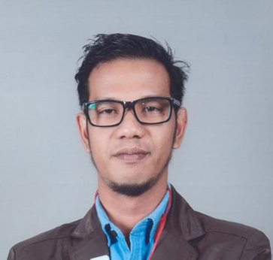

Objective
Seeking a CAD drafting position wherein I can apply my skills, knowledge and ability in your good company. Offers proficiency in 2D and 3D, surveyed legend formation and utilizing acquired skills of converting any rough hand sketch into a computer drafted.

A self and multi-tasking individual and team player a performance driven and detail oriented CAD Operator for more than Eight (8) years of experience in designing. Strengths in enhancement in pre-existing designs focused on improved layout size and increased speed, program analysis and re-write and small-group designs as well as production to improve. Exposed in office routine and computer skilled.
Have the ability to learn quickly with less supervision and can cope up in a busy environment.

Experiences:
March-2015 to March-2017 | STC (Saudi Telecom Company)  (AutoCAD Operator) | Saudi Arabia
Jan-2011 to July-2012 | Freelance (CAD Operator/3D Visualizer) | Philippines
Dec 2005 to Jan - 2009 | Freelance (CAD Operator/3D Visualizer) | Philippines
2000 – 2005 | R’Place Networking Inc. – Internet Café (Operation Manager / System Administrator) | Philippines

Job Description:
- Architectural and Structural design.
- Interior & Exterior Rendering
- V-ray Rendering
- Bar Bending Schedule shop drawing
- Steel Detailer
- Fabrication shop drawing STEEL/METAL SHEET
- Railway shop drawing
- Geographical/Coordinated Shop Drawing
- External Reference / Attributes
- All kind of civil design.
- HVAC – MEP – BRIDGE – BIM - TELECOM
- Prepare daily/weekly work report, Shop Drawings, AS BUILT, Section Detailing, 3D modeling,
Isometric detailing, Dismantling Detail
- Site supervisor / Site Engineer
- Prepares rough sketches by studying customer’s specification;
- Creating a picture of the system, components and or parts to support sales and marketing.
- Prepares final drawings by studying engineering sketches, specification and supporting documents, developing a layout of the system, depicting relationship of components
- Networking of all company computers.
- Installation of various software such as operating system, MA Office and others.
- Management of company internet services.
- Hardware and Software Installation.
- Various trouble shooting functions;
- Provides on call screening and eradication services for various clients.
- Handled all official work.
- Maintained compile records and database.
- Make research of viable information for hotel reference and reporting.
- Worked with MS Word, Power Point and Excel
- In charge of day by day operations of computer facilities which includes liaison with suppliers and client; supervision of employee’s attendance and performance
- Handling stock availability; Proper coordination & maintaining neatness for customer attraction.

Education:

Other Trainings / Seminars:
TESDA (Technical Education and Skill Development Authority)
Computer Hardware Servicing
(CHS)

Other Trainings / Seminars:
TESDA (Technical Education and Skill Development Authority)
Autodesk AutoCAD 2013
Autodesk 3D Studio Max

Skills:
- 2D and 3D Architectural / Structural / HVAC / Fire Fighting / BRIDGE / Telecom
- Autodesk Autocad / 3DS Max / Revit / Civil 3d
- Sketchup / Lumion / Phantom / Nitro
- Adobe Acrobat / Photoshop / Premiere
- Microsoft Office – Word / Excel / PowerPoint
- OS MAC (DOS, Microsoft XP, Windows 7, Windows 8, Windows 10, Ubuntu & Linux)
- Hardware and Software Installation and Networking
- Hardware & Software Troubleshooting
- Driving of 2 wheels and 4 wheels’ vehicle.

