Sadik.364096@2freemail.com
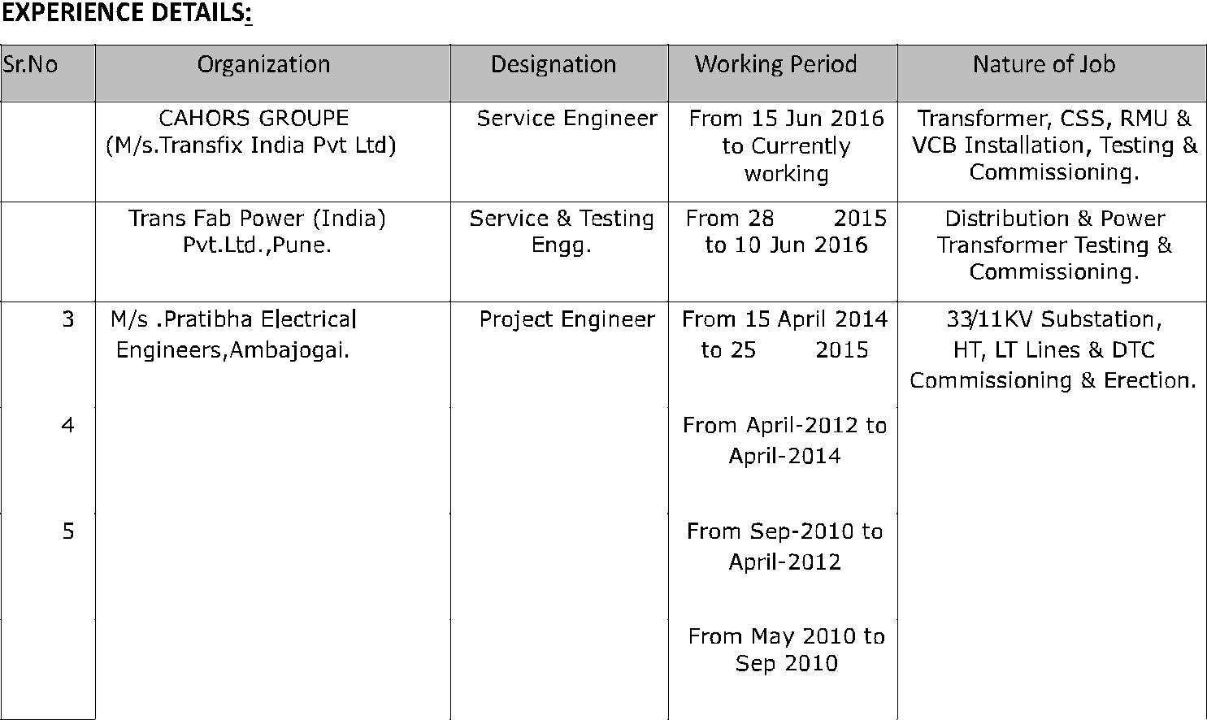

1

2 | May

 |  |  | May
 | ZTE PVT LTD | Implementation | Telecom engineer
 |  | Engineer
 | TVS PVT LTD | BTS Installation & | Telecom engineer
 |  | commissioning
 |  | Engineer
6 | Sohel telecom pvt ltd . | BTS engineer | Telecom engineer

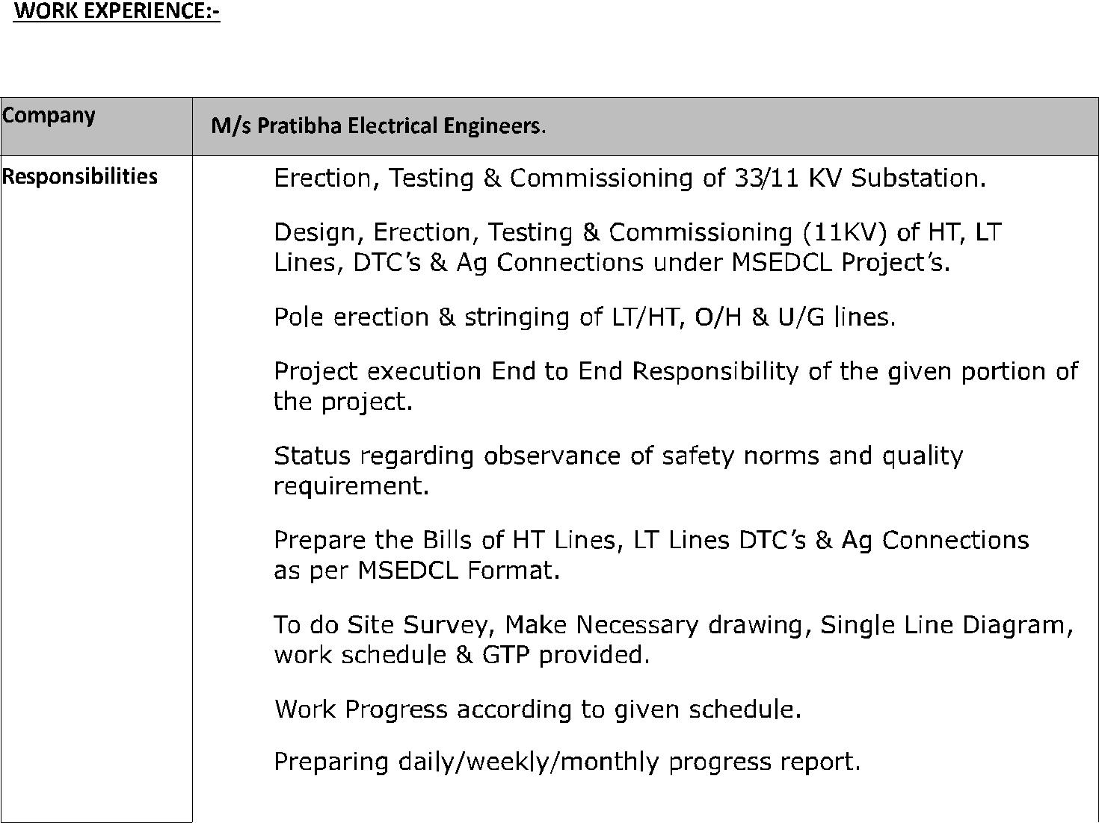

∑

∑

∑

∑

∑

∑

∑

∑

∑

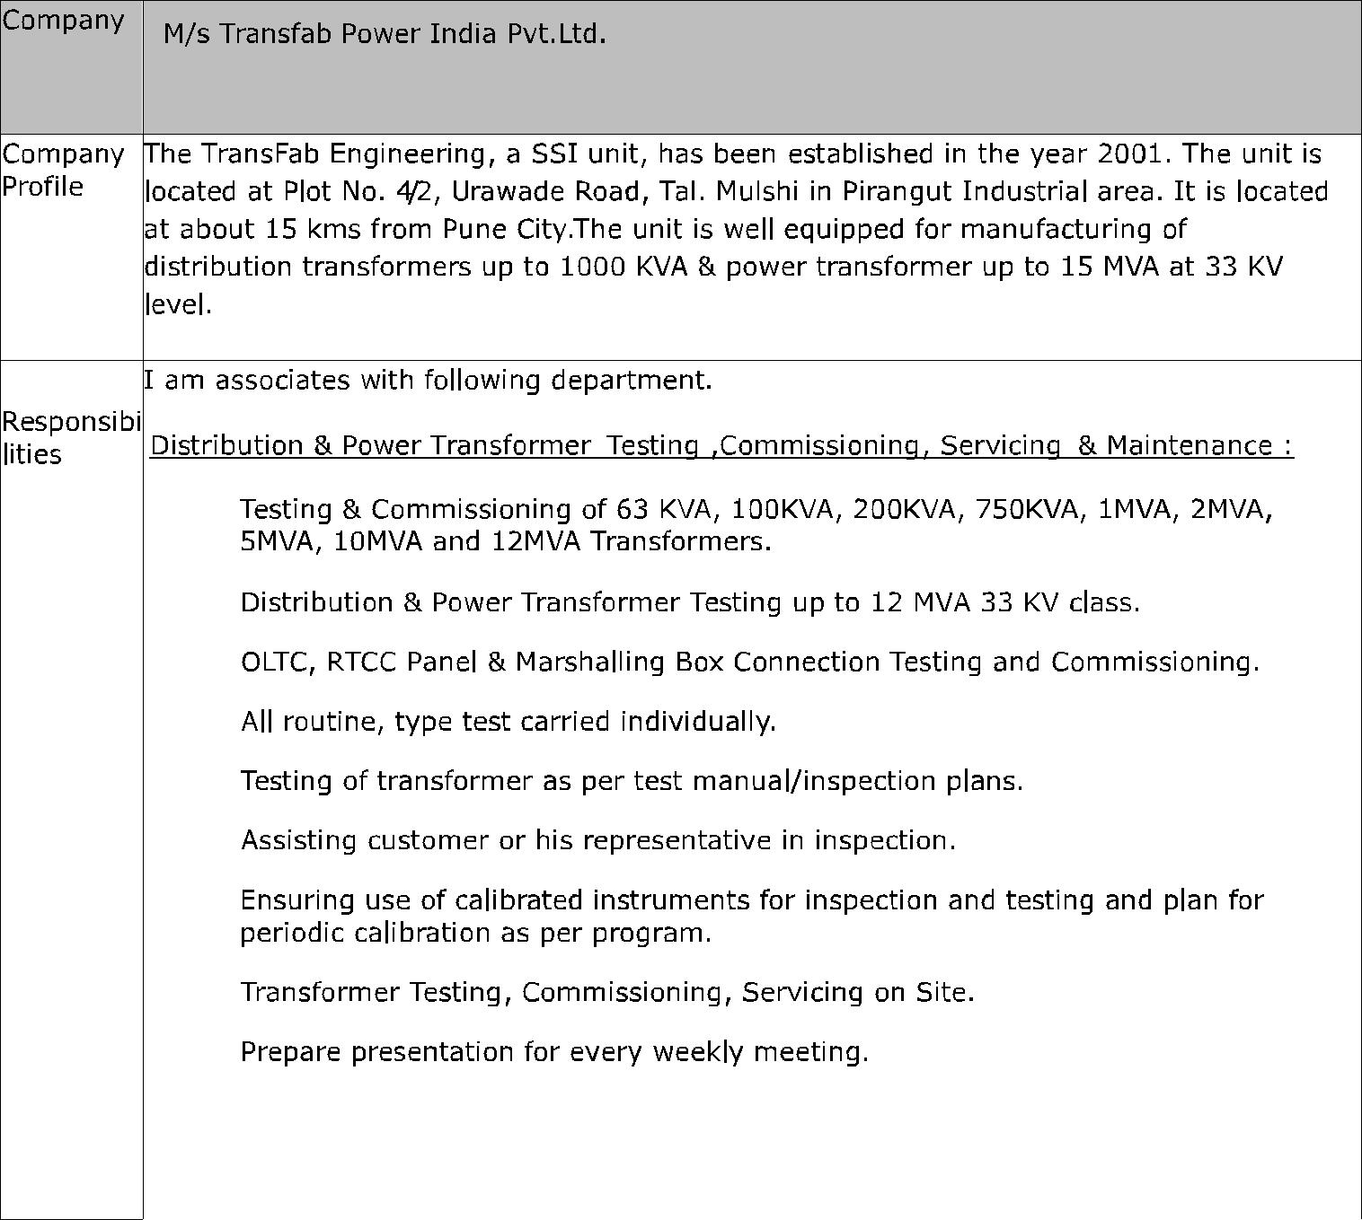

∑

∑

∑

∑

∑

∑

∑

∑

∑

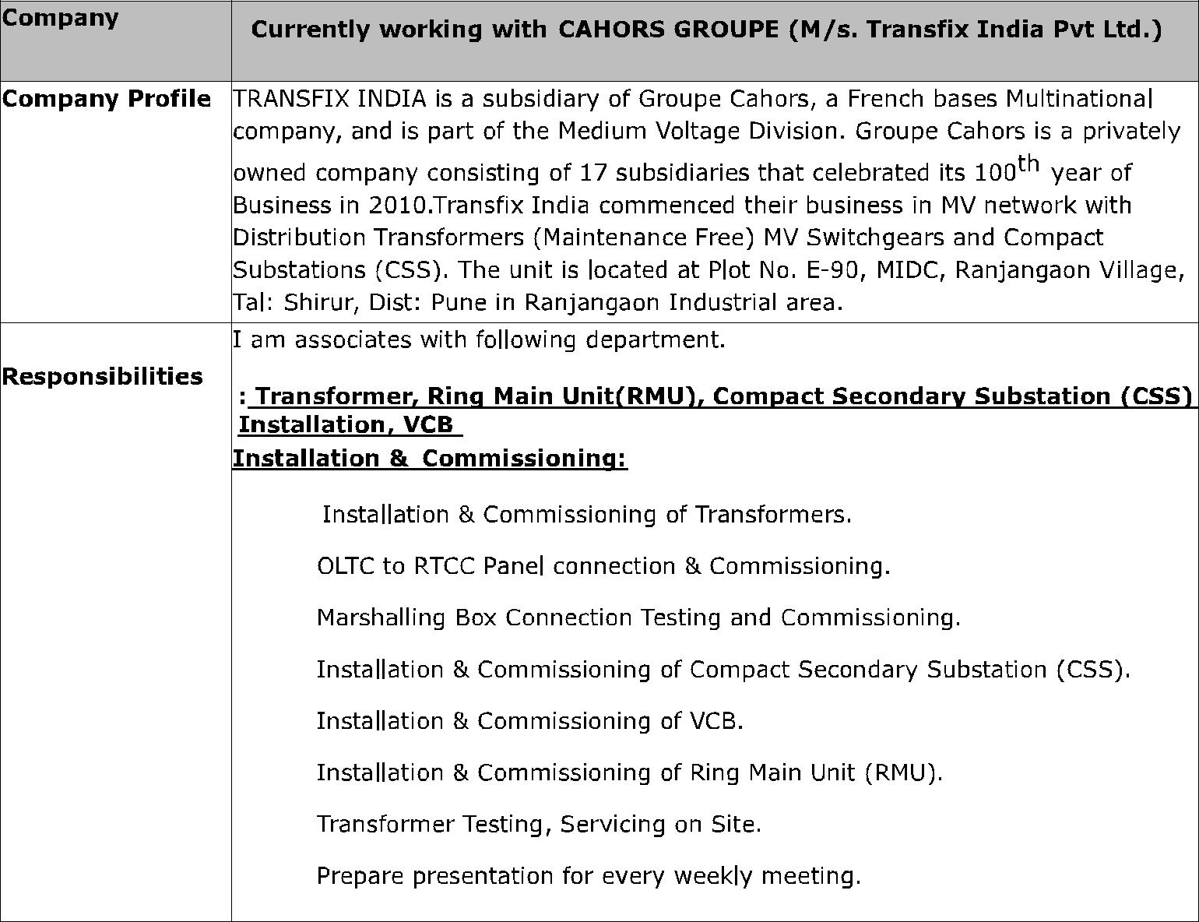

∑

∑

∑

∑

∑

∑

∑

∑

Handled Phase VII GSM UMTS Project of BSNL Pune and Nashik cluster (Maharashtra Circle) as Implementation Engineer under the guidance of Circle Head.

Educational Profile

Year | Degree / certificate | Institute / School | Percentage | Year
2010 | B.E(Electronics | J.D.I.E.T Yavatmal | 60.30% | 2010
 | &Telecommunication) | (Amravati university)
2001 | H.S.C. | Amravati Board | 58.00% | 2001
1998 | S.S.C | Amravati Board | 48.00% | 1998

Feb

