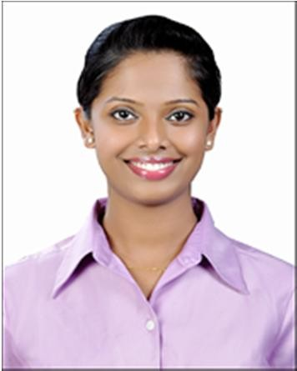 Janice
Janice.364107@2freemail.com
CAREER SUMMARY

A motivated, resilient and compellingly persuasive individual with 10+ years of experience who loves nothing more than helping customers resolve their problems or find things that they want. I am a service oriented professional who is very confident when handling enquiries, complaints, and communications. I am a team player, who is able to work to timely demands and effectively manage multiple workloads. I am looking for a suitable position with a company that has a unique spirit and which not only believes in giving people the opportunity to do a great job, but will also support them in achieving their future ambitions.

Areas of Expertise& Personal Skills

- Customer satisfaction
- Interpret customer feedback
- Managing customer data
- Customer solutions
- Customer rapport
- Resolving problems
- Excellent communicator
- Good problem solver / Attention to detail
- Honest & hardworking

Professional Qualifications

- First Aid Qualified
- Diploma in Customer Service
- Diploma in Aviation, Hospitality & Travel Management

Academic Qualifications

- Bachelor of Business Management, Apex Institute of Management, Mangalore, India
- Diploma in Aviation, Hospitality & Travel Management, Frankfinn Institute of Airhostess Training, Bangalore, India

WORK EXPERIENCE

Q5 Arch Engineering Consultancies
September 2015 – Present
Executive Secretary

- Screen and direct calls and visitors.
- Handle confidential documents ensuring they remain secure.
- Maintained construction documentation, project plans and files.
- Initiate relevant action such as replying to requests by sending a form letter/e-mail, arranging meetings or compiling recurring reports.
- Maintain company database of projects.
- Maintaining expense report, employees file, annual/absence leave template, payment request template.
- Process and follow up with employee insurance, trade license renewal, company establishment card.
- Petty cash process for paying/recording transactions and manage payroll of all the employees.
- Filing – payment vouchers, receipt vouchers, invoices, company documents, records, reports and quotations.
Le Royal Meridien Beach Resort & Spa (Starwood properties), Dubai April 2010 - August 2015
Customer Support

- To provide prompt, efficient and professional service for guest, making sure of meeting guest’s requirement.
- Ensuring the team stay motivated to complete their day to day task.
- Conducting one-on-ones and performing development plans, attrition management and absenteeism management.
- Mentoring the new trainees with their job tasks and monitoring their calls.
- Scheduling the rosters and providing feedbacks.
- Maintaining weekly status report and a daily productivity report.
- Providing hospitality solutions and relationship management with customers.
- Dealing efficiently with queries and complaints from customers
- To respond and ensure the safety of staff/ guest and property of the hotel.
- To ensure that the request of the guest will be delivered fast and accurate.
- To have right attitude and a professional approach towards all our guests.
- Monitors automated systems including fire alarms and telephone equipment when engineering and maintenance department is closed.

Accenture PVT Ltd, Bangalore, India Feb 2007- Mar 2010
Customer Manager

- Providing advice on making a claim and the processes involved;
- Processing new insurance claims notifications;
- Collecting accurate information and documents to proceed with a claim;
- Analyzing a claim made by a policymaker;
- Guiding policyholders on how to proceed with the claim;
- Contacting trades people from a network of approved professionals and arranging for them to make repairs on the policyholder's vehicle;
- Monitoring the progress of a claim;
- Investigating potentially fraudulent claims;
- Identifying reasons why full payment may not be made;
- Ensuring fair settlement of a valid claim;
- Building relationships with loss adjusters, forensic accountants and solicitors, as well as other legal/claims professionals;
- Ensuring the customer is treated fairly and that the customer receives excellent service in accordance with industry and company guidelines;
- Handling any complaints associated with a claim;

Personal Details

Date of Birth: Aug 11, 1988 Marital Status: Married
Visa Type: Residence Visa
Interests: Music, Cooking, Dancing & Travelling Languages: English, Hindi, Konkani, Tulu & Kannada.

