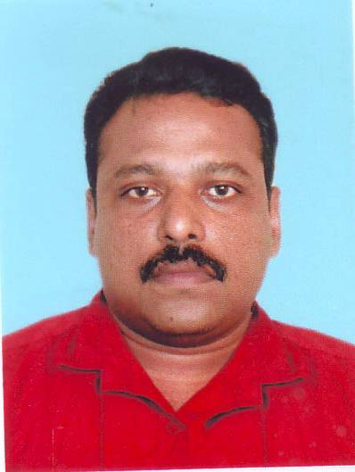
CURRICULUM VITAE

OOMMEN
OOMMEN.364110@2freemail.com

Civil Supervisor with 14 years experience in Earth work ,roadworks, & Civil Works in INDIA & MIDDLE EAST
OBJECTIVE:
Looking for exciting career opportunities in esteemed organization in the field of Civil Engineering which proves my caliber.
KEY SKILLS:
- Having good attitude towards safety & quality
- Goal oriented & good customer satisfaction
- Good Team player with strong interpersonal & Communication skills.
SUMMARY OF EXPERIENCE:
ABROAD : 9 YEARS EXPERIENCE IN MIDDLE EAST
IN INDIA : 5 YEARS EXPERIENCE IIN INDIA
OVESRSEAS EXPERIENCE
Experience at a glance
Current : AS a senior foreman with AL
Habthoor Leightor group
Client:RTA(Road Transprt Authority
Dubai)
Project(Airport road upgradation)
Role:supervision of utilities works and
Road works
From Aug 2014 to Octo.2015: As civil supervisor with AL ADRAK
OMAN
Client: ROP(Royal Oman Police)
Project : Buildings and infrastructure
Facilities for Royal Oman Police.
Responsibilities :- Independent handling
Of Infrastructure Group including Machinary movement, planning of
Schedule of project, daily reporting and
Overall supervision of earth work, Road
Works , kerbstone and manhole works
For the project.
From Feb 2011 to Nov.2012 As a Civil Foreman with consortium of
Technicas Reunidas (TR) Ltd and Conso-
lidated Contractors intl Co for ADCO
(ABUDHABI Company for on Shore
Oil Operation)
Project : Sahil & Shah FFD ABUDHABI
Shah and sahil oil field pipe line project
and civil works
. The project scope is rerouting of
Existing flow lines from oil wells to deg-
Assign stations and lying of new Main
Oil Line.
Responsibilities Takes permits for the
Work, preparation of Roads for the
Project Road Diversions and Road Cro
Ssing . Supervision for layer by layer
Back filling and compaction test.
Subgrade, subbase prepration of the
Roads by heavy machineries including
Scrapper, bulldozer, grader etc.
From Sep.2009 to Sep.2010 : As a Civil Supervisor with AL EZ Trade.
Transport & Cont. co MUSCAT
Project : roadworks project works .
Client : OCCIDENTAL
OMAN(OXY) SAFAH OIL FIELDS,
IBRI, MUSCAT
Responsibilities: Earth work project
Rigpad preparations and its service
Road preparations.Independent handling
of the project. Meeting with consultant
and RFA (request for final approval).
Daily safety tool box talk to the working
Crew.Controlling of the heavy equipm-
ents.
From June 2008 to May 2009: As a Civil Supervisor with Consortium
DODSAL Engg DUBAI and TECHNIP
ITALY.
Project: 64 “ Water Pipeline Project from
FUJAIRAHTO AL-AIN (131 km) for
TRANSCO ABUDHABI
Project Scope: ROW preparation, Exca-
vation, Lying, Backfilling, & Berm
preparation of 64 ”water line.
Responsibilities: permit holder in the
Project, supervision of the trenching
Activities & existing services crossings.
From APR .2005 to APR 2008: As a civil Foreman with WADE ADAMS
DUBAI.
Projects: DUBAI Media production Zone
Mirdif Villa project, SHARJAH Internat-
onal Airport
Responsibilities : Supervision of all the
activities From Earth works up to
Kerbstones & Footpaths (Earthworks,
formation works Sub grade & Sub base
of the Roads, Excavation, lying & Back-
filling of All Utilities including Sewage,
Drainage, Water & Irrigation lines)
MAJOR CONSTRUCTION WORKS
- Mass Area Paving

- All underground facility
- Supervision of mass all type of pipelines
- Supervision of trenching,padding,backfilling works
DOMESTIC EXPERIENCE
- Worked with RAY CONSTRUCTION MUMBAI, INDIA in various projects like MIDC PUNE, RELIANCE JAMNAGER ETC.
NATURE OF DUTY
- Study of drawings
- Indenting the materials as per standards with suitable specifications
- Executing the work as per the plans, specifications and drawings
- Proper follow up of work activities
- Quality inspection of procured, semi finished and finished items.
- Safety of men machinery involved in the activity
- Proper coordination with client

EUDCATIONAL QUALIFICATION
Technical : Diploma in Civil Engineering
Knowledge on Computer : MS – OFFICE

PERSONNEL PROFILE
Date of Birth : 17/03/1978
Nationality : Indian
Languages Known : English, Hindi & Malayalam
Civil Status : Married
DECLARATION
I, Oommen, hereby declare that the above particulars mentioned by me are true to the best of my knowledge and belief and in case they found false, my candidature shall be liable to reject.

