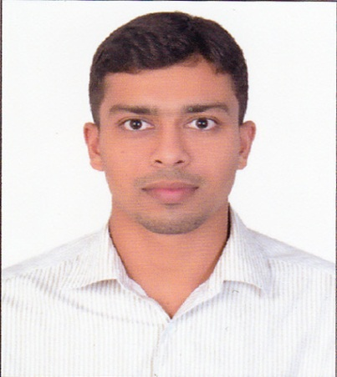
CURRICULUM VITAE
JISHAD
JISHAD.364121@2freemail.com
Professional Summary :
With diverse experience in Electrical Engineer for more than 3 years, I am currently looking for a career growth with a major corporate, in your esteemed organization where I can use my talents, leadership and motivational skills, with enthusiasm to develop team members to achieve superior results helping the organization as well as myself grow.
Excellent Organizational and communication skills and would like to seek good position in a dynamic and challenging professional environment.
Professional Experience:
- Currently working from February 2015
DUBAI PIPES FACTORY LLC.
General Electrical engineer
2) 2 years of experience
STEEL & INDUSTRIAL FORGINGS LTD
KERALA,INDIA
Designation : Engineer (Maintenance)
Period : July 15th, 2013 – January, 22th, 2015
Job Responsibilities:
- Managing activities pertaining to Maintenance of Electrical and Mechanical equipment’s
- Actively associated with the operation of 11 KV/440V downstream distributions and associated power system network and breakdown/preventive maintenance of plant and equipment.
- Operation and Maintenance of 11 KV, 2MVA step down transformer substation,11 KV/440 V substation, LT distribution network, Industrial control systems,11KV ,630 A oil circuit breakers,3200 A air circuit breakers
- Supervising the function of troubleshooting, problem solving and management of various Electrical and Mechanical equipment’s.
- Acquired competency in trouble shooting and maintenance of Continue Winding machine, helical machine, coupling machine and pipe calibrating machines, CNC machine with Siemens (802 D/801 D)/Fanuc (Oi-MC) controls, PLC control circuits.
- Carry out preventive and predictive maintenance to increase the machine availability.
- Coordinating with Managers, Co-Engineers during execution of work.
EXPERIENCE IN 110 KV SUBSTATION- KODUVALLY
Actively associated with the operation of 110 KV/11KV downstream Transmission Operation and Maintenance of 110 KV, 12.5 MVA step down transformer substation, and kuttyadi hydro Electric power station, Diesel power plant nallalam.
Educational Qualification & Certifications:

- Bachelor of Engineering Electrical and Electronics Engineering (2009-2013)
Anna University, India.
- HIGHER SECONDARY(2009)
- SSLC (2007)
- Auto cad drawing

Achievement:
- Student coordinator for the national level symposium conducted by college.
- Program Convener of the College Department Association
Personal Information:
- Date of Birth : 30th May 1992
- Nationality : Indian
- Marital Status : Single
- Driving License : UAE
Declaration:
I hereby declare that the information furnished above is true to the best of my knowledge and belief

