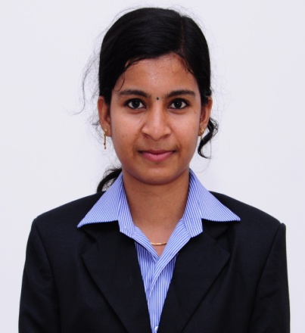
ARSHA
ARSHA.364123@2freemail.com
Profile:
I am a graduate in B.Sc physics and have completed MBA with specialization in Human Resource Management and Marketing Management. I am interested in learning new skills and technologies.
Career Objective:
I would like to build my career in a good working environment where I would be able to significantly contribute my best.
Work Experience:
- Worked as a HR Executive at Bismi Hypermart Pvt Ltd, Alappuzha, Kerala, India from 28-03-2016 to 03-04-2017.

Key Responsibilities Handled:
- Assist the HR manager in planning of Organizational recruitment.
- Resourcing, screening and short listing resumes through internal reference, head hunting.
- Take the interview of the employees.
- Make the joining documents of employees.
- Convey the Policies and rules to the employees.
- Maintaining employee’s personal files and communicating HR policies.
- Tracking attendance, maintaining leave records etc.
- Resolve PF and ESI related issues
- Identification of training needs and nominating candidates for training.
- Developing employee engagement programs like R & R, Birthday celebration, and managing welfare measures, Family get together etc.

- 2 years of experience as a Trainer under Synergians.

Educational Qualifications:

- Masters in Business administration with dual specialization in Human Resource Management and Marketing Management from IMT Punnapra, Kerala, India
- Bachelors of Physics from SD College, Alappuzha, Kerala, India
- Schooling from KKKPMGHSS Ambalapuzha, Kerala, India
Projects:
- A study on “Optical Absorption of K₂Cr₂O₇” as part of completion of B.Sc Physics graduation under Kerala University.
- An Organization study in Aditya Birla Retails.
- A study on “ Working environment of employees at textiles in Alappuzha”
- A study on “Employee Engagement at Bismi Hypermart Pvt. Ltd
Participated Programs:
- Participated as a Management trainee in association with the “Golden Store Launch” of “more”, Aditya Birla.
- Participated in Best Woman Research Award programme conducted by synergians.
- Participated in National HR Conclave conducted in TKM Institute of management and technology.
- Participated in several management fests conducted by various colleges.
- Participated in several personality development programs conducted in my colleges.

Achievements
- Acted as a co-coordinator in conducting management fest “VIDARAN 2K14” at IMT, Punnapra.
- Worked as a trainer under Synergians for their “Kids MBA” programme.
- Several programs conducted by Social club of Institute of Management and Technology, Punnapra.
- Worked as member of Rotract club as a youth wing of Rotary Club Alappuzha.

Personal Information:
Date of Birth : 27-05-1993
Gender : Female
Marital status : Married
Languages Known : Malayalam, English, and Hindi
Personal Strength : Team player, Optimistic, punctual.
Hobbies & Interest : Travelling, Take caring of pets and cooking.

Declaration:
I hereby declare that the above mentioned information’s are correct up to the best of my knowledge and I bear the responsibility for the correctness of the above mentioned particulars.

