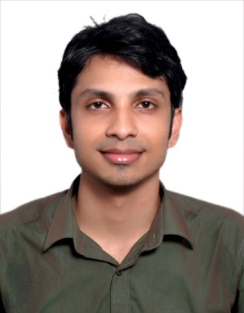 ARUN
ARUN.364124@2freemail.com
Curriculum Vitae
CAREER OBJECTIVE
To pursue knowledge throughout my career and to become a responsible employee by working sincerely for the mutual benefit of me and the organization.

PERSONAL DETAILS

Birth October 27, 1990
Religion Christian
Sex Male
Marital Status Single
Nationality Indian

COURSE | DURATION OF COURSE | INSTITUTION | BOARD/UNIVERSITY
B.TECH  Mechanical | 2009-2013 | VJCET, Vazhakulam | M.G University
CLASS 12 | 2008 | THSS,ALUVA | Higher Secondary Education
CLASS 10 | 2006 | Infant Jesus Public School, Alangad | Central Board of Secondary Education
EDUCATION

WORK EXPERIENCE
SITE SUPERVISOR 10/10/2013-31/10/2014
LAKSHMI MEP INFRAH PVT LTD
ARUMBAKKAM, CHENNAI, INDIA
- Quality Control
- Site In charge
- Knowledge in Permit to work System
- Describe Isometric Drawing to worker
- Work Management Skill
- Pipe Fabrication-Spool Making based on isometric drawing
- Erection Work Management of HVAC Systems
- Documentation skill

LECTURER-MECHANICAL 11/1/2015-30/4/2016
SKILTEK DIPLOMA COLLEGE
ERNAKULAM-NORTH, INDIA

SITE SUPERVISOR 11/07/2016-Still working
ESPOIR WORKSHOP
VENGOLA, PERUMBAVOOR, INDIA
- BOM preparation
- Permit to work system preparation procedure
- Daily Activity Report Preparation
- Material take off procedure
- Conduct safety tool box meeting
- Preparation of MS and JSA
- Checklist preparation Procedure
- Work Management Skill based on Man power

SKILLS AND PUBLICATIONS
- Mechanical Design Software-AUTOCAD-Isometric Drawing
- Pipe Fabricator training in ESPOIR(From 11-7-2016 to 11-10-2016)
- M.S Office(M.S Word, M.S Excel, M.S Power Point)

TRAININGS AND CERTIFICATES
- Mechanical Design Software-AUTOCAD 2D
- NDT Level 2 ASNT Approved Certificate
- Process Piping Design & Engineering as per ASME b-31.3
- One month training program in Industrial Automation and measurements
Including hands on training on Pneumatic Circuit Design

CONFERENCE AND WORKSHOP
ESPOIR (Enlighten Skills Program for Oil and Rig) ACADEMY
Technical and Supervisory Course
Technical Course
- Hands on training in OFC(Oxygen fuel cutting) operation
- Hands on training in pug cutting operation
- Hands on training for using bevel cutter and Chop Saw Cutter
- Bevel angle and root face preparation using AG7 And AG4
- Safety conscious in using PPE
- Experience in using Fall Harness Equipments and lanyards
- Technical Knowledge about welding defects in pipe joints
- Spool preparation

LANGUAGES KNOWN
- Malayalam (Mother Tongue)
- English (Fluent)
- Tamil(Less Fluent)
- Hindi(Less Fluent)

DECLARATION
I confirm and declare that the above furnished details are true and correct to the best of my knowledge and belief.

