AMRITHA
Amritha.364127@2freemail.com

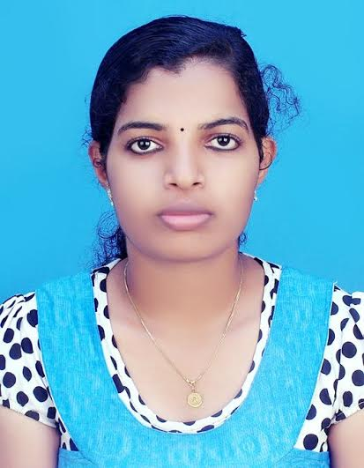
Professional Objective
To work with an organization that gives opportunity to utilize my skills and the best of my knowledge in achieving a common goal of the organization and bright personal career .Seeking a challenging position in reporting and editing in an organization which encourages continuous learning in addition to personal and professional growth.
Educational Qualification
MASTER OF SOCIAL WORK (2013 - 2015)
Specialization : COMMUNITY DEVELOPMENT
Course | University/  Board | Institute | Year | Percentage
MSW | Central University Of Kerala | Central University Of Kerala | 2013-2015 | GPA 6.85
BA ENGLISH | Kannur University,  Kerala | Payyanur College | 2010-13 | 69%
T.T.C | Department of Education | G.T.T.I Mathamangalam | 2008-10 | 75%
Plus Two | Board of Higher Secondary Education, Kerala | Govt. Higher Secondary School, Kottila | 2007-08 | 83%
SSLC |  | Govt. Higher Secondary School, Kottila | 2006 | 67%
Work Experience

- Teacher Traineee
- school : Mathamangalam U.P school
Duration : 8 July 2008 to may 8 2009
Location : Mathamangalam
- school : Kuttur L.P School
Duration : 8 August 2009to12 januvary 2010
Location :Kuttur

- Msw student Traineee
- Field Work 1
Field : Periya
Duration : 12 July 2013 to 21 December 2013
Location : Kasargod
- Field Work 2
Field : Periya
Duration : 12 July 2014 to 21 December 2014

Project Work

A STUDY ON PREVELANCE OF DEVIANT PEER RELATIONSHIP OF ADOLESCENTS IN KANNUR DISTRICT

Internship

- Agency : DON BOSCO
Field : Community Development
Duration : 2 June 2014 to 28 June 2014
Location : Banglore

- Agency : PEERMADE DEVELOPMENT SOCIETY
Field : Community Development
Duration : 16 March 2015 to 11 April 2015
Location : Idukki

Computer Skills

- MS office
- Photoshop

Strengths

- 100% commitment and hardworking to the jobs assigned.
- Good listening ability and patience.
- Strong but realistic belief in own capabilities and ideas.
Maintain a positive attitude in the face of changes in work assignments or conditions.

Personal Profile
Name : Mrs. Amritha. E.V. K
Date of Birth : 06-07-1990
Father's Name : Mr. Ravindran. E.V
Sex : Female
Marital Status : Married
Languages Known : English, Hindi and Malayalam
Nationality : Indian

VISA STATUS

On Husband visa

Declaration

I hereby declare that all the information presented above is true to the best of my knowledge.

Date:
Place:
Yours Sincerely
AMRITHA E.V.K

