OBJECTIVE:
To get the chance in your esteemed organization to build my career and utilize my technical expertise to fulfill the organization requirements.

Muhammad
Muhammad.364139@2freemail.com

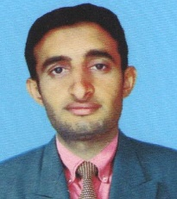
PERSONAL INFORMATION:
- Domicile. : Vehari (Punjab) Pakistan.
- Religion : Islam
- Nationality : Pakistani
- Marital Status : Single
QUALIFICATION:

Degree | Year | Marks | Board/University
Matric | 2008 | 508/850 | BISE Multan
I.COM | 2010 | 679/1100 | BISE Multan
B.SC | 2013 | 420/800 | BZU Multan
MCS | 2017 | 2.93/4.0  74% | Comsats institute of information technology Vehari

Projects:
- Online blood donors in asp.net(Final Year Project)
Programming Languages Skills:
- Asp.net
- HTML
- CSS
- Database

