LITTO
LITTO.364153@2freemail.com

To,

HR MANAGER,

Dated: Thursday, March 30, 2017

Dear Sir/ Madam,

Please find attached my resume for the mentioned position. It is with great anticipation that, I present my resume to you for this vacancy as I firmly believed that I perfectly qualified for the role. I am self-motivated, friendly and enjoy being in office environment. I consider myself to be an enthusiastic person who performs all office tasks to the highest standard and within given time scale. My core strength includes-

- Competent level with Microsoft office.

- Problem solving ability.

- Ability to confidently communicate to senior level staff.

I am responsible for the all aspect of the day to day running of the filling, copying, report writing and invoicing jobs. I consider myself to be qualified in all competencies that you want from a candidate.

In closing I would like to thank you for your consideration,and I look forward to discussing the possibilities with you in greater detail in near future.

Thanking you.

Sincerely,

Page1

1

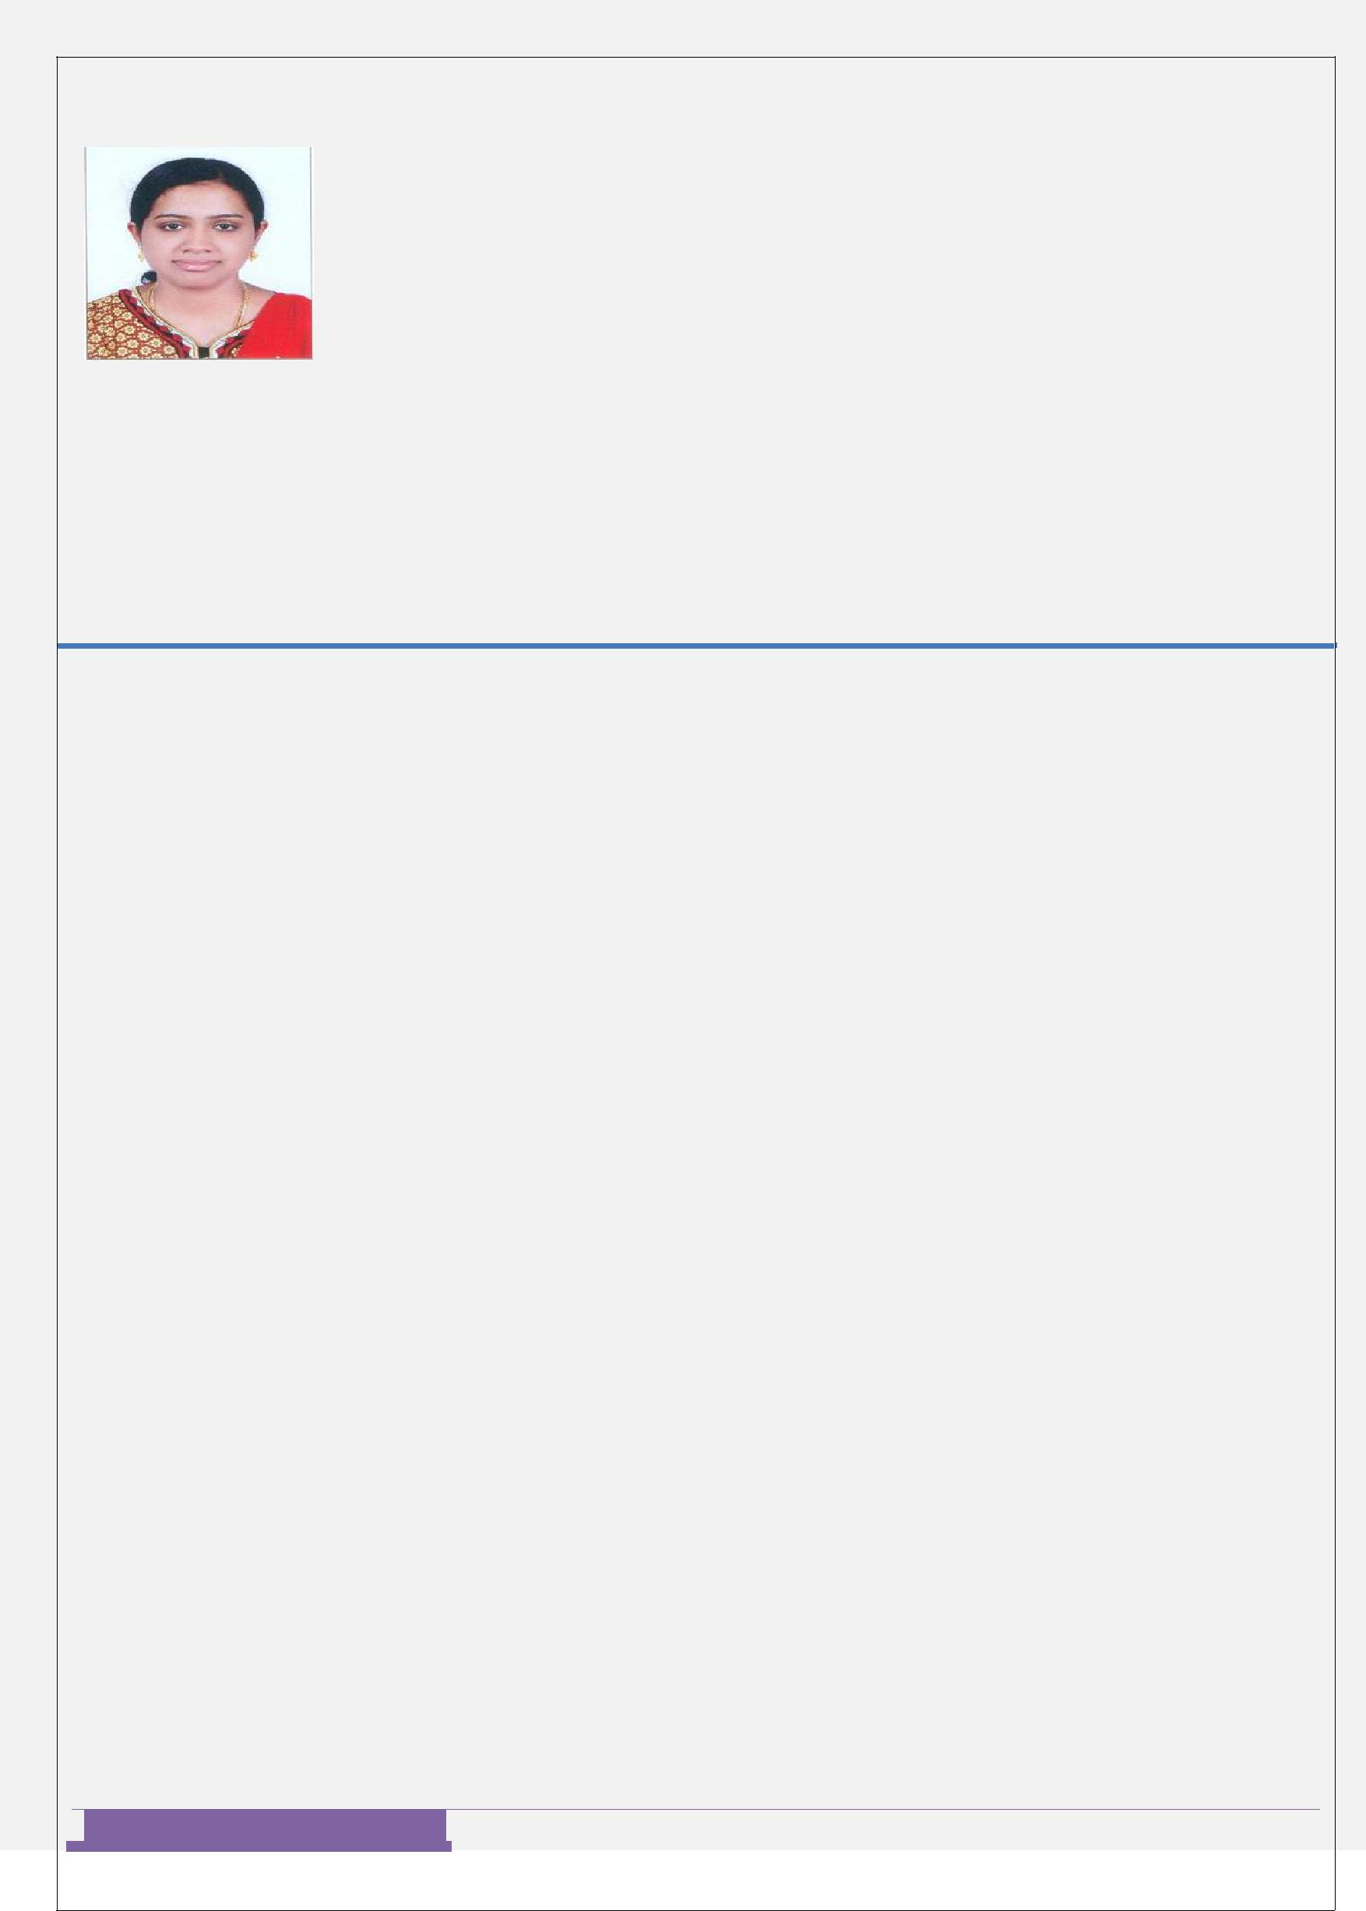

CURRICULAM VITAE

LITTO

Applied Post: HR Assistant,Administration Assistant,Computer Operator.

.

CAREER OBJECTIVE:

To secure a challenging position in an organization, where I can effectively contribute my skill and full potential as well as for the welfare and development of an Organization.

EDUCATION QULAIFICATION:

- 10th and 12th(C.B.S.E) From Rajasthan,Bhiwadi.

- Completed B.COM From St. Stephens College,Pathanapuram.

- Completed MBA in HR From ICFAI University, Tripura.

TECHNICAL SKILLS:

Thorough working knowledge such like as MS Office, Power point, Excel & tally.

PERSONAL ABILITY:

- Ability to prioritize task.

- Punctual and reliable.

- Can work without supervision.

- Ability to cope and work under pressure.

- Good written and verbal communication skills.

- Ability to work as part of team.

- Having a patient outlook.

- Able to motivate and negotiate with the people.

- Flexible in work.

Page2

2

WORK EXPERIENCE:

Organization Name –FEATHER TOUCH CERAMICS PVT. LTD. Designation: Administrative Assistant :From 15/5/2013 to 31/7/2014

- Perform various clerical duties such as documenting, photocopying, faxing, mailing and organizing filling system.
- Responsibility to handle the telephone enquiries.

- Collecting and mailing correspondence.

- Providing general information to customers.

- Maintain office operations of supplies and equipement.

- Provide general information to customers.

- Supervise other clerical staff.

- Assisting the administrative manager in performing the office work.

- Creating presentation and writing up reports.

- Maintain the office database retrieved and organized information for individual employees .

- Keeps employee records up to date by processing employee status changes in a timely manner.

- Convey the policies and rules to the employees.

- Track the daily attendance of the employees.

- Handle the all other responsibilities related to the job.

Page3

3

PERSONAL INFORMATIONS

HUSBAND'S NAME |  |  | : ROY
DATE OF BIRTH |  |  | :6 NOV 1988
PLACE OF BIRTH |  |  | :PATHANAPURAM
NATIONALITY |  |  | :INDIAN

.
RELIGION & CASTE

MARITAL STATUS

MOTHER TONGUE

LANGUAGE KNOWLEDGE

HOBBIES

: CHRISTIAN (Orthodox)

: MARRIED

: MALAYALAM

: ENGLISH, HINDI & MALAYALAM.

: Reading books, listening to Music, travelling.

DECLARATION

I hereby declare that all the above information are true and correct to the best of my knowledge and believe.

Place: DUBAI.

Date: Thursday, March 30, 2017

Page4

4

