Muhammad
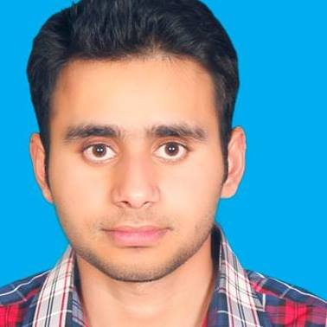
Muhammad.364178@2freemail.com
CAREER OBJECTIVE:
Highly skilled and knowledgeable Civil Engineer with a strong record of sound and safe public works construction projects. Adept at coordinating with building and engineering professionals for every project stage. Strong multitasked with exceptional skill in functioning well in a high-pressure work environment.
Resume objective should clearly demonstrate these abilities.

CAREER PROFILE/SKILLS:

- B.O.Q bills and estimation
- Research work on building material and their behavior
PROFESSIONAL WORK EXPERIENCE:

Organization: IFTIKHAR & COMPANY
(Construction Company like Arabian constructing company)
Tenure: August001– 15 September,2015
Designation: Site In charge

Responsibilities:

- Top Supervision of Civil Work
- Preparation of bills of B.O.Q and Detail estimation
- Preparation of Contractor's claim/bill after due verification at site
- Research work on building material and their behavior

Achievement:

- Surgical Tower in Mayo Hospital Completed Successfully

Organization: Techno Time Construction- PVT. Limited
(Construction Company like ALNASR)
Tenure: July15 –31August, 2016
Designation: Site Supervision

Responsibilities:

- B.O.Q bills preparation
- Building material research work
- Site Supervision of civil engineering work

Achievements:

- OPF Housing Society Roads are completed excellently

ACADEMIC EDUCATION:

DEGREE/CERTIFICATION | EXAMINING BODY: | YEAR
Bachelor of Science in Civil Technology | The University of Lahore, Lahore | 2017

CERTIFICATION/ ADDITIONAL SKILLS:

- MS Office (All versions, esp. MS Word, MS Power Point and MS Excel)
- MS Excel (MS Formulae, Reports Automation, Macros, Presentations w.r.t. Analysis)
- AUTOCAD (AutoCAD Skills Excellently)
- PRIMAVERA (Primavera Knowledge)

TRAININGS & WORKSHOPS:

CREATING MOMENTS OF MAGIC – CMOM Year - 2011
- Successfully meeting the requirements of Service Excellence Training by AMER SIDDIQUE President & CEO Golden BLUE Group

Excel GURU Training Year - 2010
- Intermediate and advance levels of MS excel

PERSONAL INFORMATION:

Date of Birth : 18December, 1992
Driving License : Learner
Nationality : Pakistani
State : Punjab
Age : 24

REFERENCE:

Reference will be furnished on demand.

