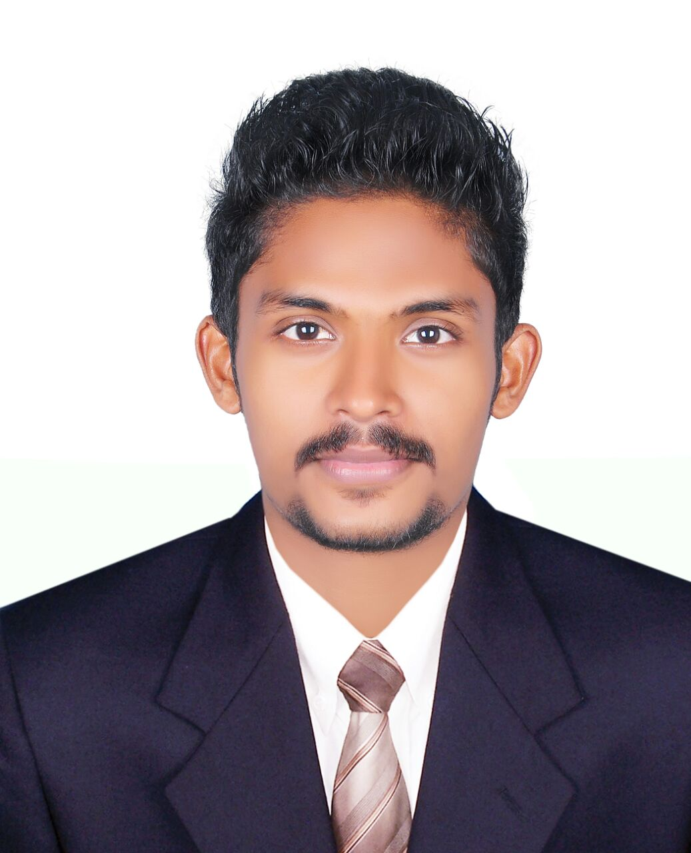
ARSHAD

ARSHAD.364181@2freemail.com
Bachelor of Computer Application
Nirmala College of Information Technology

CAREER OBJECTIVE

Intend to build a career with leading corporate of hi-tech environment with committed and dedicated people, which will help me to explore myself fully and realize. My potential and to use my technical skills, strong desire to work, as a key player in challenging and creative environment.

Year | Course  Board/University | School/College | Percentage/CGPA
2013-2016 | Bachelor of Computer  Application | Nirmala College of Information Technology (NCIT), Chalakudy. | 60%
2012-2013 | XIIth Standard  State Board of Secondary Education | K.V.H.S.S,Eriyad | 70 %
2010-2011 | Xth Standard  State Board of Secondary Education | R.M.VH.S.S,perinjanam | 88%
SCHOLASTIC RECORDS

OTHER QUALIFICATION

- BodyBuilding & Personal Fitness
- Have knowledge in Workouts ,Training ,Excersises and Fitness
- CCNA(under cisco) Network Fundamentals and IP Routing

EXPERIENCE

- 2 Years Experience as Personal Fitness Trainer in Rock Spot Fitness Centre Kaipamangalam, Thrissur Dt
- 1 Year experience in Mens casual wear sales

ACADEMIC PROJECTS

Project Type | Project Name | Front End | Back end | Description
Mini Project | Bike Showroom Management  System | Visual Basic | Microsoft SQL | This project is mainly focused on providing information about the upcoming and currently available bikes in a showroom and the staffs can easily saves the data with software which to do the registrations and transactions easily.
Main Project | Martial Arts Website | Adobe Dreamweaver CS6 | MySQL Server | It is used to get the feedback of masters in the academy about the students practicing in the academy. It has a number of registrations and transactions.

ACHIEVEMENTS
- Demonstrated skills in the College seminars- implemented strategic plans, cross-functional coordination and ensuring optimal utilization of resources.
- Effective communicator with strong leadership, people management, training, presentation, analytical and technical skills
- Actively participated in conducting educational events, college fairs, information sessions and recruitment activities
- Got 1st prices in the college,intercollege dance competitions
- Participated in football at sub district level and won Second Place in the year 2010-2011
- Participated in international Mixed Martial Arts completion in Mumbai
- Got brown Belt (style: shitoryu & shotokan) in the year 2011 & 2013
- Participated in Flash Mob Chalakudy,Thrissur,Kozhikode (Kerela)
PERSONAL SKILLS

- Communication Skill
- Good Leadership Quality
- Dedicated
- Hardworking

HOBBIES

- Dance
- Martial Arts
- Acting
- Sports

I hereby declare that the information and facts stated above are true and correct to the best of my knowledge and belief.

