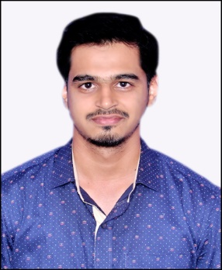
Syed Syed.364182@2freemail.com
Dubai

CAREER OBJECTIVE

An ambitious, creative and dedicated Civil Engineering Professional with about 4 years result driven experience, aspiring a career in the field of construction industry to utilize acquired skills and knowledge in achieving organizational goals, while attaining personal and professional growth. Seeking a challenging assignment as a,
Site Engineer
in a growth oriented organization of repute
QUALIFICATION

Bachelor of Engineering in Civil Engineering (2009-2013) with First Class
from Visvesvaraya Technological University, Karnataka, India

WORK EXPERIENCE
- Mahaveer Infratech, Mysore Mar 2016-Mar 2017
Position: Site cum Planning Engineer
Project: G+8 Residential Apartment ‘Adeswar Vatika’ with 200 Flats.

- Mahaveer Foundation, Mysore Aug 2013-Feb 2016
Position: Site Engineer
Project: G+7 Residential Apartment ‘Parshwa Vatika’ with 77 Flats.

JOB RESPONSIBILITITES
- Generally responsible for implementations of all civil works at site.
- Interpreting details/ drawings and carrying out works as per approved drawings.
- Monitoring RCC related shuttering, formwork and rebar detailing prior to concrete pouring.
- Checking masonry construction as per drawings from clients.
- Preparation of daily, weekly, monthly, reports on work progress using Primavera
- Coordinating and controlling MEP works by regular inspections in coordination with MEP Engineer.
- Supervision of workers and foreman as per standard method statements prior to start of works.
- Monitoring finishes works as per finishing schedule, material approvals and drawings and to the satisfaction of the Architect.
- Preparation of bar bending schedule, BOQ’s etc.,

- Taking final measurements and quantities at site for submission of contractor’s payment invoice.
- Preparing PO to order Material from vendors and follow-up of the same
- Coordinating with Consultant’s representatives for Inspection of works and site instructions.
- Following all the statutory parameters/ approvals from competent authorities on the basis of daily, weekly and monthly review as well as monitoring and reporting them in time to Construction Manager
- Ensuring strict adherence to safety precautions and other site related ethics, in collaboration with the Project Manager.
- In charge of setting up regular meetings between Project Manager, Consultants and Contractors.
- Also in charge of inspecting flooring works such as tiles, granite and marble.

ACADEMIC ACHIEVEMENTS

- Steel Design Competition: Bagged 1st place in the National Level Student Steel Design Competition organised by Association of Consulting Civil Engineers (Mysore Chapter).
- Mini project: A mini project under the title “Ecologically sustainable development of Residential buildings” was conducted in the 6th semester of engineering course.
- Technical paper presentations: Have participated in various technical paper presentation competitions at college and inter-collegiate levels.

TECHNICAL SKILLS

- AutoCAD
- MS office
- STAAD Pro (Basic)
- Primavera P6 (Basic)

PERSONAL SKILLS

- Comprehensive problem solving capability.
- Desire and willing to work in a team.
- Quick learner and can easily adapt to new and changing situations.
PERSONAL DETAILSDate of Birth : 11-Oct-1991
Gender : Male
Marital Status : Single
Visa Status : Visit Visa
Languages known : English, Hindi, Urdu and Kannada. Arabic (to read)

