Dear Sir/ Madam,

My name is S. Kamala I come from a teacher family background. I have done my schooling in St.Joseph's Convent, P.U.C in First Grade College, B.com in Bangalore University, M.com in Madras University, Pre Primary Teacher's training in Bangalore(Vagdevi Vilas School) Marathahalli, B.Ed in Early Childhood Education at New Zealand in Tertiary college.
These have given me a strong background in many of the principles of human behavior.
I have 1 year of teaching experiences in Chrysalis High School Bangalore for P3.
And 2 years in Mount Litera Zee School for P3.
I have good skills in guiding learning, I am constructive and creative, I play a role of sharing attitude, active participant and more responsible.
You will find me to be well spoken, energetic, confident and personable type of person, on whom your esteemed organization will rely. Please consider my resume for additional information on my experience.
Thank you for your time and consideration. I look forward to speak with you.

Kamala Kamala.364251@2freemail.com 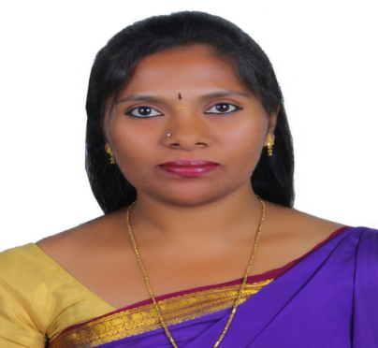

PERSONAL SUMMARY: I am hardworking, determined and driven professional with strong desire to excel in everything I do. I’m able to bring an organized and systematic approach to any role, and on a more personal level able to maintain excellent working relationships with students and colleagues. Regularly delivering beyond expectations, I’m now looking for a suitable position with an educational institution where new ideas are welcomed and key decision making is required.

SKILLS : Ability to involve with children easily
Good Teaching Skills
Have Patience and Polite approachable
CAREER HISTORY
- Worked as kindergarten teacher for P3 in Chrysalis High School Bangalore for 1 year.
- Worked for P3 in Mount Litera Zee School Bangalore for 2 years.

RESPONSIBILITIES HANDLED:
- Developing the skills of children by providing them healthy atmosphere and using the different teaching methods.
- Inspiring the students to learn the new things and by doing so shaping their future according to their interest.
- Prepare lesson plan and methods of assessment.
- Arranging meeting with parents and disusing the development of the children.
- Developing the various aspects of children i.e. physical, emotional, mental and social by allowing them to learn according to their creativity.
- Organizing the students in the group so they can interact with each other and by doing so they can develop their personality.
- Maintaining the complete records of students.
- Ability to motivate the children, so they will consider themselves a special personality.

AWARDS AND ACHIEVEMENTS:

- Participated in cultural activities in schools and college.
- Participated in various Sports Event in school.

EDUCATIONAL BACKGROUND:
- B.Ed. in Early childhood in New Zealand at Tertiary college (Online, Pursing).
- Pre-Primary Teacher’s Training 2013-2014(Bangalore).
- M.Com 2012-2014 (Madras University).
- B. Com 2008-2011(Bangalore University).
- II PUC 2007- 2008(Bangalore University).
- S.S.L.C. 2006.

COMPUTER : MS Word, Excel, Power point, Email, Tally 9.0

PERSONAL:

Father Name : SUSAI

Date of Birth : 29/04/1990

Nationality : Indian

Gender : Female

Marital Status : Spinster

Language Known : English, Kannada, Hindi & Tamil

INTEREST : Interaction with children, Teaching, Dancing, Comparing and
Singing.
)

STRENGTHS:

- I have good skills in guiding learning.
- Iam constructive and creative.
- I play a role of sharing attitude.
- Active participant and more responsible

DECLERATION:

I hereby declare that the above particulars are true to the best of my knowledge.

