Curriculum vitae
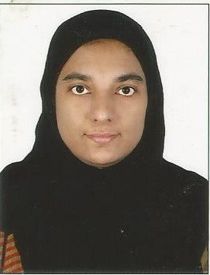

ASSISTANT PHARMACIST
MOH LICENSE
NISHA
Email ID: nisha.364253@2freemail.com
OBJECTIVE
A position with growth potential where my discipline, positive attitude, professionalism, untiring efforts and interest can be utilized

PERSONAL SKILLS
Compassionate Problem Solving Skills
Capable of working under pressure Inventory Control & Management
Effective Team Player Good Communication Skills

With an experience of more than ten years as a pharmacist, I have gained the complete understanding of the cosmetic, health supplement and drugs registration requirement of UAE and handling insurance claims.

- Prepares medications by reviewing and interpreting physician orders;
- Dispenses medications by compounding, packaging, and labeling pharmaceuticals.
- Controls medications by monitoring drug therapies; advising interventions.
- Completes pharmacy operational requirements by organizing and directing technicians' work flow; verifying their preparation and labeling of pharmaceuticals; verifying order entries, charges, and inspections.
- Provides pharmacological information by answering questions and requests of health care professionals; counseling patients on drug therapies.

WORK EXPERIENCE
1) Designation : Assistant Pharmacist
Working as Assistant pharmacist
LIFE Pharmacy Group, Sharjah
From May 2014 to Aug 2016

2) Designation : Pharmacist
Organization : P M G Medicals
Kozhencherry, Kerala, India
Duration : March 2010 to Sept 2013

3) Designation : Pharmacist
Organization : Geo Medical Trust Hospital, Pathanamthitta, Kerala, India
Duration : Oct 2005 to April 2009

4) Designation : Pharmacist
Organization : Muthoot Medical Center, Pathanamthitta,
Kerala, India
Duration : Mar 2002 to Oct 2004

ORGANIZATION

1) Muthoot Medical Center is one of the biggest and well equipped medical centers in private sector in Kerala, India offering quality services in various specialties. It is a good referral and training institution for nurses and other medical professions. It is having high –tech theater complex like general and laparoscopic surgery, urology neuro surgery, ortho, ENT etc

2) GEO Medical trust Hospital also having the same specialties like muthoot medical centre

EDUCATIONAL QUALIFICATION

Diploma in Pharmacy Course : Directorate of Medical Education
Kerala – India - 1999

Pre Degree Course : Mahatma Gandhi University
Kerala – India

Diploma in Office Automation : Software Training & Development Centre
Kerala – India

PERSONAL DETAILS

Language known : English, Malayalam, Tamil
Date of Birth : 31st Jan 1979
Sex : Female
Religion : Muslim
Nationality : Indian
Marital status : Married
Passport Details : issued from Trivandrum
Visa status : Dependant visa
Reference : Will be provide as on request

License : MOH (UAE)

DECLARATION

I hereby declare that particulars given above are true and correct to the best of my knowledge and belief. I assure that I will be very sincere and dedicate in discharging my duties and responsibilities. I am looking forward for your kind consideration.

Place: SHARJAH NISHA

