RAGI
RAGI.364274@2freemail.com 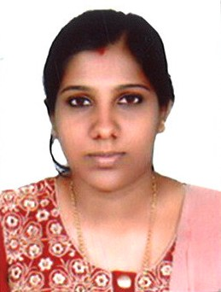

Objectives
To work with an internationally reputed organization where my qualification, experience, skills and capabilities will be focused to the best interest of the organization enabling its dynamic growth.

Professional Synopsis

- Energetic and enthusiastic.
- Initiative, Responsible, Punctual and Organized.
- Outstanding personality and good command over multi languages.
- Cooperative and adjusting nature on new environments.
- Used to design and conduct lessons for students
- Gave individual attention to students for improving school results
- Provide monthly written report to the school board on the progress of the class at the end of each month.

Work Experience

- Worked as a Teacher in PNMGHS School ,Kerala,India on 2013-2014.

Educational Qualifications
- Degree in History (BA) kerala Univercity (2008-2010)
- Degree in Social Science (B.Ed) kerala Univercity (2011-2012)

Additional skills
- MS office

Languages Known
- English ( Read, Write& Speak)
- Malyalam (Read , Write& Speak)
- Hindi ( Read & Write)

Declaration

I hereby agreed that the above information given by me is true to the best of my knowledge and belief.
Yours Sincerely,

