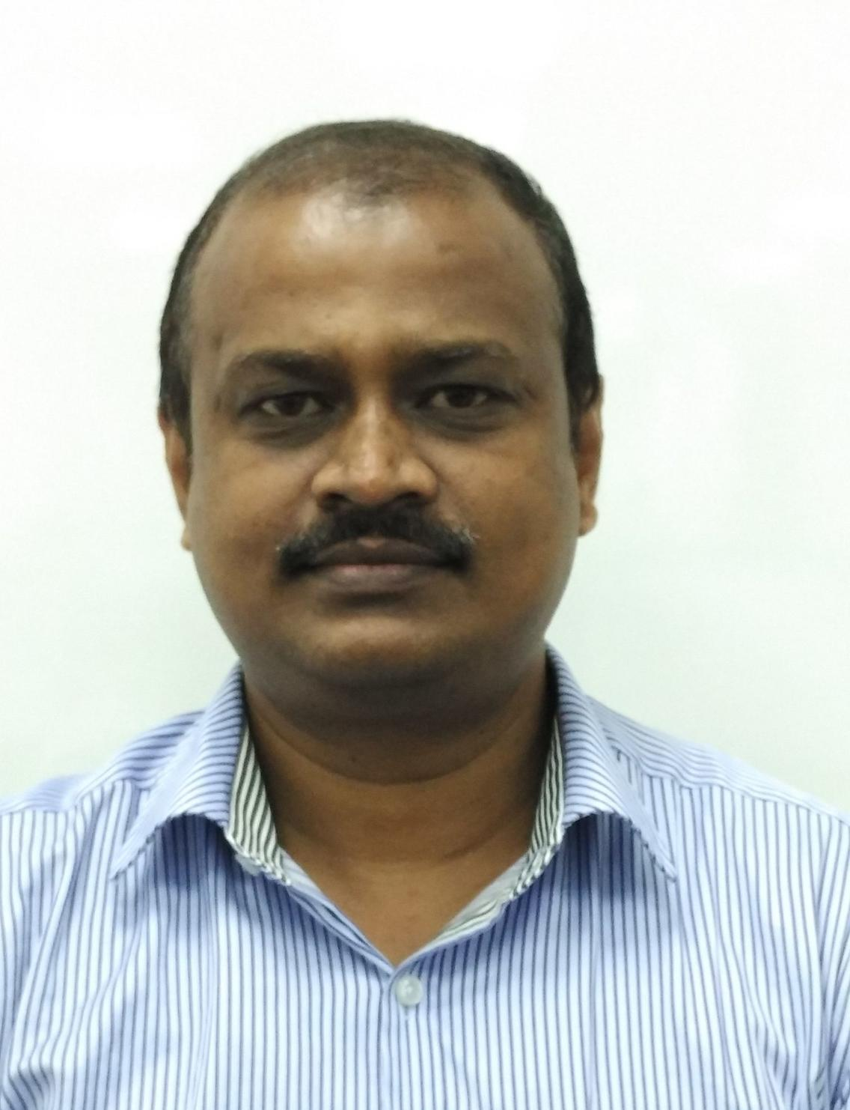
education/Qualifications
Bachelor’s Degree in Civil Engineering – Anna University Chennai – 2006
Diploma in Civil Engineering – State Board of Technical Education - 1991
CODES & STANDARDS
BS Codes, Euro Code, AS / NZ Codes, American Codes and IS Codes
SOFTWARES
STAAD Pro., Limcon, AFES, HILTI Profis, TEDDS, Fast track, Procon, MS Office and Autocad
otherS
Date of Birth: 14-05-1973
Nationality: Indian
Languages: English, Tamil, Hindi

Shanmuganathan
Shanmuganathan.364288@2freemail.com

CIVIL & STRUCTURAL ENGINEEr

Summary biography
- As a C & S Engineer expertise in design of RCC & Steel Structures and piling & foundation calculations, design of equipment, tanks and vessel foundations and also the hydraulic design calculations for storm water drainage for the whole project
- Projects worked on greenfield, brownfield, pharma, refinery and oil and gas
- Projects involved are new facilities and also the improvements to existing facilities
- Preparation of detailed design calculation for the submissions to the BCA & other authorities, preparation of deliverable list and drawing checking to ensure the quality of deliverables
- Delivers the design calculation & drawings with in the scheduled time and the duration
- Review of Shop drawing
- Resolving the Technical queries (TQ’s) from site & coordination
- Preparation of Technical Bidding Evaluation and sub-con & construction site coordination
Areas of Expertise
- Expertise on Oil & gas, Petrochemical, Process, Industrial and pharma projects.
- Projects worked from small size to over 10 million and the duration 3 months to up to 2 years
- Deliverable Quality Monitoring
- Scheduling
- Civil & Structural Engineering
Relevant Project Experience
July - 2012 to July - 2016:
Organization: JACOBS ENGINEERING LIMITED, Singapore.
Designation: Civil & Structural Engineer
Project: EASTMAN
Client: Eastman Chemicals
Title: Kuantan Resin Plant, Malaysia
Responsibilities:
- Design of PVOH the main Plant buildings steel structure, substructure and foundations.
- Design of tanks and equipment foundations
- Design calculation for substructure package for structures such as WWTP and Pipe racks.
- Steel superstructure calculation for pipe racks and pipe supports.
- Shop drawings review
Project: AMGEN
Client: AMGEN Manufacturing Kypolis
Title: AMGEN API Pharma Facility, Singapore
Responsibilities:
- Design of main AMGEN API building’s RCC structure, substructure and foundations.
- Design of Steel roof, staircases and canopies
Project: CRODA
Client: Croda
Title: Alkoxylation Project
Responsibilities:
- Design calculation for substructure package and piling package for reactor module process structure, transformer shelter, pipe racks, containment sump and fire water tank.
- Steel superstructure calculation for reactor module process structure, transformer shelter and pipe racks
- Steel superstructure calculation for pipe racks and pipe supports.
Project: NOVARTIS
Client: NOVARTIS
Title: Novartis Biopharm OPS Project
Responsibilities:
- Design calculation for substructure package and piling package for utility structures such as stack foundation, WWTP & FW retention basin, tank farm slab and pipe racks
- Steel superstructure calculation for pipe racks, pipe bridges and pipe supports
- Storm Water Drainage layout and Hydraulic calculations for the whole project
Project: DUPONT
Client: DUPONT CHEMICALS
Title: Dupont AP2WML+PRISM
Responsibilities:
- Design calculation for substructure package for the main process building and utility structures such as FW retention basin, waste tank pit.
- Design of substructure package for DP process and warehouse building
- Steel superstructure calculation for platforms, pipe racks and pipe supports

August - 2011 to June-2012:
Organization: DOPET, Qatar.
Designation: Sr. Engineer – Civil & Structural
Project:
- Installation of CEMS (Continuous Emission Monitoring System) Shutdown related project at Dukhan, for QP (Qatar Petroleum)
Responsibilities:
- Preparation of scope of work for the engineering subcontractor, surveying & geotechnical consultants.
- Raise technical queries and clarifications to the client.
- Attend client meetings & site meetings
- Review of engineering design documents and drawings
November - 2009 to July-2011:
Organization: CHIYODA SINGAPORE (PTE) LTD, Singapore.
Designation: Engineer – Civil & Structural
Project:
- BDEP & EPC’m for SCOT & BUGIS – at BUKOM island, for SHELL Eastern Petroleum, Singapore SCOT is a Brownfield project and BUGIS is Greenfield project).
Responsibilities:
- Preparation of engineering deliverable list and based on the project schedule and the document numbering procedure.
- Prepare and maintain the design input control sheet by coordinating with other disciplines.
- Document retrieval at the client’s design library for the existing As-built data.
- Design of pipe racks (supported with vessels and operating platforms, staircase), equipment structures loaded with horizontal waste heat boilers for which provided with monorail beams for pulling out the tube bundle, operating stage & stanchions, etc.
- Design of additional tier to the existing pipe rack and design for strengthening if required.
- Coordination with designers for 3D model review with SPR
- Design of equipment foundations, piling and pile caps based on interphase check with the existing U/G facilities.
- Coordinate with the Chiyoda’s branch office in India for the drawings.
- Preparation of scope, terms and conditions for the Fabrication and Erection subcontract.
- Technical Bidding Evaluation (TBE) and raising technical clarification to the bidders.
- Attend site meetings; clarify the TQ from the subcontractors.
Sep - 2008 to Sep - 2009:
Organization: CHIYODA CORPORATION, Japan.
Designation: Engineer – Civil & Structural
Projects:
- Pearl GTL project, Qatar.
- BDEP global projects
Responsibilities:
- Review of engineering design documents & drawings prepared by the Chiyoda’s branches in India & Philippines.
- Coordinate & Review of fabrication shop drawings from subcontractors and fabrication companies (MCADD, Malaysia and Hanmaek, Korea).
- Clarification for the TQ from site.
- Technical Bidding Evaluation (TBE) and raising technical clarification to the bidders
- Preliminary design & documentation work for FEED projects and tendering projects.
Jun - 2006 to Sep - 2008:
Organization: Intercontinental Development Engineering AE&E Pvt. Ltd (I.D.E.A), Chennai, India.
Designation: Engineer

Projects:
- Detailed Engineering of offsite & Utility Facilities for PTA Project of MCC PTA at Haldia, Calcutta, India. & AUM project in West Indies. (Client: TOYO – India & TEC Japan)
- BDEP global projects
- Worsley Multi Fuel Cogen Project, Australia.
- 3 Months worked in Sydney for a deputation at AE & E, Australia.
Responsibilities:
- Design of pipe racks (3 tiers, 10x9 m bay – top tier with E & I trays), pipe bridges (up to 20 m span), Equipment structures, pipe stanchions, maintenance ware houses, etc in STAAD using IS, BS, AISC LRFD & AS codes.
- Design of CFB boiler supporting structure (40 m x 50 m x 54 m height – 13 floors) loaded with silos, bunkers and other equipment & operating platforms in Microstran using Australian codes & standards.
- Connections design in spread sheet.
- Design of RCC substation buildings.
- Design of Pile caps with the optimized number of pile group, footings, horizontal & vertical equipment foundations, pipe sleepers, etc in spread sheet.
- Coordinate with the drafting team for the preparation of GA & detail drawings and drawing checking as per the client’s standards and requirement.
Mar - 2004 to Jan - 2006:
Organization: EXCEED INTERNATIONAL (P) Ltd, Chennai, India.
Designation: Engineer
Projects:
- Back Office Support for US Head office Exceed Technologies – Government submittals for Residential condos / Commercial complexes.
Responsibilities:
- Communicate & Follow the instructions from the PE in USA.
- Structural components as columns, beams, slabs & foundations design in spread sheet with the STAAD analysis result.
- Design of Steel buildings – service buildings, storage house, maintenance buildings in STAAD using AISC codes & standards.
- Lead the drafting team & control the progress and quality of the engineering deliverables.
Oct - 2002 to Feb - 2004:
Organization: Free Lance & Private Works.
Designation: Engineer
Projects:
- Planning & Drafting and Estimation for Residential buildings, etc.
- Construction Site Supervision
Jun - 1999 to Sep - 2002:
Organization: DOUGLAS OHI LLC, Muscat, OMAN
Designation: Site Supervisor

Project:
- Construction of Permanent Accommodation for Contractors for PDO at NIMR & Qarn-Alam (OMAN)
Responsibilities:
- Setting out & marking at site for the building as per the coordinates in the drawing using ‘Total Stations’.
- Execution of the construction as per the drawing and specification.
- Monitor the safety & quality procedures in the execution.
- Planning for the man power & materials to attain the progress as per the schedule, in MS project.
- Coordinate with the M&E subcontractors
- Raise RFI to the client / consultant for the technical queries & clarification.

Apr - 1991 to Jun - 1999:
Organization: PRIVATE CONSULTANCY / CONSTRUCTION COMPANIES, Madurai, India
Designation: Drafts person & Site Supervisor
Projects:
- Residential & Commercial buildings and Community hall
- Renovation, additions and modification in industrial annexure buildings such as warehouse, go downs, machine shop and generator house.
Responsibilities:
- Involved in site survey / measurement, preparation of conceptual & govt. approval drawings, structural & construction drawings and RCC detailing & bar bending schedule preparation.
- Preparation of Drawings, Estimation, construction schedule, agreement for the subcontractors.
- Periodical site check & attending site meetings.
- Quantity surveying and bill checking.

Declaration | I do hereby declare that the information given above is true to the best of my knowledge and belief.

