Summary

Five years' professional experience in construction firms as site and technical office architect, working in high-rise building, educational developments and residential buildings for both contracting & consulting companies in Egypt and Saudi Arabia.

Experience
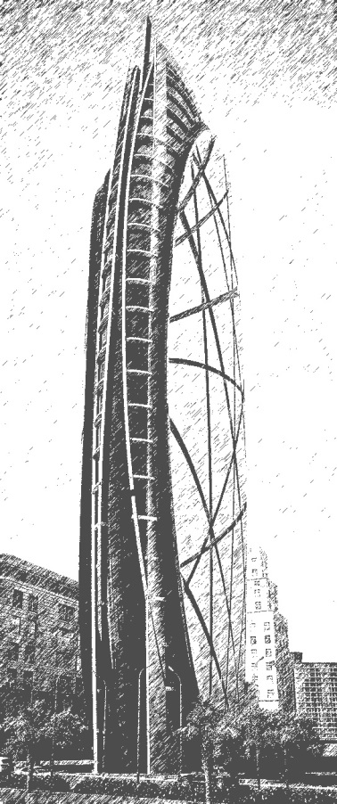
Site Architectural Engineer
MAIDAT Cont. Co. LTD
February 2016 – December 2016 - Riyadh, KSA

Project Name: SPIMACO ADDWAEIH OFFICE TOWER
Project Value: 100,000,000.00 SAR
Client: SPIMACO ADDWAEIH pharmaceutical Co.

Consultant: East Consulting Engineering Center (ECEC)
SPIMACO ADDWAEIH TOWER a 23-story office tower located at Al Sahafah,
Riyadh, Saudi Arabia.
Duties & Responsibilities:
- Day-to-day management of the site, including supervising and monitoring the site
labor force and the work of any subcontractors.
- Supervision of Architectural Works.
- Ensuring that all materials used and work performed are as per specifications.
- Preparing architectural shop drawings.
- Preparing architectural material submittals.
- Reporting Daily/Weekly Site Progress to the consultant.
- Surveying and Calculating As-Built Bill of Quantities.
- Site Work Invoices for Sub-Contractors.
- Liaising with clients and their representatives (architects, engineers and surveyors)
including attending regular meetings to keep them informed of progress.

Site Architectural Engineer
MAIDAT Cont. Co. LTD
November 2014 – February 2016 - Riyadh, KSA

Project Name: The Second Technical College in Riyadh
Project Value: 85,000,000.00 SAR
Client: Technical and Vocational Training Corporation
Consultant: Al-Askar Engineering
The project consists of 153000 m2 layout, Administration building, 4 Educational buildings, Workshop, Mosque, Multi-purpose Hall, Cafeteria, Water tank, Septic tank, Electrical room, Generator room and 2 Guard rooms.

Duties & Responsibilities:
- Day-to-day management of the site, including supervising and monitoring the site labor force and the work of any subcontractors.
- Supervision of Architectural Works.
- Ensuring that all materials used and work performed are as per specifications.
- Preparing architectural shop drawings.
- Preparing architectural material submittals.
- Reporting Daily/Weekly Site Progress to the consultant.
- Surveying and Calculating As-Built Bill of Quantities.
- Site Work Invoices for Sub-Contractors.
- Liaising with clients and their representatives (architects, engineers and surveyors) including attending regular meetings to keep them informed of progress.

Site Architectural Engineer
Al-Rai Engineering Consultants
January 2014 – November 2014 - Riyadh, KSA
Project Name: Housing for girls' technical institute in Riyadh
Project Value: 30,000,000.00 SAR
Client: Technical and Vocational Training Corporation
Main Contractor: Hamad Al-Saghyir for commercial investment Co.
The project consists of 23000 m2 layout, 3 Housing buildings (144 Room), Water tank, Septic tank, Electrical room, Generator room and Guard room.
Duties & Responsibilities:
- Review, coordinate and approve all architectural works including shop drawings and submittals.
- Supervise and inspect all architectural works carried by the contractor.
- Coordinate with other disciplines to ensure correct implementation of the project construction specifications and standards.
- Assist in the ongoing coordination activities with the project parties (MEP, Structure, Contractor, Sub-Contractors).
- Revise All Finishing Quantities given by the contractors.
- Revise the monthly contractor’s Invoices.
- Revise the claims & variation orders given by the contractor.
- Reporting Daily/Weekly Site Progress.
- Attending weekly meetings.

Site, Technical office Architectural Engineer
Al-Khaleg Engineering & Construction
Jul 2012 – Jan 2014 - Egypt
Duties & Responsibilities:
- Preparing all shop drawings.
- Quantity Survey of Materials and Finishing.
- Regular visits to the sites.
- Handling of Site Issues and Clarifications.
- Procurement of all Materials (Civil, MEP, Finishing).
- Issuing of Monthly Invoices and Variation Orders.
- Supporting Site Team, QC/QA and Management through different Issues.

Education

Mansoura University

Bachelor degree in Architectural Engineering

2007 – 2012

Grade : Good

Software and Skills

• AutoCAD (Autodesk certified Course - Certificate No. 1681518S564)

• Revit Architecture (Autodesk certified Course - Certificate No. 1GSFWDVKAW2)

• Project management professional preparation course

• Adobe Photoshop

• MS Office

• MS Project

