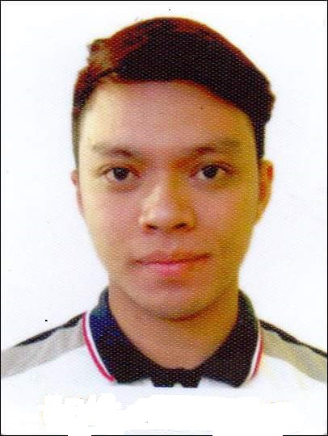
JEZREEL

JEZREEL.364336@2freemail.com

____________________________________________________________________________

OBJECTIVES

- To acquire a job that will be able to apply my skills, educational background, and ability to work well with people.
- To be able to work in an environment that promotes an individual’s growth together with the company.

QUALIFICATIONS

- Guaranteed 100% accuracy and timeless in work outputs
- Ability to do multi-tasking work assignments and can work with minimum supervision
- Dependable, dedicated, hardworking and enthusiastic in the performance of responsibilities
- Knowledgeable in the use of Microsoft Office Applications
- Good command communication skills both oral and written (English & Filipino)
- Willing to be trained

PERSONAL BACKGROUND
DATE OF BIRTH: MARCH 13, 1992
HEIGHT: 167CM
WEIGHT: 125.6LBS
GENDER: MALE
CIVIL STATUS: SINGLE

VISA STATUS: VISIT VISA
VALID UNTIL: 15 June 2017

EDUCATIONAL BACKGROUND
Course Program: Continuing Professional Education
Negros Oriental State University (NORSU)
Siaton Campus
Brgy. 3, Siaton Negros Oriental
2015-2016

Tertiary: Graduated Bachelor of Science in Hotel and Restaurant Management
Asian College – Dumaguete Campus
Dr. V. Locsin St., Dumaguete City
2009-2013

Secondary Level: Carmel High School
Pob.1, Siaton Negros Oriental
2005-2009

Primary Level: Datag Elementary School
Brgy. Datag, Siaton Negros Oriental
1999-2005

ACADEMIC AWARD/ EXTRA – CURRICULAR INVOLVEMENT

CLASS HONORS STUDENT LEADER
Asian College – Dgte Campus College of Tourism and
S.Y. 2012-2013 Hospitality Management
Vice – President
S.Y 2011-2012

STUDENT ASSISTANT OUTSTANDING STUDENT OF THE YEAR
Asian College – Dgte Campus Asian College – Dgte Campus
S.Y 2011-2013 S.Y. 2011 – 2012

WORK EXPERIENCES

Local Government Unit
LGU Link
Municipality of Siaton
June 1, 2015 - January 15, 2017

VENTURES LINK INC.
Technician
Vote Counting Machine
May 2016

BACOLOD CHICKEN INASAL
Waiter
Jupiter – Makati Branch
July 21, 2014 – December 21, 2014

SBARRO
Busboy
Glorietta 2, Ayala Center
Makati City
January 29, 2014 – June 28, 2014

ON-THE-JOB TRAINING (with Certificates)

On-the-Job Training
Asia Novotel, Dumaguete City
Total of 600 hours
October 2012 – February 2013

On-the-Job Training
Crown Regency Beach Resort, Boracay
Total of 200 hours
April 21, 2012 – May 13, 2012

On-the-Job Training
Resto Palmyra, Dumaguete City
42 Hours in Food and Beverage Services
August 2012

Actual Shipboard Training
Pier 2, Manila, Philippines
January 28- 31, 2011

Food and Beverage Overview,
Housekeeping Overview &
Bed Making For Actual Demo
Held at Manila Hotel, One Rizal Park 0913
Manila, Philippines
January 29, 2011

