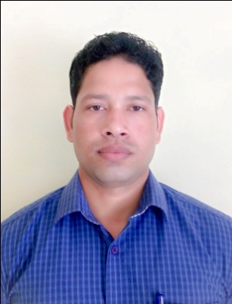
CURRICULUM-VITAE
SOHIT
SOHIT.364345@2freemail.com

1. SUMMARY
Respected Sir/Madam,
I would like to introduce myself, as a Bachelor of Technology in Mechanical Engineering from Kurukshetra University. I am currently working as Production Engineer (Production Planning and Control) in Lakshmi Precision Screws Ltd. I wish to put forth my candidature for a suitable post in your organization. Given an opportunity I will render my best service and work.

2. WORK EXPERIENCE
- Lakshmi Precision Screws Limited, Rohtak, Haryana, India
Production Engineer (Production Planning and Control)
(April 2014 – Till Date)
Role and responsibilities:
- Planning day to day to achieve maximum production.
- Material requirement Planning.
- Preparation of daily production reports and management reports.
- Prepare & Implement action plans to maximize overall equipment efficiency of machines.
- Distribution of work load to operators in order to achieve daily production target.
- Troubleshooting and solving technical problems.
- Supervising and monitoring daily activities at shop floor.
- Analysis of daily tool consumption and generation of production reports.
- Maintaining 5S in workplace.
- Checking Machines daily.
- Maintaining of tool life & instrument calibration records.
- Arranging, repairing and maintaining tools.
- Apex Aluminum Extrusion Pvt. Ltd., Jaipur, Rajasthan, India
Production Engineer (June 2013 – April 2014)
Role and responsibilities:
- Production Planning, Manpower Planning and Raw material Planning.
- Productivity increasing by implementing new techniques.
- Attending customer complaints & solving problems.

3. TECHNICAL SKILLS
- Good working knowledge of machines i.e.
- Lathe
- Milling
- Grinding (Surface, I.D, O.D )

4. STRENGTH
- Achieve on time production
- Eliminate 8 wastage
- Machine utilization
- Target oriented, strong will power and better planning and coordination
- Enthusiasm to learn new concepts.
- Easily adaptable nature.

5. ACADEMIC QUALIFICATION
- High School , in 2007 from U.P Board, 70.0 %
- Sr. Secondary in 2009 from U.P Board, 71.0 %.
- B.Tech (Mechanical) in 2013 from Kurukshetra University, 74.06 %, Honors.

6. TRAINING AND WORKSHOPS
- A workshop on Renewal Energy Technology (RET).
- A course on AUTO-CAD Design.
- A course on CATIA Design.

7. COMPUTER SKILLS
Microsoft Excel, Microsoft Office, Auto CAD, CATIA.

8. PERSONAL DETAIL
Date of Birth : 16th July, 1993
Language known : English/Hindi
Nationality : Indian
I hereby declare that the information is true to the best of my knowledge.

