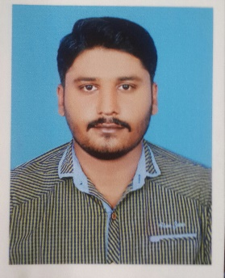
NAZIM
Nazim.364349@2freemail.com

Resume:
A highly talented, professional and dedicated Civil Engineer looking for a prospective career in the field of Civil Engineering amidst challenging environments that would utilize and hone my professional and interpersonal skills.
EDUCATION:
- 1st division in Diploma of Associate Engineer
Faran Institute of Technology Gujarat, Punjab.
18th OCT 2012
- Diploma of AutoCAD
Professional Academy of design & Civil Technology
Grade A 30th Sep 2012
- 1st division in Metric in Science Govt. High School Chechain
1st Aug 2008

EXPERIENCE:
Al-Khalil Construction Company (Pvt) Ltd. Islamabad:
Work as a SUPERVISOR from 7th Nov 2012 to 10th Dec 2016
Total 4 Year experience in field.
- Site supervisor for construction work.
- Check design calculations of designers and other engineers within the team.
- Lead design reviews, risk assessments from a technical standpoint.
- Produced Works Information, including pavement layouts, geometric design and new and existing services.
- Produced designs compliant with project strategies on planning, the environment, risk, safety and quality.
- Supervise technicians, technologists and other engineers within the team.
- Assisted Production Integrators with planning activities.
- Very good with management.

Personal details
- Date of Birth: 10 Sep, 1989.
- Sex: Male.
- Nationality: Pakistani.
- Marital Status: Unmarried.
- Place of issue: Gujrat.

Languages Known
- To Read & Write: English, Urdu & Punjabi.
- To Speak: English, Urdu & Punjabi.

