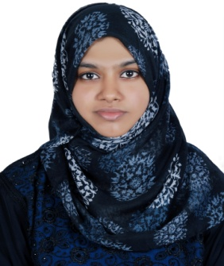
SHAMSEENA
SHAMSEENA.364354@2freemail.com

OBJECTIVE

To be associated as an employee with a progressive organization that gives me scope to
update knowledge and skills in accordance with the latest ideas and be a part of the team
work that dynamically works towards the growth of the organization and gain satisfaction.

EDUCATIONAL QUALIFICATIONS

. Pursuing ACCA , (Fundamentals F5 and F6)
PWC’s Academy, Dubai

- Bachelor of Commerce ( Finance)
City International Training Centre, ajman (Calicut University)

- Grade 12 ,CBSE stream with 79% (Commerce),
New Indian Model School, Dubai

- Grade 10,CBSE stream with 7.6 ,
New Indian Model School, Dubai

TECHNICAL SKILLS

- Internet Applications
- MS Word
- MS Excel
- My SQL(basics)

PERSONAL SKILLS

- Effective inter-personal skills.
- Ability to manage and accomplish individual, team and organizational goals.
- Pro-active and people oriented.
- Driven to learn and apply new ideas and skills.
- Able to identify, visualize and implement solutions to problems.
- Ability to adapt with the changing environment.
- A possible attitude and total belief in my capabilities.
- Good analytical skill with strong interpersonal skill.

OTHER SKILLS

- Excellent social and communication skills.
- Disciplined and accurate.
- Able to stay calm under pressure.
- Ambitious, self-motivated, energetic, sincere and hardworking.

PERSONAL DETAILS

Age & Date of birth : 01/06/1995
Nationality : Indian
Sex : Female
Religion : Islam
Marital Status : Single
Languages Known : English, Hindi and Malayalam
Current Address : P.O. Box: 124819, Dubai, UAE
Hobbies : Reading, Listening to music, cooking and learning new technology

DECLARATION

I do hereby confirm that the information given above is true to the best of my knowledge and belief.
Place : Dubai
SHAMSEENA

