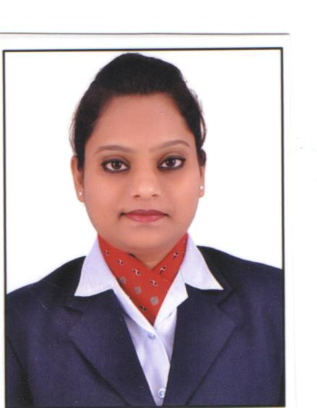

Kavita
Kavita.364356@2freemail.com

Academic Qualifications:
- M.B.A in Finance from ICFAI University.

- Graduation in B.Com (Accounts) from Gujarat University with 53% in 2010.

- H.S.C from St. Mary’s High School, Gujarat Secondary Education Board,
With 60% in 2007.

- S.S.C from Sheth R.T.New Education High School, Gujarat Secondary Education Board,

- Gandhinagar with 64.43% in 2005.

Additional Qualifications:
- Completed course in CCC from C-DAC, Ahmedabad with A+ Grade.

- Completed course in Tally from C-DAC, Ahmedabad with A Grade.

Technical Qualifications:
- Well versed in MS Office & Internet.
Work Experience:
- Worked as an Accountant in Kavita Fabricators
- Worked as a customer service associates at Kotak Securities
(From June ‘2014 to February 2015)
- Worked with Spice jet Pvt. Ltd for 1 year 4 months as a Tr.CSE.

Key Responsibilities:-
- Customer facilitation
- Create Reservation Special Service Request
- Ticketing and queries with regarding our product
- Understand the customer’s requirement
- Documentation and analyzing the required information and data.

Strengths:
- Punctuality, Sincerity, Reliable

REFERENCE:

As per your request

Place : Dubai

Date : 26/04/2017

